STATE LOAD DESPATCH CENTRE

ODISHA

Procedure for First Time Charging/Energization (FTC) and Integration ofNew orModifiedPowerSystemElement

Table of Contents

Contents | Page No
Introduction | 1
Definitions and Interpretation | 4
Section 1:
Procedure for integration of a new or modified power system elements and issue of certificate of successful trial operation by State Load Despatch Centre

Section 2:
Procedure for obtaining first time charging/clearance from SLDC&commencementofGridAccessfordrawalofstart-up power for conventional generating plants (Thermal, Gas & Hydro),Bulk Consumers or Load Serving Entities and Combined(Load&Captive)generationcomplex

I NTRODUCTION
ThisFirsttimeCharging(FTC)procedureisapplicabletoall State transmission utility/ state generating stations and any other user/licensee connected to and involved in developing the State transmission system.
IndianElectricityGridCodeprovidesforformulationofoperatingprocedureby SLDC.Thesameisquotedbelow:
“A set of detailed operating procedures for each state shall be developed and maintained by the respective SLDC inconsultationwiththe concerned personsforguidanceofthe staffoftheSLDCanditshallbeconsistentwithIEGCtofacilitate compliancewith therequirementofthisIEGC.”
InaccordancewiththeaboveprovisionsandasapartofSLDCoperating procedure,thefirsttimechargingprocedureforenergizationandintegrationof newormodifiedpowersystemelementhasbeenprepared.Thisprocedure specifiestherequirementstobefulfilledbytheconnectivitygranteespriorto obtainingthepermission of the SLDC.Thisprocedurespecifiesoperational and study requirements for integration of new or modified power system elements with thegrid.
For integrating the new or modified power system elements in the grid, the followingareprerequisitebeforeFirsttimechargingofPowersystemelements.
- PowerpurchaseAgreements(PPA),connectivitydetailsandagreements
- StatutoryclearancesasperCEAorasperrespectiveStategovernment authorities which everapplicable
- PTCC clearanceCertificate
- Compliancesofvariousregulation/standardsofCERCandCEA
- Ensure to correct and appropriate settings of protection asper RPC

approved protection philosophy
- ProvidesRealtimeSCADAdataandtelemetryatSLDCs
- InstallationofmetersasperprovisionsofCEAregulations
- Dedicated Voice/Data communication from generating /substation in redundant and alternatepath.
- Staticanddynamicmodellingdataforsystemstudies
- CompliancesofrelevantclausesofIEGC and OGC andoperatingproceduresof SLDC
- Compliancetoanyotherregulationsandstandardsspecifiedfromtimeto time
Basedontherequirements,FirstTimeCharging(FTC)procedureispreparedby SLDCtofollowuniformlyinthe State andisdividedintothreesectionsas follows:
Section1:-ProvidesthedetailsofrequirementforIntegrationofconventional generatingplants(Thermal,Gas&Hydro),BulkConsumersorLoadServing EntitiesandCombined(Load&Captive)generationcomplex
Section2:-ProvidesthedetailsofrequirementforIntegrationofSolar,Windor Hybrid Power Plant/Wind or Solar Power Parks, WPD/SPD/HPD those are state entities
Section 3:- Provides the details of requirement for integration of a new or modified power system elements and issue of certificate of successful trial operationbyStateLoadDespatchCentre(SLDC).
For integrating new or modified power system elements in the grid, all concernedshallhavetosubmittheAnnexures(A1-A6),(B1-B5)and(C1-C4)as per the time line mentioned in Section 3 of this document in addition to the requirementdescribedintherespectiveSections.JurisdictionofSLDCforissuingchargingcodeandtrialcertificateisasfollows:
- FirsttimeChargingcode,subsequenttestingcodeswillbeissuedasfollows:
SLDC- Power system elements belongs to 220kV and 132kV belonging to STU, Station Transformers(STs)atgeneratingstationthosearestate entities.;Generating station,BulkConsumersorLoadServingEntitiesandCombined(Load&Captive) generationcomplexthosearestateentities.

- TrialCertificatewillbeissuedasfollows:
SLDC- Transmission lines designated as STU for voltage level of 220kV and below which are state entities, state generating stations
ForIssuanceofTrialoperationcertificatebySLDCthefollowingshallbe ensured by allconcerned
  - Compliance all the documents / sharing of data & information stated in respectiveSections
  - CompletionoftrialoperationasperCERCregulation/procedure.
  - SubmittingtheAnnexure(C1-C4)asperFTCprocedure.

Definitions and Interpretation (As defined in the Indian Electricity Grid Code)

1.1. In this procedure, unless the context otherwise requires,
- "Act" means the Electricity Act, 2003 (36 of 2003) and subsequent amendments thereof;

- "actualdrawal"inatime-blockmeanselectricitydrawnbyabuyer,asthecasemay be,measuredbytheinterfacemeters;

- "actual injection" in a time-block means electricity generated or supplied by the seller,asthecasemaybe,measuredbytheInterfacemeters;

- "beneficiary"meansapersonwhohasashareinanInter-StateGeneratingStation;

- "Commission"meanstheCentralElectricityRegulatoryCommissionreferredtoin sub-section(1)ofsection76oftheAct;

- "Deviation"inatime-blockforasellermeansitstotalactualinjectionminusitstotal scheduledgenerationandforabuyermeansitstotalactualdrawalminusitstotal scheduleddrawal;

- “DisturbanceRecorder(DR)”meansadeviceprovidedtorecordthebehaviourofthe pre-selecteddigitalandanalogvaluesofthesystemparametersduringanEvent;

- “Event Logging Facilities” means a device provided to record the chronological sequenceofoperations,oftherelaysandotherequipment;

- "GridCode"meanstheGridCodespecifiedbytheCommissionunderclause(h)of sub-section(1)ofSection79oftheAct;

- “Inter-StateGeneratingStation(ISGS)”meansaCentralgeneratingstationorother generatingstation,inwhichtwoormorestateshaveShares;

- "interface meters" means interface meters as defined by the Central Electricity Authority under the Central Electricity Authority (Installation and Operation of Meters)Regulations,2006,asamendedfromtimetotime;

- “InterStateTransmissionSystem(ISTS)”means
  - Anysystemfortheconveyanceofelectricitybymeansofamaintransmission linefromtheterritoryofoneStatetoanotherState
  - TheconveyanceofelectricityacrosstheterritoryofaninterveningStateas well as conveyance within the State which is incidental to suchinter-state transmission ofenergy
  - ThetransmissionofelectricitywithintheterritoryofStateonasystembuilt, owned,operated,maintainedorcontrolledbyCTU;

- “Licensee”meansapersonwhohasbeengrantedalicenseunderSection14ofthe Act;

- "LoadDespatchCentre"meansNationalLoadDespatchCentre,RegionalLoad

Despatch Centre or State Load Despatch Centre,as the case maybe,responsible for coordinating scheduling in accordance with the provisions of Grid Code;

- "regional entity"means a person whose metering and energy accounting is done at the regional level;

- "Scheduled generation"at any time or for a time block or any period means schedule of generationinMWorMWhex-busgivenbytheconcernedLoadDespatchCentre;

- “TransmissionLicense”means a License grantedunderSection14oftheActto transmitelectricity;"time-block"meansatimeblockof15minuteseachforwhich specialenergymetersrecordvaluesofspecifiedelectricalparameterswithfirsttime blockstartingat00.00hrs;

- State transmission utility means as notified by the State govt of Odisha under section 39(1) of the Act.

- State generating station means A generating station whose entire generation of electricity is dedicated to the State.

Section 1:

Procedure
for integration of a new or modified power system elements and issue of certificate of successful trial operationby State Load Despatch Centre (SLDC)

Table of Contents

 | Contents
1. | Compliance to the regulations
2. | Intimation for energization to SLDCs

1. | AnnexureA1:Intimationregardinganticipatedchargingofthe  line along with other documents
2. | Annexure A2: List of elements to be charged andElement  Rating details
3. | AnnexureA3:Singlelinediagramoftheconcernedsubstations,  along with status of completion of each dia/bus/breakers
4. | Annexure A4: List of SCADA to be made available
5. | Annexure A5: Type and Location of Energy meters as per  relevant CEA Regulations
10. | Annexure A6: Connection Agreement, If any
11. | AnnexureB1:Requestforchargingofthenewtransmission elementalongwiththesummaryoftheundertakingsbeing  submitted
12. | Annexure B2: Undertaking in respect of Protective systems
13. | Annexure B3: Undertaking in respect of Telemetry and  communication
14. | Annexure B4: Undertaking in respect of Energy metering
15. | AnnexureB5:UndertakinginrespectofStatutoryclearances

`Procedure for integration of a new power system elements

This procedure is applicable for following power system elements:
- 220 kV level transmission lines/Auto transformers/ Bus/Bay/ Generating Transformer/any other elements emanating from STU substations
- Station Transformers(STs) at generating station those are state entities.
- Generating station those are state entities.
- Bulk Consumers or Load Serving Entities those are state entities.
- Combined(Load&Captive) generation complex those are state entities.

Indian Electricity Grid Code provides for formulation of operating procedure by NLDC/RLDCs. The same is quoted below:

““A set of detailed operating procedures for each state shall be developed and maintained by the respective SLDC in consultation with the concerned persons for guidance of the staff of the SLDC and it shall be consistent with IEGC to facilitate compliance with the requirement of this IEGC.”
.

In accordance with the above provisions and as a part of SLDC operating procedure, procedure for energization of a new or modified power system elements belonging to any transmission licensee has been formulated to enable SLDC for secure and reliable integration of new elements.This procedure specifies requirements for integration with the grid such as protection, telemetry and communication systems, metering, statutory clearances and modelling data requirements for system studies.

The details of the same are as follows:

      - Compliance to theregulations:All the transmission licensee shall be complied to the regulation & their amendments mentioned below-

Central Electricity Authority(Technical Standards for Connectivity to the Grid Regulations,2007
        - Central Electricity Authority(Technical Standards for Construction of Electrical Plants and ElectricLines)Regulations,2010
        - Central Electricity Authority (Measures Relating to Safety &Electric Supply)Regulations,2010
        - Central Electricity Regulatory Commission (Communication Systemfor Inter-StateTransmission of Electricity)Regulations,2017
        - Central Electricity Authority (Installation and Operation ofMeters)
Regulations, 2006
        - Central Electricity Regulatory Commission(Grant of Connectivity,Long- term Access and Medium-term Open Access in Inter-State Transmission and related matters)Regulations,2009
        - Central Electricity Regulatory Commission(Fees and Charges for Regional Load Despatch Centres)Regulations,2019
        - Any other regulations and standards specified from time to time

      - IntimationforenergizationtoRLDCs-All the Transmission Licensees including deemed transmission licensees or cross-border entity(Indian side) intending to energize a new or modified any power system elements, which is part of inter- state transmission system,shall intimate the concerned SLDC the details as per the formats given below, atleast(10)days prior to the anticipated date of first test charging.

- AnnexureA1:Intimation regarding anticipated charging of the power system elements along with the list of the desired documents being submitted.

- AnnexureA2:List of elements to be charged with their Rating

- AnnexureA3:Single line diagram of the concerned substations,along with status of completion of each dia/bus/breakers clearly indicating which elements are proposed to becharged.

- Annexure A4 : List of SCADA points to be made available (as per standard requirement, SLDC would need all MW and MVAr data, voltage and frequency of all the buses, all the breaker and isolator positions, OLTC tap positions, Main-1/Main-2 protection operated signals, DC side SCADA data in case of HVDC station, data for SVC/STATCOM as per SLDC requirement)

- Annexure A5 : Location of Energy meters as per relevant

CEA regulations 287

- AnnexureA6:Connection Agreement,wherever applicable along with all annexures.
      - Within 3days of submission of above information by the Transmission Licensee, concerned SLDC shall acknowledge the receipt of the same, as per Format II,and seek clarifications, if any. The transmission licensee shall submit the desired information/ documents to the concerned SLDC within next three days.

The Transmission Licensee shall also submit the following documents in thisregard:

- AnnexureB1: Request for charging of the new or modified power system elements along with the summary of the undertakings being submitted as per Format III
- AnnexureB2:Undertaking in respect of Protective systems as per

FormatIIIA 288

- AnnexureB3:Undertaking in respect of Telemetry and communication as per Format III B
- AnnexureB4:Undertaking in respect of Energy metering as per FormatIII C

AnnexureB5:Undertaking in respect of Statutory clearances as per
Format III D

      - On satisfying itself with the submitted information as stated above under Para3, the SLDC would issue a provisional approval for charging to the Transmission Licensee as per Format IV within two days of receipt of above documents.On the designated day,the transmission licensee shall charge the transmission line and do trial operation as per the timeline mentioned in Format III,after obtaining the real time code from SLDC. All attempts would be made by the real time operating personnel at the concerned SLDC to facilitate charging and commissioning of the new or modified power system elements at the earliest, ubject to availability of realtimedata and favorable system conditions.Charging of any new elements will not be allowed after 18:00hrs.

Documents to be submitted by Transmission Licensee/Generating Stations to SLDCs

Annexure | Subject | Remarks
Annexure A1 | Intimationregardinganticipatedchargingofthelinealong with otherdocuments | As per Format I
Annexure A2 | ListofelementstobechargedandElementRatingdetails | As per Format I A
Annexure A3 | Single line diagram of the concerned sub stations, along with status of completion of each dia/bus/breakers
Annexure A4 | ListofSCADApointstobemadeavailable(asperstandard requirement,RLDCwouldneedallMWandMVArdata,voltage and frequency of all the buses, all the breaker andisolator positions, OLTC tap positions, Main-1/Main-2 protection operatedsignals)
Annexure A5 | Type and Location of Energy meters as per relevant CEA  regulations
Annexure A6 | Connection Agreement, wherever applicable along with all annexures
Annexure B1 | Requestforchargingofthenewtransmissionelementalong withthesummaryoftheundertakingsbeingsubmitted | As per Format III
Annexure B2 | Undertaking in respect of Protective systems | AsperFormatIIIA
Annexure B3 | Undertaking in respect of Telemetry and communication | AsperFormatIIIB
Annexure B4 | Undertaking in respect of Energy metering | AsperFormatIIIC
Annexure B5 | Undertaking in respect of Statutory clearances | AsperFormatIIID

Annexure - A1
Format - I
Intimation by Transmission Licensee regarding anticipated charging of new elements

<Name of Transmission Licensee>

Name of the transmission element :

Type of Transmission Element : Transmission Line / ICT / Auto transformer / Power transformer / Bus Reactor / Line Reactor / Bus / Bay / Series Capacitor / Series Reactor / Station transformer / Generator transformer

Voltage Level :
Owner of the Transmission Asset :
Likely Date and time of Charging :
Likely Date and time of start of Trial Operation :

Place:
Date:

(Name and Designation of the authorized person with official seal)

Encl: Please provide full details.

Annexure A2: Format IA: List of elements to be charged and Element Rating details

AnnexureA3: Single line diagram of the concerned sub-stations, along with status of completion of each dia / bus / breakers

Annexure A4: List of SCADA points to be made available

Annexure A5: Location of installation of Energy meters as per relevant CEA regulations

Annexure A6: Connection Agreement, if applicable along with all annexures

Annexure - A2
Format - IA

List of elements to be charged and Element Rating details

- List of Elements to be charged:

- Element Ratings:

  - Transmission Line -

1 | From Substation
2 | To Substation
3 | Voltage Level (kV)
4 | Line Length (km)
5 | Conductor Type
6 | No of sub-conductors

  - ICT/Auto transformer / Power transformer -

1 | Voltage(HVkV /LVkV)
2 | Capacity(MVA)
3 | Transformer Vector group
4 | Total no of taps
5 | Nominal Tap Position
6 | Present Tap Position
9 | Tertiary Winding Rating and Ratio
10 | % Impedance

  - Shunt/Series Reactor -

1 | Sub-station Name/ Line Name
2 | Voltage
3 | MVAR Rating
4 | Switchable / Non Switchable
5 | In case of Bus Reactor, whether it can be taken as line reactor

(Name and Designation of the authorized person with official seal)

Annexure - A4

<Name of licensee>

List of SCADA points to be made available:

Station | Element to be charged | List of SCADA points to be  made available | Remarks

(Name and Designation of the authorized person with official seal)

Annexure - A5

Please make a diagram to describe position of meter in bays.

Format - II

< SLDC Odisha >
Not to be filled by Applicant, Please don’t include this page.
Acknowledgement of Receipt by SLDC

This is to acknowledge that the intimation of likely charging of (Name of the transmission element)
Has been received from (Name of the owner of the transmission asset) on (Date).

Kindly complete the technical formalities in connection with energy metering, protection and real time data and communication facilities and inform us of the same three (3) days before charging of the above transmission element as per Formats III, IIIA, IIIB, IIIC and IIID.

Or

The intimation is incomplete and the following information may be submitted within three (3) days of issue of this acknowledgment receipt.

1. ‐

2.

3.

……………………………..

Date

Signature

Name: Designation:
SLDC
Annexure B1
Format - III

<Name of Transmission Licensee - OPTCL>

Request by Transmission Licensee for first time charging and start of Trial Operation

Pastreferences:
Name of the transmission element:

Type of Transmission Element : Transmission Line / ICT / Auto transformer / Power transformer / Bus Reactor / Line Reactor / Bus / Bay / station Transformer / Generator Transformer / series Reactor

Voltage Level :

Owner of the Transmission Asset :
Proposed Date and time of first time charging:
Proposed Date and time of Trial Operation :

Place:
Date:
(Name and Designation of the authorized person with official seal)

Encl:

Annexure B2: Undertaking in respect of Protective systems as per Format – IIIA

Annexure B3: Undertaking in respect of Telemetry and communication as per Format – IIIB
Annexure B4: Undertaking in respect of Energy metering as per Format – IIIC
Annexure B5: Undertaking in respect of statutory clearances as per Format – IIID

Annexure - B2

Format - IIIA

< Name of Transmission Licensee - OPTCL>

Undertaking by Transmission Licensee in respect of Protective systems

The following transmission element is proposed to be charged on________tentatively around______

S.no. and Name of transmission element:

1.0 It is certified that all the systems as stipulated in Part‐III of the Central Electricity Authority (Technical Standards for Connectivity to the Grid) Regulations, 2007 (as amended from time to time)have been tested and commissionedandwouldbeinpositionwhentheelementistakenintoservice.

2.0 The protective relay settings have been done as per the guidelines of the Regional Power Committee (RPC) as per Section - 5.2l of the Indian Electricity Grid Code (IEGC). The necessary changes have also been made / would be made appropriately for the following lines at the following substations:

Sl. No: | Name of the substation | Name of the line

Place:
Date:

(Name and Designation of the authorized person with official seal)

Annexure -B3

Format - IIIB

< Name of Transmission Licensee – OPTCL >

Undertaking by Transmission Licensee in respect of Telemetry and communication

The following transmission element is proposed to be charged on_________tentatively around_____hours.

S.no. and Name of transmission element:

The list of data points that would be made available to SLDC in real time had been indicated vide communication dated _____. It is certified that the following data points have been mapped and real time data would flow to SLDC immediately as the element is charged and commissioned.
S.  no | Name of substation | Data point (analog as well as digital) identified in earlier  Communication dated | Point to point checking  done jointly  with RLDC (Y/N) | Data would be available at SLDC (Y/N) | Remarks (path may be specified)
1 | Sending end | Analog
 |  | Digital
 |  | SoE
 |  | Main Channel
 |  | Standby Channel
Voice Communication
(Specify: )
2 | Receiving end | Analog
 |  | Digital
 |  | SoE
 |  | Main Channel
 |  | Stand by Channel
Voice Communication
(Specify: )

It is also certified that the data through main channel is made available to SLDC as well as alternate communication channel is available for data transfer to SLDC to ensure reliable and redundant data as per IEGC (as amended from time to time). Also, Voice communication is established as per IEGC. The arrangements are of permanent nature. In case of any interruption in data in real time, the undersigned undertakes to get the same restored at the earliest.

Place:
Date:
(Name and Designation of the authorized person with official seal)

Format – IIIC

< Name of Transmission Licensee – OPTCL >

Undertaking by Transmission Licensee in respect of Energy metering

The following transmission element is proposed to be charged on__________ tentatively around______hours.

S.no. and Name of transmission element:

Special Energy Meters (SEMs) conforming to CEA (Installation and Operation of Meters) Regulations, 2006 and amendment Regulations, 2010 have been installed and commissioned. The SEMs are calibrated in compliance of regulation 9 of Part-I of CEA (Technical Standard for Grid Connectivity) Regulations 2007 as per the following details:

Sl.  no | Name of sub - station | Feeder name | Make  of  meter | Meter no | CT  Ratio | PT / CVT  Ratio
1
2
5
6

Data Format Conformity: Yes / No
Polarity as per Convention: Yes / No
Time Drift Correction carried out: Yes / No

The data from the above meters would be forwarded on weekly basis to the SLDC as per section
6.4.21 of the Indian Electricity Grid Code (IEGC) (as amended from time to time) and also as and when requested by the SLDC.
(SLDC to indicate the email ids where the data has to be forwarded)

Annexure B5

Format - III D

< Name of Transmission Licensee – OPTCL >

Undertaking by transmission licensee in respect of statutory clearances

It is hereby certified that all statutory clearances in accordance with relevant CERC Regulations, CEA standards / regulations and PTCC route clearance for charging of___________________ have been obtained from the concerned authorities.

Place:
Date:

(Name and Designation of the authorized person with official seal)

Annexure - A1
Format - I
Intimation by Transmission Licensee regarding anticipated charging of new elements

<Name of Transmission Licensee>

Name of the transmission element :

Type of Transmission Element : Transmission Line / ICT / Bus Reactor / Line Reactor / Bus / Bay / Series Capacitor / Series Reactor / Station transformer / Generator transformer

Voltage Level :
Owner of the Transmission Asset :
Likely Date and time of Charging :
Likely Date and time of start of Trial Operation :

Place:
Date:

(Name and Designation of the authorized person with official seal)

Encl: Please provide full details.

Annexure A2: Format IA: List of elements to be charged and Element Rating details

AnnexureA3: Single line diagram of the concerned sub-stations, along with status of completion of each dia / bus / breakers

Annexure A4: List of SCADA points to be made available

Annexure A5: Location of installation of Energy meters as per relevant CEA regulations

Annexure A6: Connection Agreement, if applicable along with all annexures

Annexure - A2
Format - IA

List of elements to be charged and Element Rating details

- List of Elements to be charged:

- Element Ratings:

  - Transmission Line -

1 | From Substation
2 | To Substation
3 | Voltage Level (kV)
4 | Line Length (km)
5 | Conductor Type
6 | No of sub-conductors

  - ICT -

1 | Voltage(HVkV /LVkV)
2 | Capacity(MVA)
3 | Transformer Vector group
4 | Total no of taps
5 | Nominal Tap Position
6 | Present Tap Position
9 | Tertiary Winding Rating and Ratio
10 | % Impedance

  - Shunt/Series Reactor -

1 | Sub-station Name/ Line Name
2 | Voltage
3 | MVAR Rating
4 | Switchable / Non Switchable
5 | In case of Bus Reactor, whether it can be taken as line reactor

(Name and Designation of the authorized person with official seal)

Annexure - A4

<Name of licensee>

List of SCADA points to be made available:

Station | Element to be charged | List of SCADA points to be  made available | Remarks

(Name and Designation of the authorized person with official seal)

Annexure - A5

Please make a diagram to describe position of meter in bays.

Format - II

<Name of RLDC>
Not to be filled by Applicant, Please don’t include this page.
Acknowledgement of Receipt by RLDC

This is to acknowledge that the intimation of likely charging of (Name of the transmission element)
Has been received from (Name of the owner of the transmission asset) on (Date).

Kindly complete the technical formalities in connection with energy metering, protection and real time data and communication facilities and inform us of the same three (3) days before charging of the above transmission element as per Formats III, IIIA, IIIB, IIIC and IIID.

Or

The intimation is incomplete and the following information may be submitted within three (3) days of issue of this acknowledgment receipt.

1. ‐

2.

3.

……………………………..

Date

Signature

Name: Designation:
RLDC
Annexure B1
Format - III

<Name of Transmission Licensee>

Request by Transmission Licensee for first time charging and start of Trial Operation

Pastreferences:
Name of the transmission element:

Type of Transmission Element : Transmission Line / ICT / Bus Reactor / Line Reactor / Bus / Bay / station Transformer / Generator Transformer / series Reactor

Voltage Level :

Owner of the Transmission Asset :
Proposed Date and time of first time charging:
Proposed Date and time of Trial Operation :

Place:
Date:
(Name and Designation of the authorized person with official seal)

Encl:

Annexure B2: Undertaking in respect of Protective systems as per Format – IIIA

Annexure B3: Undertaking in respect of Telemetry and communication as per Format – IIIB
Annexure B4: Undertaking in respect of Energy metering as per Format – IIIC
Annexure B5: Undertaking in respect of statutory clearances as per Format – IIID

Annexure - B2

Format - IIIA

< Name and Address of Transmission Licensee>

Undertaking by Transmission Licensee in respect of Protective systems

The following transmission element is proposed to be charged on________tentatively around______

S.no. and Name of transmission element:

1.0 It is certified that all the systems as stipulated in Part‐III of the Central Electricity Authority (Technical Standards for Connectivity to the Grid) Regulations, 2007 (as amended from time to time) have been tested and commissioned and would be in position when the element is taken into service.

2.0 The protective relay settings have been done as per the guidelines of the Regional Power Committee (RPC) as per Section - 5.2l of the Indian Electricity Grid Code (IEGC). The necessary changes have also been made / would be made appropriately for the following lines at the following substations:

Sl. No: | Name of the substation | Name of the line

Place:
Date:

(Name and Designation of the authorized person with official seal)

Annexure -B3

Format - IIIB

< Name and Address of Transmission Licensee>

Undertaking by Transmission Licensee in respect of Telemetry and communication

The following transmission element is proposed to be charged on_________tentatively around_____hours.

S.no. and Name of transmission element:

The list of data points that would be made available to RLDC in real time had been indicated vide communication dated _____. It is certified that the following data points have been mapped and real time data would flow to RLDC immediately as the element is charged and commissioned.
S.  no | Name of substation | Data point (analog as well as digital) identified in earlier  Communication dated | Point to point checking  done jointly  with RLDC (Y/N) | Data would be available at RLDC (Y/N) | Remarks (path may be specified)
1 | Sending end | Analog
 |  | Digital
 |  | SoE
 |  | Main Channel
 |  | Standby Channel
Voice Communication
(Specify: )
2 | Receiving end | Analog
 |  | Digital
 |  | SoE
 |  | Main Channel
 |  | Stand by Channel
Voice Communication
(Specify: )

It is also certified that the data through main channel is made available to RLDC as well as alternate communication channel is available for data transfer to RLDC to ensure reliable and redundant data as per IEGC (as amended from time to time). Also, Voice communication is established as per IEGC. The arrangements are of permanent nature. In case of any interruption in data in real time, the undersigned undertakes to get the same restored at the earliest.

Place:
Date:
(Name and Designation of the authorized person with official seal)

Format – IIIC

< Name and Address of Transmission Licensee>

Undertaking by Transmission Licensee in respect of Energy metering

The following transmission element is proposed to be charged on__________ tentatively around______hours.

S.no. and Name of transmission element:

Special Energy Meters (SEMs) conforming to CEA (Installation and Operation of Meters) Regulations, 2006 have been installed and commissioned. The SEMs are calibrated in compliance of regulation 9 of Part-I of CEA (Technical Standard for Grid Connectivity) Regulations 2007 as per the following details:

Sl.  no | Name of sub - station | Feeder name | Make  of  meter | Meter no | CT  Ratio | PT / CVT  Ratio
1
2
5
6

Data Format Conformity: Yes / No
Polarity as per Convention: Yes / No
Time Drift Correction carried out: Yes / No

The data from the above meters would be forwarded on weekly basis to the RLDC as per section
6.4.21 of the Indian Electricity Grid Code (IEGC) (as amended from time to time) and also as and when requested by the RLDC.
(RLDC to indicate the email ids where the data has to be forwarded)

Annexure B5

Format - III D

< Name and Address of Transmission Licensee>

Undertaking by transmission licensee in respect of statutory clearances

It is hereby certified that all statutory clearances in accordance with relevant CERC Regulations, CEA standards / regulations and PTCC route clearance for charging of___________________ have been obtained from the concerned authorities.

Place:
Date:

(Name and Designation of the authorized person with official seal)

Section 2

Procedure for obtaining first time charging/clearance from SLDC & commencement of Grid Access for drawal of start-up power for conventional generating plants (Thermal, Gas & Hydro),Bulk Consumers or Load Serving Entities and Combined (Load & Captive) generation complex

Table of Contents

 | Contents | PageNo.
1. | Control Area | 8
2. | Connectivity Details | 8
3. | Energy Metering | 11
5. | Telemetry & SCADAintegration | 11
6. | IntegrationofBulkConsumersorLoadServingEntitiesand  Combined (Load and Captive) generation complex | 11
7. | Statutory approval & first-time charging | 11
8. | Start-up power drawal under DSM | 11
9. | Modelling data for simulation study | 12
10. | Drawal & Injection of Infirm Power | 12
11. | Declaration of Commercial Operation Date (COD) | 12
Annexure
1. | Annex-1:SLDCUserRegistrationForm(Appendix-IVofSLDC  fees & chargeregulation) | 16
2. | Annex-2:UndertakingbyBulkConsumersorLoadServing  EntitiesandCombined(LoadandCaptive)generationcomplex | 19
3. | Annex-3:CERCApprovedProcedurefordrawalofstart-up  power under DSM | 21
4. | Annex-4(A):ProcedureforCollectionofModellingdatafrom  Coal fired station | 31
5. | Annex-4(B):ProcedureforCollectionofModellingdatafrom  Gas power station | 77
6. | Annex-4(C):ProcedureforCollectionofModellingdatafrom  Hydro Power Station | 123
7. | Annex-5: Details of Hydro plant | 177
8. | Annex-6: Check-List of information to be submitted by a  new state entity to SLDC | 179

Procedureforobtainingfirsttimecharging/clearancefromSLDC&
commencement of Grid Access for drawal of start-up powerfor
conventionalgeneratingplants(Thermal,Gas&Hydro),BulkConsumers
or Load Serving Entities and Combined (Load and Captive)generation
complex

References:
- CERC(IndianElectricityGridCodeRegulations)2010&subsequentamendments
- CERCApprovedProcedureforDrawlofStart-uppowerdated12.08.2014
- CERC(DeviationSettlementMechanism)Regulation2014&amendmentsthereof
- CERC(FeesandChargesofRegionalLoadDespatchCentre)Regulation2019
- CERC(GrandofConnectivity,LongTermAccessandMediumTermOpenAccessin InterStateTransmission)Regulation2009andamendmentsthereof
- CEA(InstallationofOperationofMeters)Regulation2006andanyAmendments thereof.
- CEA(TechnicalstandardforConnectivitytotheGrid)Regulation,2007&amendments
- CEA(Measuresrelatingtosafety&electricsupply)Regulations-2015&amendments

Documents Submission toSLDC

The following documents shall be submitted by conventional generating plants (Thermal,Gas&Hydro),BulkConsumers/LoadServingentitlesandCombined(load+captivegeneration)complextorespective SLDCbefore commencement of any startup activities ofany Unit:

  - ControlArea:ControlAreajurisdictionofGeneratingstation,BulkConsumersorLoadServingEntitiesandCombined(Load&Captive)generationcomplexshallbein accordancewithclause6.4.2ofChapter-6ofIEGC-2010 and clause6.4.2 of Chapter-6 of OEGC-2015.

  - ConnectivityDetails:Asperclause4.1ofIndianElectricityGridCode(IEGC)-2010, CentralTransmissionUtility(CTU),StateTransmissionUtility(STU)andUsers connectedto,orseekingconnectiontoInterStateTransmissionSystem(ISTS)shall comply with thefollowing:
    - CentralElectricityAuthority(TechnicalStandardsforconnectivitytotheGrid)
Regulations, 2007 which specifies the minimum technical and design criteria
    - Central Electricity Regulatory Commission (Grant of Connectivity, Long-term AccessandMedium-termOpenAccessininter-stateTransmissionandrelated matters)Regulations,2009andsubsequentamendmentsthereof.
    - CERCApprovedProcedureforgrantofconnectivitytoInterStatetransmission

systemvideorderdated31.12.2009.A
copy of the Connectionagreement

(CON-6) shall be submitted to RLDC along with formats CON-3, CON-4, CON-5
as provided in the CERC approved Procedure.
    - Similarly,anyinformationonLongTermAccess,MediumTermOpenAccessavailedfromCTUshallbesubmittedtoRLDCalongwithcopyofLTA/MTOA agreements,etc.
    - Copyofsignedpowerpurchaseagreementasapplicabletobesubmittedto the respectiveSLDC.
    - As per clause 6.3 of the CERC Approved procedure dated 31.12.2009, the generatingstationsincludingcaptivegeneratingstationshallsubmitthelikely date of synchronization, likely quantum and period of injection of infirm powerbeforebeingputintocommercialoperationtotheRLDCconcernedat leastonemonthinadvance.

  - EnergyMetering:
As per CEA regulations on metering standards
Sl No. | Stages | Main Meter | Standby meter | Check meter
1 | Generating station | On all outgoing feeders including bus sectionalizer or tie line between two stages of generating stations having different tariffs or different ownership or both | On all outgoing feeders including bus sectionalizer or tie line between two stages of generating stations having different tariffs or different ownership or both | (i)High Voltage (HV) side of Generator Transformers (ii) High Voltage side of all Station Auxiliary Transformers

  - Telemetry & SCADAintegration:
As per clause 4.11 of OGC 2015, all Agencies including CGSwho are allowed open access shall provide Systems to telemeter power system parametersuch as flow, voltage and status of switches/ transformer taps etc. in line with interfacerequirements and other guideline made available to the nearest SCADA Interface Pointof the Transmission Licensee. The associated communication system to facilitate dataflow up to the nearest SCADA Interface Point of the Transmission Licensee, as the casemay be, shall also be established by the concerned Agency as agreed by STU inConnection Agreement. All Agencies in coordination with STU shall provide the
required facilities at their respective ends and the nearest SCADA Interface Point of theTransmission Licensee as agreed in the Connection Agreement. However, the SCADAcommunication facilities should be made available in every 220kV grid S/S by OPTCL

  - IntegrationofBulkConsumersorLoadServingEntitiesandCombined(Loadand Captive) generationcomplex:
SystemsecuritytobeensuredduringtheintegrationofBulkConsumersorLoadServing EntitiesandCombined(LoadandCaptive)generationcomplex.Additionalrequirementtobe fulfilled by Bulk Consumers or Load Serving Entities and Combined (Load and Captive) generation complex, other than the information mentioned in this procedure. Notarized Undertakingtobesubmittedtotheowneroftheabove-mentionedentitiesasperAnnex- 2.

  - Statutoryapproval&first-timecharging
StatutoryapprovalforenergizationfromtheCentralElectricityAuthority;Govt.ofIndiain line with the CEA(Measures relating to safety & electric supply) Regulations-2015& amendments)istobesubmittedtoSLDCbeforeenergizationofanyElectricalInstallationat yourend.

Firsttimechargingofanynewormodifiedpowersystemelementiscarriedoutasperthe procedureforintegrationofanewormodifiedpowersystemelements.Chargingwillbe allowedonlyaftersubmissionoftheinformationmentionedinProcedureforintegrationofa new or modified power system elements & after obtaining necessary approval from SLDC.

  - Start-uppowerdrawalunderDSM:
AspertheHon’bleCERCNotificationdated12thAug2014on4thAmendmenttoCERC(Grant ofConnectivity,Long-termAccess(LTA)andMedium-termOpenAccess(MTOA)ininter-state
transmissionandrelatedmatters)Regulations,2014andtheCERCApprovedProcedurefor availing start-up power from the grid by generating stations under commissioning phase through deviation settlement mechanism (DSM), Generating station has to follow the enclosedprocedureatAnnex-3,beforecommencementofanyactivity.Allthedocumentsto besubmittedasmentionedintheenclosedprocedureatAnnex-3includingthedulyfilled “Applicationformseekingstartuppower”whichisapartoftheprocedure.

  - Modelling data for simulationstudy:
ModellingdataforsimulationstudyfortheThermal,GasandHydrogeneratingstationtobe submittedasperAnnex-4(A),Annex-4(B)andAnne4(C)respectively.
FortheBulkConsumers/LoadServingentitlesandCombined(load+captiveGeneration) complex,Mathematicalmodel(ifany)sharedwithSTUforcarryingoutinterconnectionstudy tobesharedwith SLDC.
HydroplantsreservoirdetailssuchasFRL,MDDL,monthlydesignenergy/10dailyenergy, ratedcumecsandratedhead,energycontentofreservoirandwatercontentdetailstobe provided as perAnnex-5.
Further a check list of items/information has to be submitted by any new state entity generator as per the format enclosed at Annex-6.

  - Drawal&InjectionofInfirmPower
AsperclauseRegulation8(7)oftheCERC(GrantofConnectivity,LTAandMTOAinISTSand related matters)Regulations-2009, and amendments thereof, any generating station, includingcaptivegeneratingplantwhichhasbeengrantedconnectivitytothegridshallbe allowedtoundertaketestingincludingfullloadtestingbyinjectinginfirmpowerintothegrid beforebeingputintocommercialoperation,evenbeforeavailinganytypeofopenaccess, afterobtainingpermissionoftheconcernedRLDC,whichshallkeepthegridsecurityinview whilegrantingsuchpermissionandthepowerinjectedintothegridasaresultofthistesting. ItshallbechargedattheratespecifiedinCERC(DeviationSettlementMechanism&related matters)-Regulations-2014asamendedfromtimetotime.

- Duringtheperiodofdrawal/injectionofinfirmpower,RLDCControlRoomshould beintimatedinadvance,thescheduledpatternofquantumofdrawl/infirminjection andtrippingandsynchronizationoftheunit.
- ForanyswitchingoperationnecessarycodeshavetobeexchangedwithRLDCcontrol room

  - DeclarationofCommercialOperationDate(COD)
CoDdeclarationofunitsofgeneratingstationshallbeinlinewith6.3AoftheGridCode(IEGC) 4thamendmentregulations.Accordingly,aftercompletionofthetrialrun,detailstobe
Forwardedto SLDCalongwiththeCoDdeclarationletter.Relevantclauses/definitionsare given under forready reference.
- IEGC6.3A.1:“DateofCommercialOperation(CoD)(ThermalGeneratingUnit)-Incase ofaunitofthermalCentralGeneratingStationsorinter-StateGeneratingStationshall mean the date declared by the generating company after demonstrating the unit capacitycorrespondingtoitsMaximumContinuousRating(MCR)ortheInstalled Capacity(IC)orNamePlateRatingondesignatedfuelthroughasuccessfultrialrun andaftergettingclearancefromtherespectiveRLDCorSLDC,asthecasemaybe,and incaseofthegeneratingstationasawhole,thedateofcommercialoperationofthe lastunitofthegeneratingstation”.
- IEGC 6.3A.2: “Date of Commercial Operation (CoD)(Hydro Generating Unit)-In case of a unit of hydro generating station including pumped storage hydro generating stationshallmeanthedatedeclaredbythegeneratingcompanyafterdemonstrating peakingcapabilitycorrespondingtotheInstalledCapacityofthegeneratingstation throughasuccessfultrialrun,andaftergettingclearancefromtherespectiveRLDCor SLDC,asthecasemaybe,andinrelationtothegeneratingstationasawhole,thedate ofcommercialoperationofthelastgeneratingunitofthegeneratingstation.
- IEGC6.3A.3:TrialRuninrelationtoathermalCentralGeneratingStationorinter- StateGeneratingStationoraunitthereofshallmeanthesuccessfulrunningofthe generatingstationorunitthereofatmaximumcontinuousratingorinstalledcapacity forcontinuousperiodof72hoursincaseofunitofathermalgeneratingstationor unitthereofand12hoursincaseofaunitofahydrogeneratingstationorunitthereof.
- TheGeneratingcompanyshallissueacertificateincompliancetoclause6.3A.1.(iii)or clause6.3A.2.(iii)ofIEGC(whicheverapplicable),signedbyCMD/CEO/MDofthe company with a copy to Member Secretary of the concerned Regional Power Committee(RPC)andHeadofConcernedRegionalLoadDespatchCentre.
- ThegeneratingcompanyshallsubmitapprovalofBoardofDirectorstothecertificates asrequiredunderIEGCclause6.3A.1.(iii)orclause6.3A.2.(iii)(whicheverapplicable) withinaperiodof3monthsoftheCODofitsunit.
- TrialCertificateofconventionalgeneratingplants(Thermal,Gas&Hydro)willbe issued by respectiveRLDC.

Generating station has to Nominate representatives (with contact number and e-mail details) for co-ordination of daily scheduling and weekly data transmission to RLDC.

Enclosures.
Annex-2:UndertakingbyBulkConsumersorLoadServingEntitiesandCombined(Load and Captive) generationcomplex
Annex-3:CERCApprovedProcedurefordrawalofstart-uppowerunderDSM Annex-4(A):ProcedureforCollectionofModellingdatafromCoalfiredstation Annex-4(B):ProcedureforCollectionofModellingdatafromGaspowerstation Annex-4(C): ProcedureforCollectionofModellingdatafromHydroPowerStation Annex-5:DetailsofHydroplant
Annex-6: Check-List of information to be submitted by a new state entity to SLDC

Otherthanthedocumentsmentionedabovetheformatsforfirsttime chargingofpowersystemelements(FormatA1-A6,B1-B5)to be submitted toSLDC.

Annex-2

Undertaking by Bulk Consumers or Load Serving Entities and Combined (Load and Captive) generationcomplex
This Undertaking is executed by MR. ……….[Name of authorized personal] on behalf of M/s
…………….[Name of company] having its registered address at……….[registered address of company], in favour of XXXXX State Load Dispatch Centre (XRLDC), Place, having its registered address at SLDC Address.
I, ………...[Name of authorized personal] working as ……………..[designation of authorized personal]atM/s [Name of company] with an ultimate installed capacity of..[Installed
Capacity] MW and having connectivity to ISTS at ..[Name of Station Name, voltage level and Transmission licensee], do here by solemnly state and confirm as under:
- Shall be capable of remaining connected to the network and operating at the frequency range between 47.5 Hz to 51.5Hz.
- Shall be capable of remaining connected to the network and operating at the voltage ranges and time periods for different voltage ranges as specified in CEA Grid Standards Regulations 2010 and discussed at RPC from time totime.
- Shall furnish the data required by SLDC to evaluate the short circuit level at the interconnectionpoint.
- Shall be capable of maintaining their steady-state operation at their connection point within a reactive power range of 0.9 lagging to 0.9 leading powerfactor.
- Shall prepare single line schematic diagrams in respect of its system facility and make the same available to the SLDC. A functional one-line diagram is required, including representationofthemajorcomponentsoftheInterconnection(i.e.powertransformers,circuit breakers,switches,reactivedevices,etc)andtheprotectiverelayingincludinglockoutrelays.
- Shall implement a protection system and share its settings with SLDCs prior to the connection. Protection system shall be designed to reliably detect faults on various abnormal conditions and provide an appropriate means and location to isolate the equipment or system automatically. The protection system must be able to detect power system faults within the protectionzone.Theprotectionsystemshouldalsodetectabnormaloperatingconditionssuch as equipment failures or open phase conditions. Bus Bar Protection and Breaker Fail Protection or Local Breaker Back Up Protection shall beprovided.
- Shall design suitable Special Protection Scheme such as under frequency relay for load shedding, voltage instability, angular instability, generation backing down or Islanding Schemesmayalsoberequiredtobeprovidedtoavertsystemdisturbances.
- Shall furnish all the real time data required from SLDC with time stampings. Suitable SCADA (metering and telemetering) equipment shall be provided to meter and to transmit real-time information at the point of interconnection to the SLDC. Such metering typically includes all energy meters, current and potential transformers and associated equipment at each point of interconnection for system control. Additional SCADA data that may be required includes but is not limited to breaker status, bus voltage, transmission line and/or transformer MW, MVAR, and current flows, alarms, etc. PMU should be suitably placed to monitor parameters at point ofinterconnection.
- Shall adhere to the existing regulations on frequency control. Disconnection scheme during low frequency conditions shall beimplemented.
- Shallimplementtheschemefordisconnectionofcomplexduringlowvoltageconditions.
- Shallensurethatconnectiontothenetworkdoesnotresultinadeterminedlevelofdistortion or fluctuation of the supply voltage on the network, at the connection point. The level of distortion shall not exceed that mentioned in CEA Technical Standards to the Grid Regulations.

- Shall submit the simulation modelling data to SLDC in the format required. Also carry out simulationsandfurnishtheresultswhetherinterconnectionissafeandreliableornot.

Place: Signature:
Date: Nameoftheauthorizedpersonal: Designationoftheauthorizedperson:

210

Procedure for availing Start up power from the Grid by the Generating Stationsunder commissioning phase through Deviation Settlement Mechanism

This procedure is called Procedure for drawal of Start-up Power for new Generating Stations, 2014.

This procedure describes the methodology to be followed by the upcoming Generating Stations seeking to avail start-up power during commissioning period.

This procedure is applicable to Generating stations without an existing Unit under Commercial operation. Where one unit has been commissioned and if the startup power is required by subsequent unit(s), the same may be availed from the existing units of the same plant under Commercial operation. In such case, the existing units shall factor the requirement of startup power by the new upcoming units before contracting/scheduling the entire sent out capability under STOA so that there will not be any under injection by the existingunit(s).

However, in case power from the unit(s) of the generating station already commissioned is fully allocated or committed under Medium Term Open Access (MTOA)/Long Term Access (LTA), subsequent unit(s) shall be allowed to draw Start-up power under this procedure.
- Scope :

This Procedure shall be followed by all State Load Despatch Centres (RLDCs), and state Generating stations under Seller category.

Definitions:

  - Construction Power: Power required for carrying out construction/erection works of plant and equipment of a new Generating Station including services such as desalination of sea water,etc.

  - Start-Up Power: Power required for running the Auxiliary equipment for commissioning activities of a new GeneratingStation.

  - Auxiliary power: Power required to keep the auxiliaries like Motor Driven Boiler Feed Pump (MDBFP), Induced Draft (ID) Fan, Forced Draft (FD) Fan, Cooling Water (CW) pumps, etc, running after tripping of a generating unit during its trialoperation.

General :

The Generating station may avail Start-up power under Deviation Settlement Mechanism from Inter-State Transmission System.

- Pre-conditions for availing Start-up power under Deviation Settlement Mechanism:

The Generating Station intending to avail Start-up power shall fulfil the following conditions:

- It has a valid Connectivity granted by STU as per CERC (Grant of Connectivity, Long-term Access and Medium-term Open Access and related matters) Regulations, 2009 (hereinafter referred to as ConnectivityRegulations)

It has signed Connection Agreement as per Con-6 of the ConnectivityRegulations
- It has established Connectivity with the STU
- It has commissioned all the switchyard equipments including Bus / Line reactor if any as per the grant of Connectivity(Con-3).
- It has established Data and Voice communication with the concerned SLDC as per clause 4.6.2 ofIEGC
- It has put in place necessary system protection in place as specified by concerned Regional Power Committee(RPC).
- It shall coordinate Generation Transformer (GT) / Station Transformer (ST) tap positions as per the direction of concerned State Load Despatch Centre(RLDC).

Procedure for applying for Start-uppower:

  - The Generating Station shall submit a request for availing Start-up power to the concerned SLDC at least one month prior to the expected date of availing Start-up power i.e 16 months before the expected date of first synchronisation of theunit.

While requesting for start-up power, the Generating Station shall furnish the following details to the concerned SLDC:

    - A copy of Connectivity approval granted by CTU along with the details of arrangement for drawing start up power,
    - ConnectionAgreement signed with CTU and other ISTS licensees as the case maybe
    - Single line diagram of the GeneratingStation
    - Inspection report of the Electrical Inspectorate of Central Electricity Authority (CEA).
    - Details of electrical scheme for drawal of construction power clearly establishing the isolation between the schemes for construction power and start uppower.
    - Details of electrical scheme for drawal of start-up power by various phases of the Generatingstation.
    - Unit details like Unit size, MCR, Auxiliaries & their ratingetc.
    - Schedule of activities and their requirement of power in terms of quantity and periodetc.

  - The Generating Station shall submit an undertaking that:

    - Drawal of power is only for the purpose of start-up power and not for the construction activity. The onus of proving that the drawal of power is for startup of Auxiliaries, testing and commissioning activities and not for Construction power shall lie with the generating stationalone.

There is no violation of any of the agreements made withthe Distribution Licensee or any otheragency.
    - The Generating Station shall indemnify, defend and save the SLDCs/RLDCs harmless from any and all damages, losses, claims and actions including those relating to injury or death of any person or damage to property, demands, suits, recoveries, costs and expenses, court costs, attorney fees, and all other obligations by or to third parties, arising out of or resulting from thisdrawal.
    - The Generating Station shall abide by IEGC and all prevailing Regulations and the directions of SLDC from time totime.
    - The Generating Station shall reschedule the start up activities as directed by SLDC due to reasons such as staggering the simultaneous drawal of Start-up power by other Generating Stations.
    - The Generating Station shall pay the charges for Deviation within due date and comply with Deviation Settlement Regulations,2014

as amended from time to time or subsequent re-enactment thereof.
    - The Generating Station shall send the Special Energy Meter (SEM) data to RLDC as per the provisions of IEGC for energyaccounting.
    - The Generating Station shall pay all incidental charges such as Transmission charges, SLDC Fee & Charges, etc., as applicable, within the duedate.
    - The Generator shall open a Revolving and Irrevocable Letter of Credit issued by a Scheduled Bank equivalent to 2 months transmission charges prior to drawal of Start-uppower.
  - The Generator shall update the following information during the period of availing the Start-up Power and likely date of first synchronisation of the unit and subsequent program for injection of infirm power:

The quantum of power to be availed on a weeklybasis.
    - The schedule is to be updated on a weekly basis, considering the deviations in the tentativeschedule.
    - Monthly Energy data of Construction power availed from the local licensee for the past 6 months period and monthly readings for the period subsequent to availing start-uppower.
    - Monthly details of start-up activities carried out during the month. The Generating Station shall also indicate whether all activities are as per commissioning schedule ornot.

- Procedure to be followed by SLDC during the period of availing Startup power:

  - The concerned SLDC shall convey the period, quantum and duration of the Start-up power, if required.

  - SLDC may permit drawal of Start-up power for one or more units at a time within a generating station keeping grid security inview.

  - SLDC will issue suitable directions to the Generating Station on Real time basis for limiting / stopping the drawal of start-up power in case of Network constraint on grounds of threat to system security or frequency or Voltage falling below the limits specified in IEGC. Such direction shall be complied by the Generating Stationpromptly.

  - The generator is entitled to draw the start-up power under Deviation Settlement Mechanism, up to the maximum period of 21 months (Fifteen months prior to expected date of synchronization and six months after synchronization) from the date of commencement of drawal of start-up power from the grid. In case startup power is required beyond the specified period, the generator shall approach C.E.R.C at least two months in advance of the date up to which permission has beengranted.

  - SLDC may direct the Generating Station to install under- frequency/under voltage relays to operate below a threshold value with suitable deadbands.

  - If simultaneous drawal of start-up power by more than one generating station is likely to cause system constraints, SLDC may stagger such drawal among various generators to relieve the constraint.

Application form seeking Startup power
Reference number :
Date :
Name of theGeneratingStation :
Unitnumber :
Unitsize :
Details ofConnectivitygranted :
Details of Start uppowerrequirement :

Sl.  No. | From date | To date | Requirement  of Power in MW | Details of Activities | Remarks

Enclosures:

Details of Reactive Compensation Equipment
Status of Commissioning works of Reactive Compensation Equipment
A copy of grant of connectivity approval given by STU,
Connection Agreement signed with STU as the case may be
Inspection report of the Electrical Inspectorate of CEA Single line diagram of the Generating station
Details of electrical scheme for drawal of construction power clearly establishing the isolation between the schemes for construction power and start up power
Details of electrical scheme for drawal of start-up power by various phases of the Generating station clearly establishing the isolation between the schemes for construction power and start-uppower
Unit details like Unit size, MCR, Auxiliaries & their rating, etc.

Undertaking

I sonof workingas in
(organisation name) am authorised to sign this undertaking. I hereby undertakethat:

Drawal of power by unit no.of (name of Generating station) is only for the purpose of start up power and not for the construction activity. (The onus of proving that the drawal of power is for start-up of auxiliaries, testing and commissioning activities and not for Construction Power shall lie with the generatingcompany)

There is no violation of any of the agreements made withthe Distribution Licensee or any otheragency.
(Organization name) shall indemnify at all times, defend and save the SLDCs/RLDCs harmless from any and all damages, losses, claims and actions including those relating to injury to or death of any person or damage to property, demands, suits, recoveries, costs and expenses, court costs, attorney fees, and all other obligations by or to third parties, arising out of or resulting from this drawal.
(Organization name) will abide by IEGC and all prevailing regulations and the directions of SLDC from time totime.
(Organization name) will reschedule the start up activities as directed by SLDC due to reasons such as staggering the simultaneous drawal of startup power by other GeneratingStations
(Organization name) will pay the charges for Deviations from schedules within due date and comply with Deviation Settlement Mechanism Regulations, 2014 as amended from time to time or subsequent re-enactmentthereof.
(Organization name) shall open a Revolving and Irrevocable LC issued by a Scheduled Bank equivalent to 2 months transmission charges prior to drawal of Start-uppower.
(Organization name) shall send the Special Energy Meter (SEM) data to RLDC as per the provisions of IEGC for energyaccounting
(Organization name) shall pay all incidental charges such as PoC charges, SLDC Fee & Charges, etc., as applicable within the due date.
(Organization name) Shall coordinate GT/ST tap positions as per the direction of concerned State Load Despatch Centre(SLDC).
(Organization name) has ensured the following before availing startuppower

- Establishment of connectivity with theISTS
- Commissioning of all the switchyard equipments including Bus/Line reactor, if any, as per the grant of Connectivity (Con-3)
- Establishing of data and voice communication with the concerned SLDC(s) as per clause 4.6.2 ofIEGC
- Putting necessary system protection in place as specified by concerned Regional Power Committee (RPC)
- Installation of SEMs as per CEA’s MeteringRegulations.

Enclosures: as above Copy to:1) RPC
2) S.L.D.C
Signature (Name ) Designation

Grant of Startup Power by SLDC

Approval number: Date :

To :

Sub : Grant of Startup power through Deviation Settlement Mechanism Sir,
With reference to yourapplicationnumber dated
, permission is hereby accorded to draw Startup power under Deviation Settlement Mechanism as per followingdetails:

Name of theGeneratingStation :
Unitnumber :
Unitsize :
Details of Start-uppowergranted :

Sl.  No. | From date | To date | Startup Power in MW granted | Remarks

You are requested to follow all the guidelines as per the Procedures.

Signature (Name) Designation

Copy to:1) RPC
2) S.L.D.C

Guideline for furnishing information for modelling Coal fired generation in Indian Grid

  - Introduction:
The purpose of this document is to act as a guideline for exchange of information for accurate modelling of coal fired thermal generation in India. Availability of fit-for-purpose steady state and dynamics models of coal fired thermal stations will enable secure operation of Indian power grid and enable identification of potential weak points in the grid so as to take appropriate remedialactions.

  - Applicability:
The guideline shall be applicable to all coal fired thermal generation in India that can have an impact on operation of the power grid of India, irrespective of connection at Intra-STS or ISTS (Inter-state Transmission System).
This document presents the desired information for collection of data for modelling of coal fired thermal generation in PSS/E software, a software suite being used pan-India at CEA, CTU, SLDCs, RLDCs, and NLDC for modelling of India’s power grid. A systematic set of data and basic criteria for furnishing data are presented.

  - Need for a fit-for-purposemodel:
There is a cost involved in developing and validating dynamic models of power system equipment. But there are much higher benefits for the power system if this leads to a functional, fit-for-purpose model, and arrangements that allow that model to be maintained over time.
A functional fit-for-purpose dynamic model will:
    - Facilitate significant power system efficiencies by allowing power system operations to confidently identify the secure operating envelope and thereby manage securityeffectively
    - Allow assessment of impact on grid elements due to connection of new elements (network elements, generators, or loads) for necessary correctiveactions
    - Permit power system assets to be run with margins determined on the basis of security assessments
    - Facilitate the tuning of control systems, such as power system stabilizers, voltage- and frequency-based special control schemesetc.
    - Improve accuracy of online security tools, particularly for unusual operating conditions, which in turn is likely to result in higher reliability of supply to power systemusers.
The power system model would enable steady state and electromechanical transient simulation studies that deliver reasonably accurate outcomes.

  - Regulation:
- CEA Connectivity Standard 6.4.d:

The requester and user shall cooperate with RPC and Appropriate Load Despatch Centre in respect of the matters listed below, but not limitedto
furnish data as required by Appropriate Transmission Utility or Transmission Licensee, Appropriate Load Despatch Centre, Appropriate Regional Power Committee and any committee constituted by the Authority or appropriate Government for system studies or for facilitating analysis of tripping or disturbance in power system;

Here Requester and User Includes a generating company, captive generating plant, energy storage system, transmission licensee (other than Central Transmission Utility and State Transmission Utility), distribution licensee, solar park developer, wind park developer, wind-solar photovoltaic hybrid system, or bulk consumer (2019 Amendment)
- IEGC 4.1:

CTU, STU and Users connected to, or seeking connection to ISTS shall comply with Central Electricity Authority (Technical Standards for connectivity to the Grid) Regulations, 2007 which specifies the minimum technical and design criteria and Central Electricity Regulatory Commission (Grant of Connectivity, Long-term Access and Medium-term Open Access in inter-state Transmission and related matters) Regulations,2009.
2.0 Coal fired thermal generation technologies:
Coal fired power plants typically burn coal to heat a boiler that produces high-temperature, high- pressure steam that is passed through the turbine to produce mechanical energy (IEEE Power and Energy Society,2013).
Coal fired power plants constitute 54.70% of India’s installed generation capacity as on 31.12.2018, and supply around 75% of energy as on 21.02.2019. The Indian Power Sector initially comprised of sub- 100MW steam-driven generators in the 1970’s, until the first 200 MW generating unit was introduced in 1977. This became almost the standard size and most generating units added during the next two decades were of 200/210 MW.
The first 500 MW unit was subsequently commissioned in 1984 and a number of 500 MW units have been commissioned since then. These 200/210 and 500 MW units form the backbone of Indian Power Sector. Meanwhile, 250 MW units have also evolved by upgrading the turbine design of existing 210MW generating units. In last decade, super-critical plants have been commissioned of magnitude 600/660 MW and 800 MWsize.
The majority of commercially available coal fired thermal generators use one of the three technologies depending upon the stream pressure within the boiler as listed below:

Technology | Temperature | Pressure
Sub-critical | 537 °C / 565 °C | Below 225 kg/cm2
Super-critical | 538/565 °C ~ Older units 565/593 °C ~ later commissioned | 247kg/cm2
Ultra-supercritical | 600/610 °C to 700°C | 250-300 /cm2
*Figures taken from Standard Technical features of BTG system for subcritical and supercritical units issued by CEA 2013. Above values are typical values only.
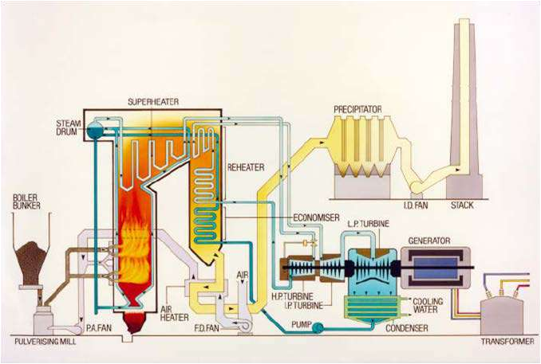
Figure 1: Schematic of a Typical Coal Fired Generator

For POSOCO to have access to verified fit-for-purpose models of coal fired thermal generation connected to Indian grid, following information is required:
- Electrical Single Line Diagram of coal fired thermal stationdepicting;
  - For individual generating units: type of technology, Complete Generator OEM Technical Datasheet (which comprises namely generator parameters like impedances & time constants, generator capability curve, V-curve, generator open and short circuit characteristics, excitation system details, inertia of generator & exciter), generator name plate, generator SAT reports including Short circuit and open circuit test results during commissioning/recentoverhauling.
  - Generator step up transformer: GT name plate/datasheet, details of LV, MV and HV, MVA rating, impedance, tap changer details, vector group, short-circuit parameters (actual positive & zero sequence impedance of GT, NGR nameplate withimpedance).
  - Excitation system :- Type of excitation system (Direct Current Commutator Exciters (type DC), AC Excitation (Rotor or brushless excitation) Systems (type AC) and Static Excitation Systems (typeST),Excitationsystemschematics(BlockdiagramofAVRsystem),transferfunctionblock

diagram of Excitation system, excitation transformer nameplate, saturation curves of the exciter (I_{a} versus I_{f} curve), IEEE standard model of excitation system, IEEE standard model and its parameter of subsystems such as Power system stabilizer (PSS), Under Excitation Limiter (UEL), Over Excitation Limiter (OEL), Voltage per Hz Limiter(V/Hz) control etc. and details thereof, factory acceptance test reports (FAT). Excitation system actual settings to be provided. AVR test report (excitation step response test).
  - Power System Stabilizer (PSS): Transfer function block diagram of PSS, IEEE Standard Model, Actual PSS software settings, PSS commissioning report and Recent PSS tuningreport.
  - Turbine-Governor system : Type of turbine (Tandem/Cross compound), model of turbine and boiler (including details of boiler controls, technology, valves, valve characteristics), model of speed governor and turbine load (if applicable) control system (including details of technology, valves, valves characteristics) , mode of operation and control, ramp rates, turbine inertia, IEEE standard model of turbine governor system and its transfer function Block diagram and its parameters, details of control mode (boiler-follow, turbine-follow, or coordinated control), commissioning report of turbine-governor system or recent governor testingreport.
- Generic models of individual components (generator, exciter (including OEL, UEL), turbine-governor and PSS of coal fired thermal plants (refer sections 3.2 to section3.5)
  - Model should be suitable for an integration time step between 1ms and 20ms, and suitable for operation up-to 100s
  - Simulation results depicting validation of generic models against user-defined models (for P, Q, V, I) and against actual measurement (after commissioning) to beprovided.
- Encrypted user defined model (UDM) in a format suitable for latest PSSE release PSS/E (*.dll files) for electromechanical transient simulation for components coal fired thermal generators (in case non- availability of validated genericmodel)
  - User guide for Encrypted models to be provided including instructions on how the model should beset-up
  - Corresponding transfer function block diagrams to beprovided
  - Simulation results depicting validation of User-Defined models against actual measurement to be provided
  - The use of black-box type representation is notpreferred.

Annexure: Formats for submission of modelling data for coal fired thermal generation

Version History:

Version no. | Release Date | Prepared by* | Checked/Issued by* | Changes
*Mention Designation and Contact Details
Details submitted:

Details pending:

  - Details of models in PSS/E for modelling coal fired thermalgeneration:
    - Synchronous Machine

Category | Parameter Description | Data
Generator Nameplate | Rated apparent power in MVA
 | Rated terminal voltage
 | Rated power factor
 | Rated frequency (in Hz)
 | Rated speed (in RPM)
 | Rated excitation (in Amperes and Volts)
Type of synchronous machine | Round rotor or salient pole No. of Poles:
Generator capability curve | The generator capability curve shows the reactive capability of the machine and  should include any restrictions on the real or reactive power range like under/over excitation limits, stability limits, etc.  Capability curve should have properly labelled axis and legible data
Generator Open Circuit and Short Circuit Characteristic | Graph of excitation current versus terminal voltage and stator current
 | No load excitation current
 | Excitation current at rated stator current
Generator vee-curves | Otherwise referred to as “V-curve”.  A plot of the terminal (armature) current versus the generating unit field voltage.
Resistance values | Resistance measurements of field winding and stator winding to a known temperature
Generator Data sheet | Direct axis synchronous reactance Xd in p.u. (Unsaturated or saturated)
 | Direct axis transient synchronous reactance Xd’ in p.u. (Unsaturated or saturated)
 | Direct axis sub-transient synchronous reactance Xd’’ in p.u. (Unsaturated or saturated)
 | Stator leakage reactance Xa in p.u. (Unsaturated or saturated )
 | Quadrature axis synchronous reactance Xq in p.u. (Unsaturated or saturated )
 | Quadrature axis transient synchronous reactance Xq’ in p.u. (Unsaturated or saturated )
 | Quadrature axis sub-transient synchronous reactance Xq’’ in p.u. (Unsaturated or saturated )
 | Direct axis open circuit transient time constant Tdo’ in sec
 | Direct axis open circuit sub-transient time constant Tdo’’ in sec
 | Quadrature axis open circuit transient time constant Tqo’ in sec
 | Quadrature axis open circuit sub-transient time constant Tqo’’ in sec
Inertia constant of total rotating mass (generator, AVR, turbo-governor set) H in
MW.s/MVA
 | Speed Damping D
 | Saturation constant S (1.0) in p.u.
 | Saturation constant S (1.2) in p.u.

Category | Parameter Description | Data
 | Nameplate Rating
Generator step up transformer (GSUT) | - Rated primary and secondaryvoltage  - Vectorgroup
 | - Impedance
 | - Tapchanger details (Numberoftaps,tapposition,tapratioetc.)

    - SiteLoad

 | Low Output |  |  | High Output
 | kW | kvar | kVA | kW | kvar | kVA
Auxiliary Load

    - ExcitationSystem

Category | Parameter Description | Data
Type of Automatic Voltage Regulator (AVR) | Manufacturer and product details
 | Type of control system :- Analogue or digital
 | Year of commissioning / Year of manufacture
 | As found settings (obtained either from HMI or downloaded from controller in digital systems)
Type of excitation system | Static excitation system OR
Indirect excitation system (i.e. rotating exciter)
- AC exciter,or
- DCexciter
Details of AVR converter | Rated excitation current (converter rating in Amperes)
 | Six pulse thyristor bridge or PWM converter
Source of excitation supply | Excitation transformer or auxiliary supply (Details thereof)
If excitation transformer, nameplate information such as type of
transformer, HV and HV winding ratings, positive and zero sequence impedance, tap positions, voltage step per tap is required.
Schematics | Saturation curves of the exciter (if applicable – see Type AC and DC)
 | Drawings of excitation system, typically prepared and supplied by the OEM
 | Single line diagram (i.e. one-line diagram) for the excitation system
Excitation limiters | What excitation limiters are commissioned?
 | Under Excitation Limiters settings
 | Over Excitation Limiters settings
 | Voltage/frequency limiter
 | Stator current limiter
 | Minimum excitation current limiter
PSS | Is the AVR equipped with a PSS?
 | How many input Channels does the PSS have? (speed, real power output or both

Category | Parameter Description | Data
 | IfthePSSusesspeed,isthisaderivedspeedsignal(i.e.synthesizedspeed signal) or measured directly (i.e. actual rotorspeed)?
Type of PSS
Block Diagram of PSS and as commissioned parameters value (Gain, time constants, filter coefficients, output limits of the PSS )

    - TurbineDetails

Category | Parameter Description | Data
Manufacturer of turbine | Manufacturer and name plate details Rating of turbine
Type of Governor | Electro-mechanical governor
 | Digital electric governor
 | Block diagram of the speed governor
Ramp rates | How fast can the turbine increase and/or decrease load, specified in MW/min
 | Stroke limits of speed changer (values of full stroke, full load and no-load in mm)
Droop | Droop setting (% on machine base)
Frequency influence limiters
- Maximum frequency deviation limiter (eg +/-2Hz)
- Maximum influence limiter (eg 10% ofrating)
Dead band | Details of frequency dead band (typically in Hz)
Steam turbine | Tandem compound : all sections on one shaft with a single generator
 | Cross compound: consists of two shafts, each connected to a generator and driven by one or more turbine section
 | Turbine sections: High pressure (HP), intermediate pressure (IP) and low pressure (LP)
 | Reheat or non-reheat: In a reheat, steam upon leaving HP section returns to boiler where it passed through reheater before entering IP section
Valves:
- Maininletstopvalve(MSV)
- Governorcontrolvalve(CV)
- Reheater stop valve(RSV)
- Intercept valves(IV)
Turbine control action:
- Boiler followmode
- Turbine followmode
- Coordinatedcontrol
 | Fast valving /bypass operation
 | Block diagram of the turbine load control
 | Reheater volume (m³), volume flow (kg/s), and average specific volume (m³/kg)

  - Generic Models for synchronousmachine
There are two typical groups of synchronous machine models, depending upon the type of machine:
- Round rotor machine (2poles):
  - GENROU – Round rotor machine model with quadratic saturationfunction
  - GENROE – Round rotor machine model with exponential saturationfunction
- Salient pole machine (more than twopoles):
  - GENSAL – Salient pole machine with quadratic saturationfunction
  - GENSAE – Salient pole machine with exponential saturationfunction

Category | Parameter Description | Data
GENERATOR model
GENROU OR GENROE | Direct axis open circuit transient time constant Tdo’ in sec
 | Direct axis open circuit sub-transient time constant Tdo’’ in sec
 | Quadrature axis open circuit transient time constant Tqo’ in sec
 | Quadrature axis open circuit sub-transient time constant Tqo’’ in sec
 | Inertia constant of total rotating mass H in MW.s/MVA
 | Speed Damping D
 | Direct axis synchronous reactance Xd in p.u. (Unsaturated or saturated)
 | Quadrature axis synchronous reactance Xq in p.u. (Unsaturated or saturated )
 | Direct axis transient synchronous reactance Xd’ in p.u. (Unsaturated or saturated)
 | Quadrature axis transient synchronous reactance Xq’ in p.u. (Unsaturated or saturated )
Direct axis sub-transient synchronous reactance Xd’’ in p.u. (Unsaturated or saturated)
= Quadrature axis sub-transient synchronous reactance Xq’’ in p.u. (Unsaturated or
saturated )
 | Stator leakage reactance Xl in p.u.
 | Saturation constant S (1.0) in p.u.
 | Saturation constant S (1.2) in p.u.
GENSAE OR GENSAL | Direct axis open circuit transient time constant Tdo’ in sec
 | Direct axis open circuit sub-transient time constant Tdo’’ in sec
 | Quadrature axis open circuit sub-transient time constant Tqo’’ in sec
 | Inertia constant of total rotating mass H in MW.s/MVA
 | Speed Damping D
 | Direct axis synchronous reactance Xd in p.u. (Unsaturated or saturated)
 | Quadrature axis synchronous reactance Xq in p.u. (Unsaturated or saturated )
 | Direct axis transient synchronous reactance Xd’ in p.u. (Unsaturated or saturated)
Direct axis sub-transient synchronous reactance Xd’’ in p.u. (Unsaturated or saturated)
= Quadrature axis sub-transient synchronous reactance Xq’’ in p.u. (Unsaturated or
saturated )
 | Stator leakage reactance Xl in p.u.
 | Saturation constant S (1.0) in p.u.
 | Saturation constant S (1.2) in p.u.

While entering the values in above table, following relationship must be kept:
Xd>Xq>Xq’≥Xd’>Xq”≥Xd’’ Tdo’>Td’>Tdo’’>Td’’
Tqo’’>Tq’>Tqo’’>Tq’’
  - Excitation systemmodel:
If a generic model is used, the first step must be to identify what type of exciter is present in the excitation system. The IEEE Std 421.5 (IEEE Recommended Practice for Excitation System Models for Power System Stability Studies published on 26th Aug 2016) has published several generic models, which are classified into three groups:
- Type DC : for excitation systems with a DCexciter
- Type AC : for excitation systems with an ACexciter
- Type ST : for excitation systems with a staticexciter
The following table shows the types of models separated into their respective groups.

DC exciter | AC exciter | Static excitation system
Type DC1A | Type AC1A | Type ST1A
Type DC2A | Type AC2A | Type ST2A
Type DC3A | Type AC4A | Type ST3A
Type DC4B | Type AC5A | Type ST4B
 | Type AC6A | Type ST5B
 | Type AC7B | Type ST6B
 | Type AC8B | Type ST7B

Category | Parameter Description | Data
DC Exciter
ESDC1A OR ESDC2A | TR regulator input filter time constant (sec)
 | KA (> 0) (pu) voltage regulator gain
 | TA (s), voltage regulator time constant
 | TB (s), lag time constant
 | TC (s), lead time constant
 | VRMAX (pu) regulator output maximum limit or Zero
 | VRMIN (pu) regulator output minimum limit
 | KE (pu) exciter constant related to self-excited field
 | TE (> 0) rotating exciter time constant (sec)
 | KF (pu) rate feedback gain
 | TF1 (> 0) rate feedback time constant (sec)
 | Switch
 | E1, exciter flux at knee of curve (pu)
 | SE(E1), saturation factor at knee of curve
 | E2, maximum exciter flux (pu)
 | SE(E2), saturation factor at maximum exciter flux (pu)
ESDC3A | TR regulator input filter time constant (sec)
 | KV (pu) limit on fast raise/lower contact setting
 | VRMAX (pu) regulator output maximum limit or Zero
 | VRMIN (pu) regulator output minimum limit
 | TRH ( > 0) Rheostat motor travel time (sec)
 | TE ( > 0) exciter time-constant (sec)
 | KE (pu) exciter constant related to self-excited field
 | VEMIN (pu) exciter minimum limit
 | E1, exciter flux at knee of curve (pu)
 | SE(E1), saturation factor at knee of curve
 | E2, maximum exciter flux (pu)
 | SE(E2), saturation factor at maximum exciter flux (pu)

Category |  | Parameter Description | Data
DC Exciter
ESDC4B |  | TR regulator input filter time constant (sec)
 |  | KP (pu) (> 0) voltage regulator proportional gain
 |  | KI (pu) voltage regulator integral gain
 |  | KD (pu) voltage regulator derivative gain
 |  | TD voltage regulator derivative channel time constant (sec)
 |  | VRMAX (pu) regulator output maximum limit
 |  | VRMIN (pu) regulator output minimum limit
 |  | KA (> 0) (pu) voltage regulator gain
 |  | TA voltage regulator time constant (sec)
 |  | KE (pu) exciter constant related to self-excited field
 |  | TE (> 0) rotating exciter time constant (sec)
 |  | KF (pu) rate feedback gain
 |  | TF (> 0) rate feedback time constant (sec)
 |  | VEMIN (pu) minimum exciter voltage output
 |  | E1, exciter flux at knee of curve (pu)
 |  | SE(E1), saturation factor at knee of curve
 |  | E2, maximum exciter flux (pu)
 |  | SE(E2), saturation factor at maximum exciter flux (pu)
 | AC Exciter
ESAC1A |  | TR regulator input filter time constant (sec)
 |  | TB (s), lag time constant
 |  | TC (s), lead time constant
 |  | KA (> 0) (pu) voltage regulator gain
 |  | TA (s), voltage regulator time constant
 |  | VAMAX (pu) regulator output maximum limit
 |  | VAMIN (pu) regulator output minimum limit
 |  | TE (> 0) rotating exciter time constant (sec)
 |  | KF (pu) rate feedback gain
 |  | TF (> 0) rate feedback time constant (sec)
 |  | KC (pu) rectifier loading factor proportional to commutating reactance
 |  | KD (pu) demagnetizing factor, function of AC exciter reactances
 |  | KE (pu) exciter constant related to self-excited field
 |  | E1, exciter flux at knee of curve (pu)
 |  | SE(E1), saturation factor at knee of curve
 |  | E2, maximum exciter flux (pu)
 |  | SE(E2), saturation factor at maximum exciter flux (pu)
 |  | VRMAX (pu) regulator output maximum limit
 |  | VRMIN (pu) regulator output minimum limit

Category | Parameter Description | Data
AC Exciter
ESAC2A | TR regulator input filter time constant (sec)
 | TB (s), lag time constant
 | TC (s), lead time constant
 | KA (> 0) (pu) voltage regulator gain
 | TA (s), voltage regulator time constant
 | VAMAX (pu) regulator output maximum limit
 | VAMIN (pu) regulator output minimum limit
 | KB, Second stage regulator gain
 | VRMAX (pu) regulator output maximum limit
 | VRMIN (pu) regulator output minimum limit
 | TE (> 0) rotating exciter time constant (sec)
 | VFEMAX, parameter of VEMAX, exciter field maximum output
 | KH, Exciter field current feedback gain
 | KF (pu) rate feedback gain
 | TF (> 0) rate feedback time constant (sec)
 | KC (pu) rectifier loading factor proportional to commutating reactance
 | KD (pu) demagnetizing factor, function of AC exciter reactances
 | KE (pu) exciter constant related to self-excited field
 | E1, exciter flux at knee of curve (pu)
 | SE(E1), saturation factor at knee of curve
 | E2, maximum exciter flux (pu)
 | SE(E2), saturation factor at maximum exciter flux (pu)
ESAC3A | TR regulator input filter time constant (sec)
 | TB (s), lag time constant
 | TC (s), lead time constant
 | KA (> 0) (pu) voltage regulator gain
 | TA (s), voltage regulator time constant
 | VAMAX (pu) regulator output maximum limit
 | VAMIN (pu) regulator output minimum limit
 | TE (> 0) rotating exciter time constant (sec)
 | VEMIN (pu) minimum exciter voltage output
 | KR (>0), Constant associated with regulator and alternator field power supply
 | KF (pu) rate feedback gain
 | TF (> 0) rate feedback time constant (sec)
 | KN, Exciter feedback gain
 | EFDN, A parameter defining for which value of UF the feedback gain shall change from KF to KN
 | KC, rectifier regulation factor (pu)
 | KD, exciter regulation factor (pu)
 | KE (pu) exciter constant related to self-excited field
 | VFEMAX, parameter of VEMAX, exciter field maximum output
 | E1, exciter flux at knee of curve (pu)
 | SE(E1), saturation factor at knee of curve
 | E2, maximum exciter flux (pu)
 | SE(E2), saturation factor at maximum exciter flux (pu)

Category | Parameter Description | Data
AC Exciter
ESAC4A | TR regulator input filter time constant (sec)
 | VIMAX, Maximum value of limitation of the integrator signal VI in p.u
 | VIMIN, Minimum value of limitation of the signal VI in p.u.
 | TB (s), lag time constant
 | TC (s), lead time constant
 | KA (> 0) (pu) voltage regulator gain
 | TA (s), voltage regulator time constant
 | VRMAX (pu) regulator output maximum limit
 | VRMIN (pu) regulator output minimum limit
 | KC, rectifier regulation factor (pu)
ESAC5A | TR regulator input filter time constant (sec)
 | KA (> 0) (pu) voltage regulator gain
 | TA (s), voltage regulator time constant
 | VRMAX (pu) regulator output maximum limit
 | VRMIN (pu) regulator output minimum limit
 | KE (pu) exciter constant related to self-excited field
 | TE (> 0) rotating exciter time constant (sec)
 | KF (pu) rate feedback gain
 | TF1 (sec), Regulator stabilizing circuit time constant in seconds
 | TF2 (sec), Regulator stabilizing circuit time constant in seconds
 | TF3 (sec), Regulator stabilizing circuit time constant in seconds
 | E1, exciter flux at knee of curve (pu)
 | SE(E1), saturation factor at knee of curve
 | E2, maximum exciter flux (pu)
 | SE(E2), saturation factor at maximum exciter flux (pu)

Category | Parameter Description | Data
AC Exciter
AC6A | TR regulator input filter time constant (sec)
 | KA (> 0) (pu) voltage regulator gain
 | TA (s), voltage regulator time constant
 | TK (sec), Lead time constant
 | TB (s), lag time constant
 | TC (s), lead time constant
 | VAMAX (pu) regulator output maximum limit
 | VAMIN (pu) regulator output minimum limit
 | VRMAX (pu) regulator output maximum limit
 | VRMIN (pu) regulator output minimum limit
 | TE (> 0) rotating exciter time constant (sec)
 | VFELIM, Exciter field current limit reference
 | KH, Damping module gain
 | VHMAX, damping module limiter
 | TH (sec), damping module lag time constant
 | TJ (sec), damping module lead time constant
 | KC, rectifier regulation factor (pu)
 | KD, exciter regulation factor (pu)
 | KE (pu) exciter constant related to self-excited field
 | E1, exciter flux at knee of curve (pu)
 | SE(E1), saturation factor at knee of curve
 | E2, maximum exciter flux (pu)
 | SE(E2), saturation factor at maximum exciter flux (pu)

Category | Parameter Description | Data
AC Exciter
AC7B | TR (sec) regulator input filter time constant
 | KPR (pu) regulator proportional gain
 | KIR (pu) regulator integral gain
 | KDR (pu) regulator derivative gain
 | TDR (sec) regulator derivative block time constant
 | VRMAX (pu) regulator output maximum limit
 | VRMIN (pu) regulator output minimum limit
 | KPA (pu) voltage regulator proportional gain
 | KIA (pu) voltage regulator integral gain
 | VAMAX (pu) regulator output maximum limit
 | VAMIN (pu) regulator output minimum limit
 | KP (pu)
 | KL (pu)
 | KF1 (pu)
 | KF2 (pu)
 | KF3 (pu)
 | TF3 (sec) time constant (> 0)
 | KC (pu) rectifier loading factor proportional to commutating reactance
 | KD (pu) demagnetizing factor, function of AC exciter reactances
 | KE (pu) exciter constant related fo self-excited field
 | TE (pu) exciter time constant (>0)
 | VFEMAX (pu) exciter field current limit (> 0)
 | VEMIN (pu)
 | E1, exciter flux at knee of curve (pu)
 | SE(E1), saturation factor at knee of curve
 | E2, maximum exciter flux (pu)
 | SE(E2), saturation factor at maximum exciter flux (pu)

Category |  | Parameter Description | Data
AC Exciter
AC8B |  | TR (sec) regulator input filter time constant
 |  | KPR (pu) regulator proportional gain
 |  | KIR (pu) regulator integral gain
 |  | KDR (pu) regulator derivative gain
 |  | TDR (sec) regulator derivative block time constant
 |  | VPIDMAX (pu) PID maximum limit
 |  | VPIDMIN (pu) PID minimum limit
 |  | KA (pu) voltage regulator proportional gain
 |  | TA (sec) voltage regulator time constant
 |  | VRMAX (pu) regulator output maximum limit
 |  | VRMIN (pu) regulator output minimum limit
 |  | KC (pu) rectifier loading factor proportional to commutating reactance
 |  | KD (pu) demagnetizing factor, function of AC exciter reactances
 |  | KE (pu) exciter constant related fo self-excited field
 |  | TE (pu) exciter time constant (>0)
 |  | VFEMAX (pu) max exciter field current limit (> 0)
 |  | VEMIN (pu),
 |  | E1, exciter flux at knee of curve (pu)
 |  | SE(E1), saturation factor at knee of curve
 |  | E2, maximum exciter flux (pu)
 |  | SE(E2), saturation factor at maximum exciter flux (pu)
 | Static Exciter
ST1A |  | TR (sec) regulator input filter time constant
 |  | VIMAX, Controller Input Maximum
 |  | VIMIN, Controller Input Minimum
 |  | TC (s), Filter 1st Derivative Time Constant
 |  | TB (s), l Filter 1st Delay Time Constant
 |  | TC1 (s), Filter 2nd Derivative Time Constant
 |  | TB1 (s), Filter 2nd Delay Time Constant
 |  | KA (pu) voltage regulator proportional gain
 |  | TA (sec) voltage regulator time constant
 |  | VAMAX (pu) regulator output maximum limit
 |  | VAMIN (pu) regulator output minimum limit
 |  | VRMAX (pu) regulator output maximum limit
 |  | VRMIN (pu) regulator output minimum limit
 |  | KC (pu) rectifier loading factor proportional to commutating reactance
 |  | KF (pu) rate feedback gain
 |  | TF (> 0) rate feedback time constant (sec)
 |  | KLR, Current Input Factor
 |  | ILR, Current Input Reference

Category | Parameter Description | Data
Static Exciter
ST2A | TR (sec) regulator input filter time constant
 | KA (pu) voltage regulator proportional gain
 | TA (sec) voltage regulator time constant
 | VRMAX (pu) regulator output maximum limit
 | VRMIN (pu) regulator output minimum limit
 | KE (pu) exciter constant related fo self-excited field
 | TE (pu) exciter time constant (>0)
 | KF (pu) rate feedback gain
 | TF (> 0) rate feedback time constant (sec)
 | KP (pu) voltage regulator proportional gain
 | KI (pu) voltage regulator integral gain
 | KC (pu) rectifier loading factor proportional to commutating reactance
 | EFDMAX
ST3A | TR (sec) regulator input filter time constant
 | VIMAX, Maximum value of limitation of the signal VI in p.u.
 | VIMIN, Minimum value of limitation of the signal VI in p.u.
 | KM, Forward gain constant of the inner loop field regulator
 | TC (s), lag time constant
 | TB (s), lead time constant
 | KA (pu) voltage regulator proportional gain
 | TA (sec) voltage regulator time constant
 | VRMAX (pu) regulator output maximum limit
 | VRMIN (pu) regulator output minimum limit
 | KG, Feedback gain constant of the inner loop field regulator
 | KP (pu) voltage regulator proportional gain
 | KI (pu) voltage regulator integral gain
 | VBMAX, Maximum value of limitation of the signal VB in p.u.
 | KC (pu) rectifier loading factor proportional to commutating reactance
 | XL, Reactance associated with potential source
 | VGMAX, Maximum value of limitation of the signal VG in p.u
 | Ɵ_{P} (degrees)
 | TM (sec), Forward time constant of the inner loop field regulator
 | VMMAX, Maximum value of limitation of the signal VM in p.u
 | VMMIN, Minimum value of limitation of the signal VM in p.u.

Category | Parameter Description | Data
Static Exciter
ST4B | TR (sec) regulator input filter time constant
 | KPR (pu) regulator proportional gain
 | KIR (pu) regulator integral gain
 | VRMAX (pu) regulator output maximum limit
 | VRMIN (pu) regulator output minimum limit
 | TA (sec) voltage regulator time constant
 | KPM, Regulator gain
 | KIM, Regulator gain
 | VMMAX, Maximum value of limitation of the signal in p.u.
 | VMMIN, Minimum value of limitation of the signal in p.u.
 | KG
 | KP (pu) voltage regulator proportional gain
 | KI (pu) voltage regulator integral gain
 | VBMAX
 | KC (pu) rectifier loading factor proportional to commutating reactance
 | XL
 | Ɵ_{P} (degrees)
ST5B | TR regulator input filter time constant (sec)
 | TC1 lead time constant of first lead-lag block (voltage regulator channel) (sec)
 | TB1 lag time constant of first lead-lag block (voltage regulator channel) (sec)
 | TC2 lead time constant of second lead-lag block (voltage regulator channel) (sec)
 | TB2 lag time constant of second lead-lag block (voltage regulator channel) (sec)
 | KR (>0) (pu) voltage regulator gain
 | VRMAX (pu) voltage regulator maximum limit
 | VRMIN (pu) voltage regulator minimum limit
 | T1 voltage regulator time constant (sec)
 | KC (pu)
 | TUC1 lead time constant of first lead-lag block (under-excitation channel) (sec)
 | TUB1 lag time constant of first lead-lag block (under-excitation channel) (sec)
 | TUC2 lead time constant of second lead-lag block (under-excitation channel) (sec)
 | TUB2 lag time constant of second lead-lag block (under-excitation channel) (sec)
 | TOC1 lead time constant of first lead-lag block (over-excitation channel) (sec)
 | TOB1 lag time constant of first lead-lag block (over-excitation channel) (sec)
 | TOC2 lead time constant of second lead-lag block (over-excitation channel) (sec)
 | TOB2 lag time constant of second lead-lag block (over-excitation channel) (sec)

Category | Parameter Description | Data
Static Exciter
ST6B | TR regulator input filter time constant (sec)
 | KPA (pu) (> 0) voltage regulator proportional gain
 | KIA (pu) voltage regulator integral gain
 | KDA (pu) voltage regulator derivative gain
 | TDA voltage regulator derivative channel time constant (sec)
 | VAMAX (pu) regulator output maximum limit
 | VAMIN (pu) regulator output minimum limit
 | KFF (pu) pre-control gain of the inner loop field regulator
 | KM (pu) forward gain of the inner loop field regulator
 | KCI (pu) exciter output current limit adjustment gain
 | KLR (pu) exciter output current limiter gain
 | ILR (pu) exciter current limit reference
 | VRMAX (pu) voltage regulator output maximum limit
 | VRMIN (pu) voltage regulator output minimum limit
 | KG (pu) feedback gain of the inner loop field voltage regulator
 | TG (> 0) feedback time constant of the inner loop field voltage regulator (sec)
ST7B | TR regulator input filter time constant (sec)
 | TG lead time constant of voltage input (sec)
 | TF lag time constant of voltage input (sec)
 | Vmax (pu) voltage reference maximum limit
 | Vmin (pu) voltage reference minimum limit
 | KPA (pu) (>0) voltage regulator gain
 | VRMAX (pu) voltage regulator output maximum limit
 | VRMIN (pu) voltage regulator output minimum limit
 | KH (pu) feedback gain
 | KL (pu) feedback gain
 | TC lead time constant of voltage regulator (sec)
 | TB lag time constant of voltage regulator (sec)
 | KIA (pu) (>0) gain of the first order feedback block
 | TIA (>0) time constant of the first order feedback block (sec)

- DC Exciters Genericmodel:
  - Type DC1A: 1992 IEEE type DC1A excitation systemmodel
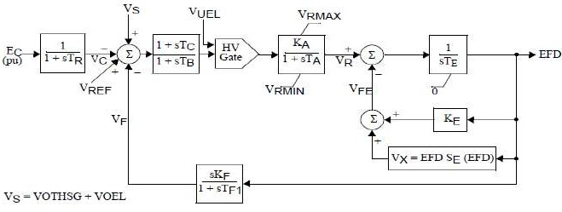

  - 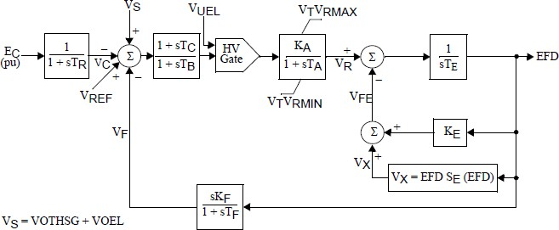Type DC2A: 1992 IEEE type DC2A excitation systemmodel

  - Type DC3A: IEEE 421.5 2005 DC3A excitationsystem
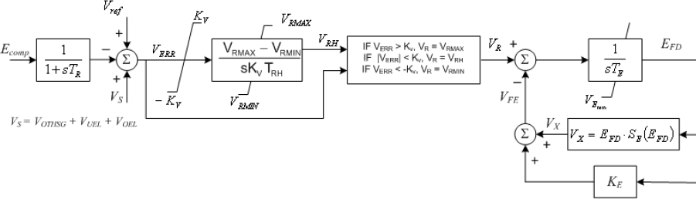

  - Type DC4B: IEEE 421.5 2005 DC4B excitationsystem
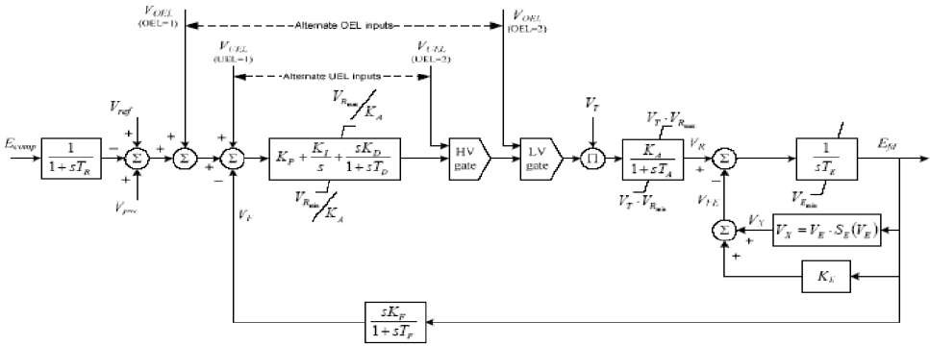

- AC Exciters GenericModels:

  - Type AC1A: 1992 IEEE type AC1A excitation systemmodel
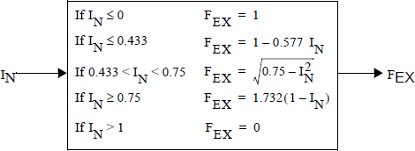
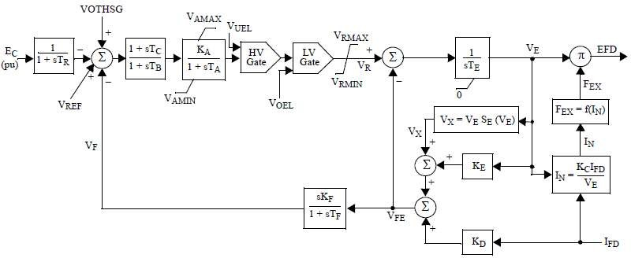

  - Type AC2A: 1992 IEEE type AC2A excitation systemmodel
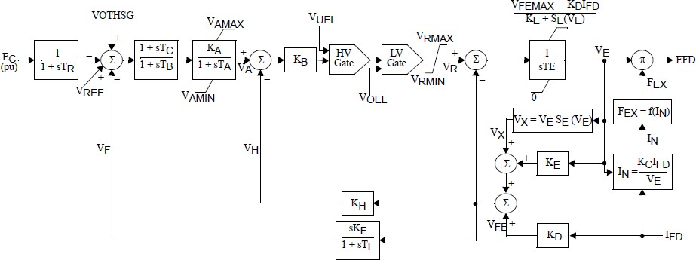

  - Type AC3A: 1992 IEEE type AC3A excitation systemmodel
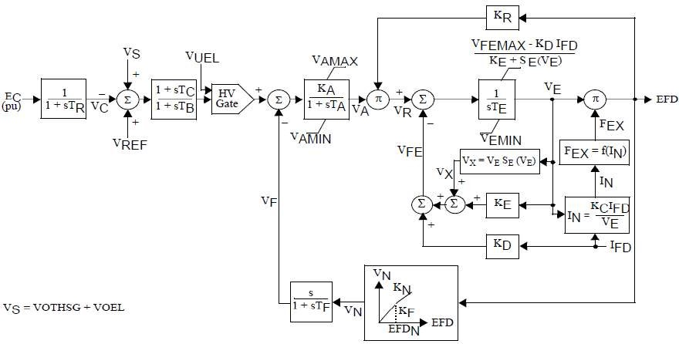

  - Type AC4A: 1992 IEEE type AC4A excitation systemmodel
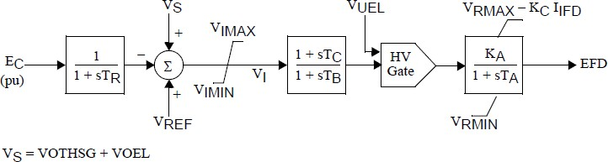

  - Type AC5A: 1992 IEEE type AC5A excitation systemmodel
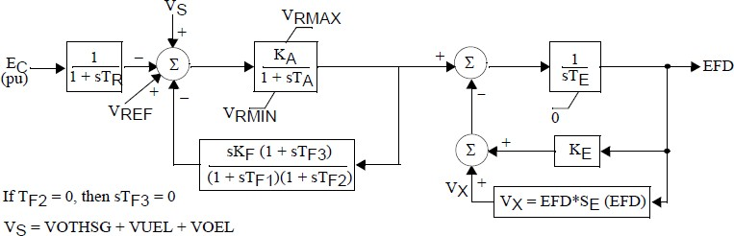

  - Type AC6A: IEEE 421.5 excitation systemmodel
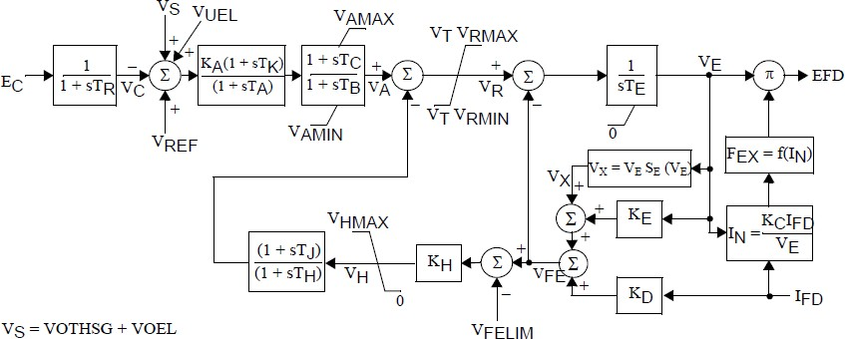

  - Type AC7B: IEEE 421.5 2005 AC7B excitationsystem
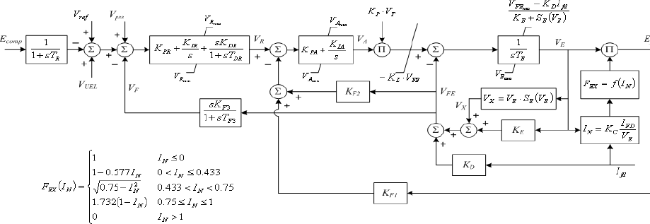

  - Type AC8B: IEEE 421.5 2005 AC8B excitationsystem
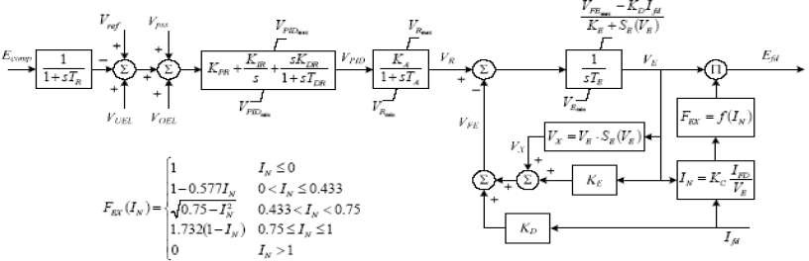

- Commonly Used Static Exciters Generic Models blockdiagrams:

  - Type ST1A: 1992 IEEE type ST1A excitation systemmodel

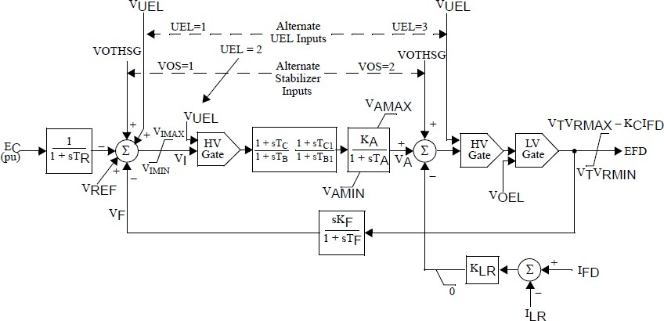
  - Type ST2A: 1992 IEEE type ST2A excitation systemmodel

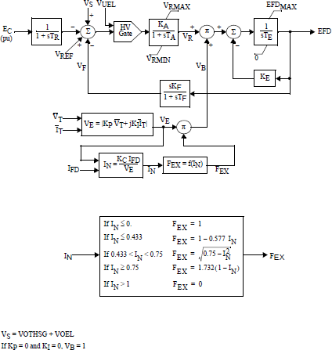

  - Type ST3A: 1992 IEEE type ST3A excitation systemmodel
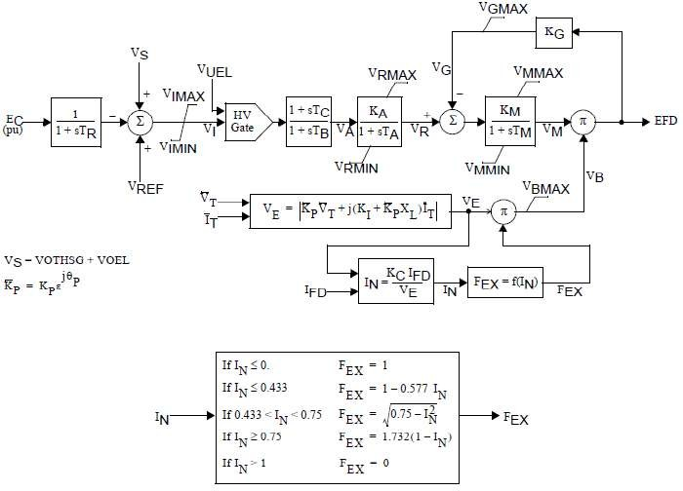

  - Type ST4B: IEEE type ST4B potential or compounded source-controlled rectifierexciter

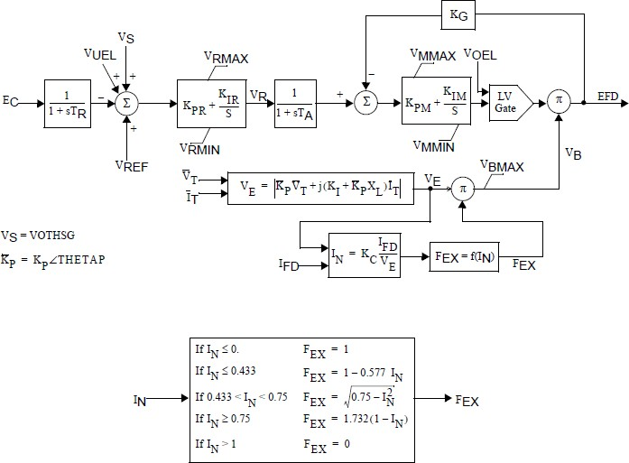

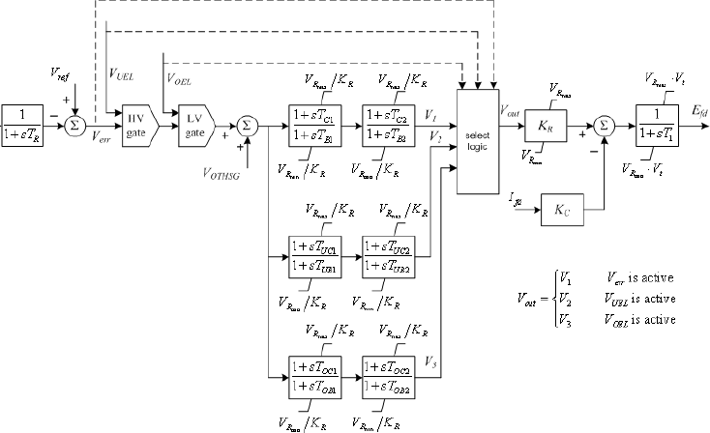
  - Type ST6B: IEEE 421.5 2005 ST6B excitationsystem

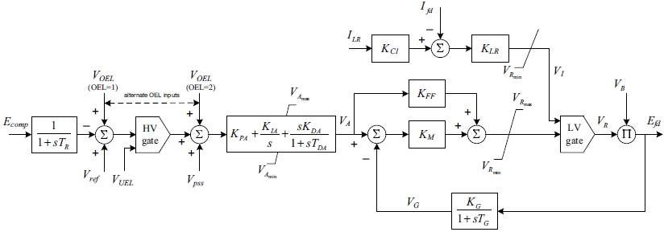

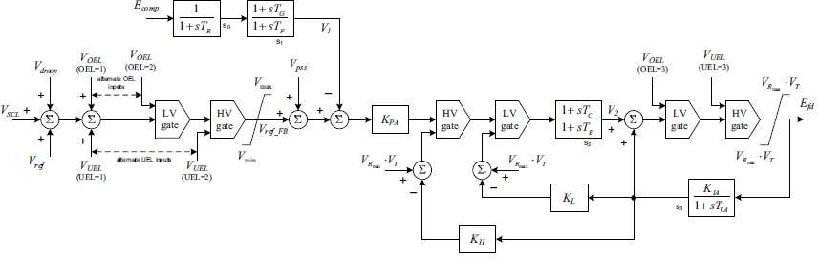

Source-PSSE Model Library

  - Power systemstabilizer:
The function of the PSS is to add to the unit’s characteristic electromechanical oscillations. This is achieved by modulating excitation to develop a component in electrical torque in phase with rotor speed deviations.
The most important aspect when considering a PSS model is the number of inputs. The following table shows the type of models separated based on the inputs:

Type | Inputs | Remarks
PSS1A | Single input | Two lead-lags  Input can either be speed, frequency or power
PSS2B | Dual input | Integral of accelerating power Speed and Power  Most common type  Supersedes PSS2A (three versus two lead lags)
PSS3B | Dual input | Power and rotor angular frequency deviation Stabilising signal is a vector sum of processed signals  Not very common

Category |  | Parameter Description | Data
 | Stabilizer Models
PSS1A |  | A1, Filter coefficient
 |  | A2, Filter coefficient
 |  | TR, transducer time constant
 |  | 0
 |  | 0
 |  | 0
 |  | T1, 1st Lead-Lag Derivative Time Constant
 |  | T2, 1st Lead-Lag Delay Time Constant
 |  | T3, 2nd Lead-Lag Derivative Time Constant
 |  | T4, 2nd Lead-Lag Delay Time Constant
 |  | Tw, Washout Time Constant
 |  | Tw, Washout Time Constant
 |  | Ks, input channel gain
 |  | VSTMAX, Controller maximum output
 |  | VSTMAX, Controller minimum output
 |  | 0
 |  | 0

Category | Parameter Description | Data
Stabilizer Models
PSS2B | TW1, 1st Washout 1th Time Constant
 | TW2, 1st Washout 2th Time Constant
 | T6, 1st Signal Transducer Time Constant
 | TW3, 2nd Washout 1th Time Constant
 | TW4, 2nd Washout 2th Time Constant
 | T7, 2nd Signal Transducer Time Constant
 | KS2, 2nd Signal Transducer Factor
 | KS3, Washouts Coupling Factor
 | T8, Ramp Tracking Filter Deriv. Time Constant
 | T9, Ramp Tracking Filter Delay Time Constant
 | KS1, PSS Gain
 | T1, 1st Lead-Lag Derivative Time Constant
 | T2, 1st Lead-Lag Delay Time Constant
 | T3, 2nd Lead-Lag Derivative Time Constant
 | T4, 2nd Lead-Lag Delay Time Constant
 | T10, 3rd Lead-Lag Derivative Time Constant
 | T11, 3rd Lead-Lag Delay Time Constant
 | VS1MAX, Input 1 Maximum limit
 | VS1MIN, Input 1 Minimum limit
 | VS2MAX, Input 2 Maximum limit
 | VS2MIN, Input 2 Minimum limit
 | VSTMAX, Controller Maximum Output
 | VSTMIN, Controller Minimum Output
PSS3B | KS1 (pu) (≠0), input channel #1 gain
 | T1 input channel #1 transducer time constant (sec)
 | Tw1 input channel #1 washout time constant (sec)
 | KS2(pu)( 0), input channel #2 gain
 | T2 input channel #2 transducer time constant (sec)
 | Tw2 input channel #2 washout time constant (sec)
 | Tw3 (0), main washout time constant (sec)
 | A1, Filter coefficient
 | A2, Filter coefficient
 | A3, Filter coefficient
 | A4, Filter coefficient
 | A5, Filter coefficient
 | A6, Filter coefficient
 | A7, Filter coefficient
 | A8, Filter coefficient
 | VSTMAX, Controller maximum output
 | VSTMAX, Controller minimum output

Commonly Used Power System Stabilizer generic models block diagrams:
- PSS1A: IEEE Std. 421.5-2005 PSS1A Single-Input Stabilizermodel
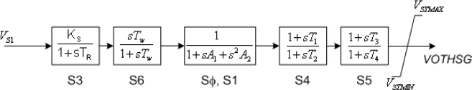
- PSS2B: IEEE 421.5 2005 PSS2B IEEE dual-input stabilizermodel

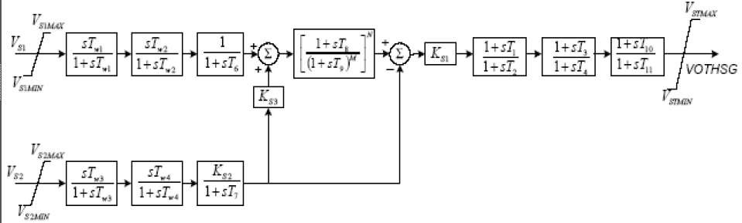
- PSS3B: IEEE Std. 421.5 2005 PSS3B IEEE dual-input stabilizermodel
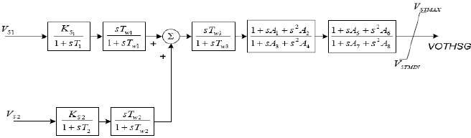
Source-PSSE Model Library

  - Generic models forturbine-governor:
The following table is a list for generic models of steam turbines:

Type | Name | Remarks
BBGOV1 | Brown-Boveri turbine governor model | Mainly used for steam turbine with electrical  damping feedback
TGOV1 | Steam-turbine governor | Mainly used for steam turbine with reheater
CRCMGV | Cross-compound turbine | -
IEEEG1 | IEEE type 1 Speed-Governor Model | Used to represent non-reheat, tandem  compound, and cross compound types.
IEEEG2 | IEEE Type 2 Speed-Governing Model | Linearized model for representing a hydro  turbine-governor and penstock dynamics
IEEEG3 | IEEE type 3 turbine-governor model | Includes a more complex representation of the  governor controls than IEEEG2 does
IEESGO | IEEE Standard Model | Simple model of reheat steam turbine
TGOV2 | Steam –turbine governor with fast valving | Fast valving model of steam turbine
TGOV3 | Modified IEEE Type 1 Speed-Governing  Model with fast valving | Modification of IEEEG! For fast valving studies
TGOV4 | Modified IEEE Type 1 Speed-Governing Model with PLU and EVA | Model of steam turbine and boiler, explicit action for both control valve (CV) and inlet  valve (IV), main reheat and LP steam effects, and boiler
TGOV5 | IEEE Type 1 Speed-Governor Model  Modified to Include Boiler Controls | Most common type of governor model, based on  TGOV1 with boiler controls
TURCZT | Czech hydro or steam turbine governor model | General-purpose hydro and thermal turbine-  governor model. Penstock dynamic is not included in the model
Source: PSSE Model Library, for models other than the above list refer to
https://w3.usa.siemens.com/smartgrid/us/en/transmission-grid/products/grid-analysis-tools/transmission-system-planning/transmission-system-planning-tab/pages/user-support.aspx

Category | Parameter Description | Data
TURBINE GOVERNOR model
BBGOV1 | fcut (>=0) (pu), cut off frequency
 | KS, frequency gain
 | KLS (> 0)
 | KG
 | KP, power regulator gain
 | TN (sec) (> 0)
 | KD, damping gain
 | TD (sec) (> 0), damping time constant
 | T4 (sec), high pressure time constant
 | K2, intermediate pressure time constant
 | T5 (sec), intermediate re-heater time constant
 | K3, high pressure time constant
 | T6 (sec), re-heater time constant
 | T1 (sec), measuring transducer time constant
 | SWITCH
 | PMAX, maximum power output limiter
 | PMIN, minimum power output limiter
TGOV1 | R, Permanent Droop
 | T1 (>0) (sec), Steam bowl time constant
 | VMAX, Maximum valve position
 | VMIN, Minimum valve position
 | T2 (sec), Time constant
 | T3 (>0) (sec), reheater time constant
 | Dt, Turbine damping coefficient
 | VMAX, VMIN, Dt and R are in per unit on generator MVA base. T2/T3 = high-pressure fraction.
CRCMGV | PMAX (HP)1, maximum HP value position (on generator base)
 | R (HP), HP governor droop
 | T1 (HP) (>0), HP governor time constant
 | T3 (HP) (>0), HP turbine time constant
 | T4 (HP) (>0), HP turbine time constant
 | T5 (HP) (>0), HP reheater time constant
 | F (HP), fraction of HP power ahead of reheater
 | DH (HP), HP damping factor (on generator base)
 | PMAX (LP), maximum LP value position (on generator base)
 | R (LP), LP governor droop
 | T1 (LP) (>0), LP governor time constant
 | T3 (LP) (>0), LP turbine time constant
 | T4 (LP) (>0), LP turbine time constant
 | T5 (LP) (>0), LP turbine time constant
 | F (LP), fraction of LP power ahead of reheater
 | DH (LP), LP damping factor (on generator base)

Category | Parameter Description | Data
TURBINE GOVERNOR model
IEEEG1 | K, Governor gain, (1/droop) pu
 | T1 (sec), Lag time constant (sec)
 | T2 (sec), Lead time constant (sec)
 | T3 (> 0) (sec), valve position time constant
 | Uo (pu/sec), maximum valve opening rate
 | Uc (< 0) (pu/sec), maximum valve closing rate
 | PMAX (pu on machine MVA rating)
 | PMIN (pu on machine MVA rating)
 | T4 (sec), time constant for steam inlet
 | K1, HP fraction
 | K2, LP fraction
 | T5 (sec), Time Constant for Second Boiler Pass [s]
 | K3, HP Fraction
 | K4, LP fraction
 | T6 (sec), Time Constant for Third Boiler Pass [s]
 | K5, HP Fraction
 | K6, LP fraction
 | T7 (sec), Time Constant for Fourth Boiler Pass [s]
 | K7, HP Fraction
 | K8, LP fraction
IEEEG2 | K, Governor gain
 | T1 (sec), Governor lag time constant
 | T2 (sec), Governor lead time constant
 | T3 (>0) (sec), Gate actuator time constant
 | PMAX (pu on machine MVA rating), gate maximum
 | PMIN (pu on machine MVA rating), gate minimum
 | T4 (>0) (sec), water starting time
IEEEG3 | TG, (>0) (sec), gate servomotor time constant
 | TP (>0) (sec), pilot value time constant
 | Uo (pu per sec), opening gate rate limit
 | Uc (pu per sec), closing gate rate limit (< 0)
 | PMAX maximum gate position (pu on machine MVA rating)
 | PMIN minimum gate position (pu on machine MVA rating)
 | σ, permanent speed droop coefficient
 | δ, transient speed droop coefficient
 | TR, (>0) (sec), Dashpot time constant
 | TW (>0) (sec), water starting time
 | a11 (>0), Turbine coefficient
 | a13, Turbine coefficient
 | a21, Turbine coefficient
 | a23 (>0), Turbine coefficient

Category | Parameter Description | Data
TURBINE GOVERNOR model
IEESGO | T1, Controller Lag
 | T2, Controller Lead Compensation
 | T3, Governor Lag (> 0)
 | T4, Delay Due To Steam Inlet Volumes
 | T5, Reheater Delay
 | T6, Turbine, pipe, hood Delay
 | K1, 1/Per Unit Regulation
 | K2, Fraction
 | K3, fraction
 | PMAX, Upper Power Limit
 | PMIN, Lower Power Limit
TGOV2 | R (pu), permanent droop
 | T1 (>0) (sec), Steam bowl time constant
 | VMAX (pu), Maximum valve position
 | VMIN (pu), Minimum valve position
 | K (pu), Governor gain
 | T3 (>0) (sec), Time constant
 | Dt (pu), Turbine damping coefficient
 | Tt (>0) (sec), Valve time constant
 | TA, Valve position at time 2 (fully closed after fast valving initialization)
 | TB, Valve position at time 3 (start to reopen after fast valving initialization)
 | TC, Valve position at time 4 (again fully open after fast valving initializations)
TGOV3 | K, Governor gain
 | T1 (sec), Governor lead time constant
 | T2 (sec), Governor lag time constant
 | T3 (>0) (sec), Valve positioner time constant
 | Uo, Maximum valve opening velocity
 | Uc (< 0), Maximum valve closing velocity
 | PMAX, Maximum valve opening
 | PMIN, Minimum valve opening
 | T4 (sec), Inlet piping/steam bowl time constant
 | K1, Fraction of turbine power developed after first boiler pass
 | T5 (> 0) (sec), Time constant of second boiler pass
 | K2, Fraction of turbine power developed after second boiler pass
 | T6 (sec), Time constant of crossover or third boiler pass
 | K3, Fraction of hp turbine power developed after crossover or third boiler pass
 | TA (sec), Valve position at time 2 (fully closed after fast valving initializations)
 | TB (sec), Valve position at time 3 (start to reopen after fast valving initializations)
 | TC (sec), Valve position at time 4 (again fully open after fast valving initializations)
 | PRMAX (pu), Max. pressure in reheater

Category |  |  | Parameter Description | Data
 | TURBINE GOVERNOR model
TGOV4 |  | K, The inverse of the governor speed droop
 |  | T1 (sec), The governor controller lag time constant
 |  | T2 (sec), The governor controller lead time constant
 |  | T3 (>0) (sec), The valve servomotor time constant for the control valves
 |  | Uo, The control valve open rate limit
 |  | Uc (<0), The control valve close rate limit
 |  | KCAL
 |  | T4 (sec), The steam flow time constant
 |  | K1
 |  | T5 (> 0) (sec)
 |  | K2
 |  | T6 (sec)
 |  | PRMAX
 |  | KP
 |  | KI
 |  | TFuel (sec)
 |  | TFD1 (sec)
 |  | TFD2 (sec)
 |  | Kb
 |  | Cb (> 0) (sec)
 |  | TIV (> 0) (sec)
 |  | UOIV
 |  | UCIV
 |  | R (>0)
 |  | Offset
 |  | CV position demand characteristic
 |  | CV #2 offset
 |  | CV #3 offset
 |  | CV #4 offset
 |  | IV position demand characteristic
 |  | IV #2 offset
 |  | CV valve characteristic
 |  | IV valve characteristic
 |  | CV starting time for valve closing (sec)
 |  | CV closing rate (pu/sec)
 |  | Time closed for CV #1 (sec)
 |  | Time closed for CV #2
 |  | Time closed for CV #3
 |  | Time closed for CV #4
 |  | IV starting time for valve closing (sec)

Category |  | Parameter Description | Data
TURBINE GOVERNOR model
TGOV4 | IV closing rate (pu/sec)
 | Time closed for IV #1 (sec)
 | Time closed for IV #2 (sec)
 | TRPLU (>0) (sec)
 | PLU rate level
 | Timer
 | PLU unbalance level
 | TREVA (>0) (sec)
 | EVA rate level
 | EVA unbalance level
 | Minimum load reference (pu)
 | Load reference ramp rate (pu/sec)

Category | Parameter Description | Data
TURBINE GOVERNOR model
TGOV5 | K, The inverse of the governor speed droop
 | T1 (sec), The governor controller lag time constant
 | T2 (sec), The governor controller lead time constant
 | T3 (>0) (sec), The valve servomotor time constant for the control valves
 | Uo, The control valve open rate limit
 | Uc (<0), The control valve close rate limit
 | VMAX, The maximum valve area
 | VMIN, The minimum valve area
 | T4 (sec), The steam flow time constant
 | K1, The fractions of the HP
 | K2, fractions of the LP
 | T5 (sec), The first reheater time constant
 | K3, The fractions of the HP
 | K4, fractions of the LP
 | T6 (sec), second reheater time constant
 | K5, The fractions of the HP
 | K6, fractions of the LP
 | T7 (sec), crossover time constant
 | K7, The fractions of the HP
 | K8, fractions of the LP
 | K9, The adjustment to the pressure drop coefficient as a function of drum pressure
 | K10, The gain of anticipation signal from main stream flow
 | K11, The gain of anticipation signal from load demand
 | K12, The gain for pressure error bias
 | K13, The gain between MW demand and pressure set point
K14, Inverse of load reference servomotor time constant (= 0.0 if load reference does
not change).
 | RMAX, The load reference positive rate of change limit
 | RMIN, The load reference negative rate of change limit
 | LMAX, The maximum load reference
 | LMIN, The minimum load reference
 | C1, The pressure drop coefficient
 | C2, The gain for the pressure error bias
 | C3, The adjustment to the pressure set point
 | B, The frequency bias for load reference control
 | CB (>0) (sec), The boiler storage time constant
 | KI, The controller integral gain
 | TI (sec), The controller proportional lead time constant
 | TR (sec), The controller rate lead time constant
 | TR1 (sec), The inherent lag associated with lead TR (usually about TR/10)
 | CMAX, The maximum controller output

Category | Parameter Description | Data
TURBINE GOVERNOR model
TGOV5 | CMIN, The minimum controller output
 | TD (sec), The time delay in the fuel supply system
 | TF (sec), The fuel and air system time constant
 | TW (sec), The water wall time constant
 | Psp (initial) (>0), The initial throttle pressure set point
 | TMW (sec), The MW transducer time constant
 | KL (0.0 or 1.0), The feedback gain from the load reference
 | KMW (0.0 or 1.0), The gain of the MW transducer
 | DPE (pu pressure), The dead band in the pressure error signal for load reference control
- The fractions of the HP unit’s mechanical power developed by the various turbine stages. The sum of K1, K3, K5 andK7 constants should be one for a non cross-compoundunit.
- Similarly fractions of the LP unit’s mechanical power should be zero for a non cross- compoundunit.Foracross-compoundunit,thesumofK1throughK8shouldequalone.
TURCZT | fDEAD (pu), Frequency Dead Band
 | fMIN (pu), Frequency Minimum Deviation
 | fMAX (pu), Frequency Maximum Deviation
 | KKOR (pu), Frequency Gain
 | KM > 0 (pu), Power Measurement Gain
 | KP (pu), Regulator Proportional Gain
 | SDEAD (pu), Speed Dead Band
 | KSTAT (pu), Speed Gain
 | KHP (pu), High Pressure Constant
 | TC (sec), Measuring transducer time constant
 | T 1 (sec), Regulator Integrator Time Constant
 | TEHP (sec), Hydro Converter Time Constant
 | TV > 0 (sec), Regulation Valve Time Constant
 | THP (sec), High Pressure Time Constant
 | TR (sec), Reheater time constant
 | TW (sec), Water Time Constant
 | NTMAX (pu), Power Regulator-Integrator Maximum Limiter
 | NTMIN (pu), Power Regulator-Integrator Minimum Limiter
 | GMAX (pu), Valve Maximum Open
 | GMIN (pu), Valve Minimum Open
 | VMIN (pu/sec), Valve Maximum Speed Close
 | VMAX (pu/sec), Valve Maximum Speed Open

Commonly Used Steam Turbine Generic Models Block Diagrams:

- BBGOV1: Brown-Boveri turbine-governormodel
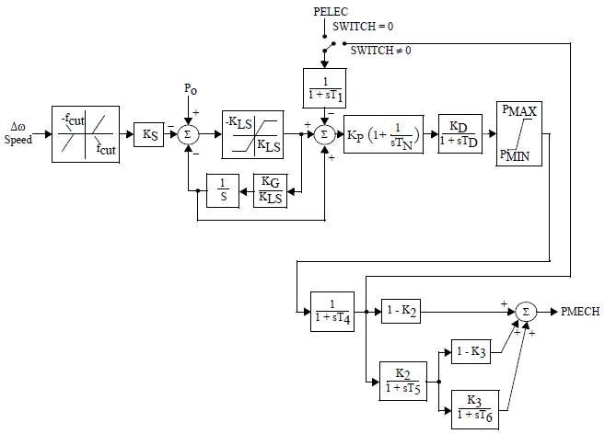

- TGOV1: Steam turbine-governor model
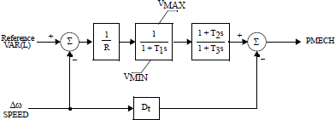

- CRCMGV: Cross compound turbine-governormodel
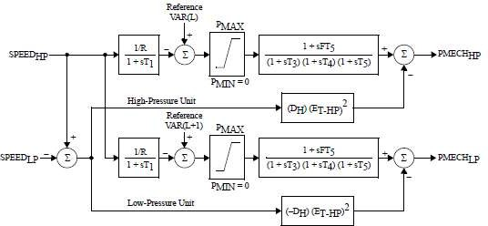
- IEEEG1: 1981 IEEE type 1 turbine-governormodel
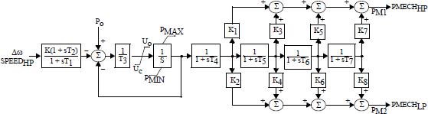
- IEEEG2: 1981 IEEE Type 2 Speed-GoverningModel
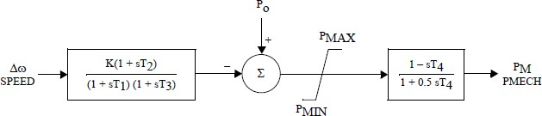

- 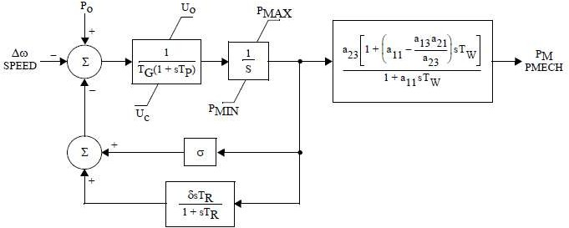IEEEG3: 1981 IEEE Type 3 Speed-GoverningModel

- IEESGO: 1973 IEEE standard turbine-governormodel
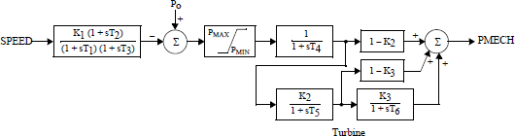

- TGOV2: Steam turbine-governor model with fastvalving
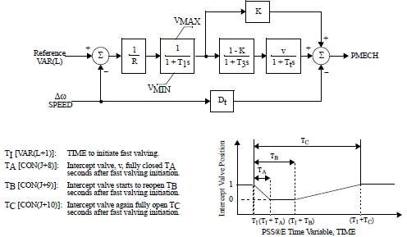
- TGOV3: Modified IEEE type 1 turbine-governor model with fastvalving
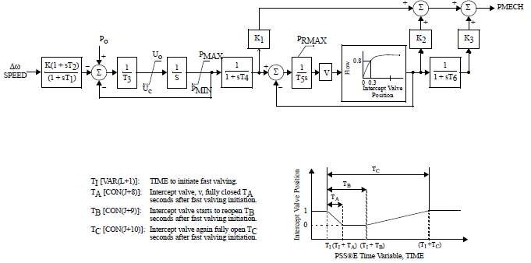

- TGOV4: Modified IEEE type 1 speed governing model with PLU andEVA
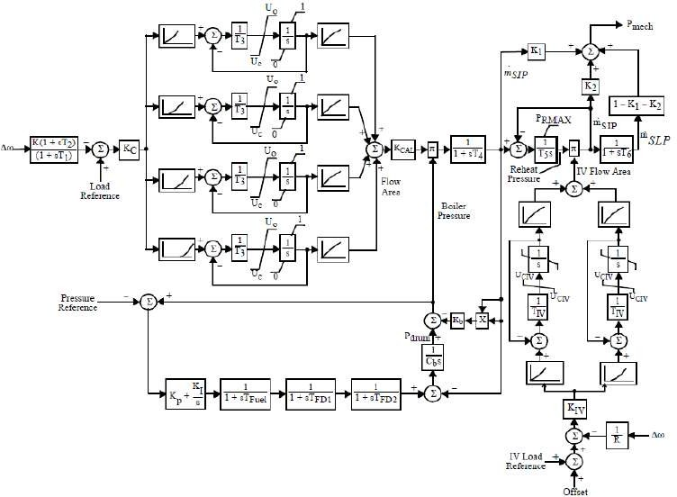
- TGOV5: Modified IEEE type 1 turbine-governor model with boilercontrols
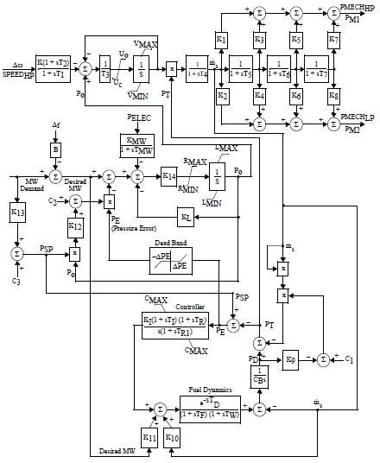

- TURCZT: Czech Hydro and SteamGovernor
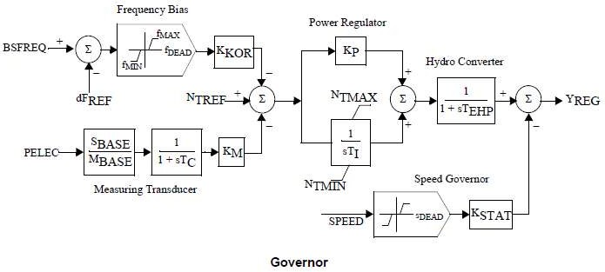

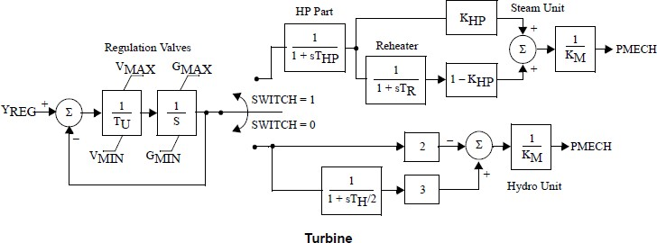
Source-PSSE Model Library

Calculation of saturation parameters:

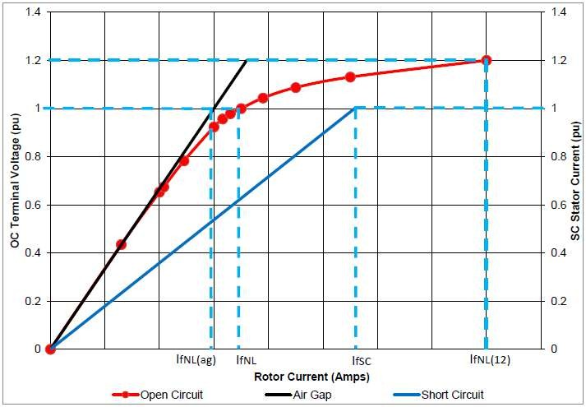
Figure 2: Open and short circuit characteristics

The saturation can be calculated using the following calculation:

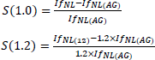

Annex-4(B)
Guideline for furnishing information for modelling Gas-fired Power generation in Indian Grid

  - Introduction:
The purpose of this document is to act as a guideline for exchange of information for accurate modelling of Gas-fired power generation in India. Availability of fit-for-purpose steady state and dynamics models of Gas-fired power generators will enable secure operation of Indian power grid and enable identification of potential weak points in the grid so as to take appropriate remedial actions.

  - Applicability:
The guideline shall be applicable to all Gas-fired power generation in India that can have an impact on operation of the power grid of India, irrespective of connection at Intra-STS or ISTS (Inter-state Transmission System).
This document presents the desired information for collection of data for modelling of Gas-fired power generators in PSS/E software, a software suite being used pan-India at CEA, CTU, SLDCs, RLDCs, and NLDC for modelling of India’s power grid. A systematic set of data and basic criteria for furnishing data are presented.

  - Need for a fit-for-purposemodel:
There is a cost involved in developing and validating dynamic models of power system equipment. But there are much higher benefits for the power system if this leads to a functional, fit-for-purpose model, and arrangements that allow that model to be maintained over time.
A functional fit-for-purpose dynamic model will:
    - Facilitate significant power system efficiencies by allowing power system operations to confidently identify the secure operating envelope and thereby manage securityeffectively
    - Allow assessment of impact on grid elements due to connection of new elements (network elements, generators, or loads) for necessary correctiveactions
    - Permit power system assets to be run with margins determined on the basis of security assessments
    - Facilitate the tuning of control systems, such as power system stabilizers, voltage- and frequency-based special control schemesetc.
    - Improve accuracy of online security tools, particularly for unusual operating conditions, which in turn is likely to result in higher reliability of supply to power systemusers.
The power system model would enable steady state and electromechanical transient simulation studies that deliver reasonably accurate outcomes.

  - Regulation:
- CEA Connectivity Standard 6.4.d:

The requester and user shall cooperate with RPC and Appropriate Load Despatch Centre in respect of the matters listed below, but not limitedto
furnish data as required by Appropriate Transmission Utility or Transmission Licensee, Appropriate Load Despatch Centre, Appropriate Regional Power Committee and any committee constituted by the Authority or appropriate Government for system studies or for facilitating analysis of tripping or disturbance in power system;
Here Requester and User Includes a generating company, captive generating plant, energy storage system, transmission licensee (other than Central Transmission Utility and State Transmission Utility), distribution licensee, solar park developer, wind park developer, wind-solar photovoltaic hybrid system, or bulk consumer (2019 Amendment)
- IEGC 4.1:

CTU, STU and Users connected to, or seeking connection to ISTS shall comply with Central Electricity Authority (Technical Standards for connectivity to the Grid) Regulations, 2007 which specifies the minimum technical and design criteria and Central Electricity Regulatory Commission (Grant of Connectivity, Long-term Access and Medium-term Open Access in inter-state Transmission and related matters) Regulations,2009.

  - Gas Power PlantClassification:
The gas turbine power plants which are used in electric power industry are classified into two main groups as per the cycle of operation and configuration:
    - Open cycle gas turbine(OCGT):
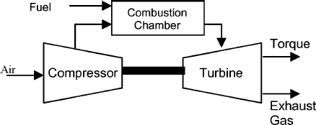In open cycle, air at the ambient condition is drawn into the compressor (either an axial-flow or centrifugal compressor) where its temperature and pressure are raised. The high pressure air proceeds into the combustion chamber, where the fuel is burnt at constant pressure. The high temperature gases then enter into the turbine where they expand to the atmospheric pressure while producing power output. The exhaust gases leaving the turbine are thrown out (not recirculated), causing the cycle to be classified as open cycle. All masses are typically on the same shaft (the compressor, combustion chamber, and turbine). This is also referred to as a “single-shaft” gasturbine.
Figure 1: Single Shaft Gas Turbine

In aero-derivative type turbines, the gas generator (compressor and compressor turbine) are mechanically separated from the power turbine. The compressor can have different speed settings to achieve higher efficiency. However, the inertia will be lower than a “single-shaft” gas turbine.
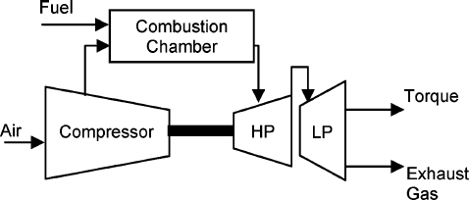
Figure 2: Aero-derivative Gas Turbine

    - Closed cycle gas turbine(CCGT):
In a closed cycle gas turbine, working fluid does not come in contact with atmospheric air. The compression and expansion process remains the same but the combustion process is replaced by constant pressure heat addition process from an external source. The exhaust process is replaced by constant pressure heat rejection process to the ambient air. The exhaust gases leaving the turbine are cooled in heat exchanger called sink where it reject heat. Therefore in this cycle, same working fluid is recirculated, causing the cycle to be classified as closecycle.
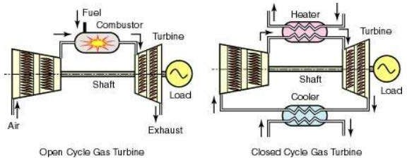
Figure 3: Typical Open and Close cycle GasTurbine

For POSOCO to have access to verified fit-for-purpose models of gas power generator connected to Indian grid, following information is required:
- Electrical Single Line Diagram of gas power stationdepicting;
  - For individual generating units: type of technology, Complete Generator OEM Technical Datasheet (which comprises namely generator parameters like impedances & time constants, generator capability curve, V-curve, generator open and short circuit characteristics, excitation system details, inertia of generator & exciter), generator name plate, generator SAT report including Short circuit and open circuit test results during commissioning/recentoverhauling.
  - Generator step up transformer: GT name plate/datasheet, details of LV, MV and HV, MVA rating, impedance, tap changer details, vector group, short-circuit parameters (actual positive & zero sequence impedance of GT, NGR nameplate withimpedance).
  - Excitation system :- Type of excitation system (Direct Current Commutator Exciters (type DC), AC Excitation (Rotor or brushless excitation) Systems (type AC) and Static Excitation Systems (type ST), Excitation system schematics (Block diagram of AVR system), transfer function block diagram of Excitation system, excitation transformer nameplate, saturation curves of the exciter (E_{fd} versus I_{f} curve), IEEE standard model of excitation system, IEEE standard model and its parameter of subsystems such as Power system stabilizer (PSS), Under Excitation Limiter (UEL), Over Excitation Limiter (OEL), Voltage per Hz Limiter(V/Hz) control etc. and details thereof, factory acceptance test reports (FAT). Excitation system actual settings to be provided. AVR test report (excitation step responsetest).

  - Power System Stabilizer (PSS): Transfer function block diagram of PSS, IEEE Standard Model, Actual PSS software settings, PSS commissioning report and recent PSS tuningreport.
  - Turbine-Governor system :- Type of prime mover (open cycle, aero-derivative gas turbine or close cycle), droop and dead-band setting, characteristic of active power versus fuel valve position (or fuel stroke reference), size of steam turbine (ST), frequency control of ST, time lag and relationship of GT and ST, model of governor control system (including details of technology, valves, valves characteristics) , inlet guide vane (IGV) characteristic, ramp rates, base load/frequency control, details of heat recovery generator-HRSG (Block diagram, GT output vs heat relationship, Drum time constant, Pressure loss due to friction in boiler tubes), , turbine inertia, IEEE standard model of turbine governor system and its transfer function Block diagram and its parameters, details of control mode (boiler-follow, turbine-follow, or coordinated control), commissioning report of turbine-governor system or recent governor testingreport.
- Generic models of individual components (generator, exciter, turbine-governor and PSS of gas power generator (refer sections 3.2 to section3.5)
  - Model should be suitable for an integration time step between 1ms and 20ms, and suitable for operation up-to 100s
  - Simulation results depicting validation of generic models against user-defined models (for P, Q, V, I) and against actual measurement (after commissioning) to beprovided.
- Encrypted user defined model (UDM) in a format suitable for latest PSSE release PSS/E (*.dll files) for electromechanical transient simulation for components of gas power generators (in case non-availability of validated genericmodel)
  - User guide for Encrypted models to be provided including instructions on how the model should beset-up
  - Corresponding transfer function block diagrams to beprovided
  - SimulationresultsdepictingvalidationofUser-Definedmodelsagainstactualmeasurementto be provided
  - The use of black-box type representation is notpreferred

Annexure: Formats for submission of modelling data for Gas-fired power generation

Version History:

Version no. | Release Date | Prepared by* | Checked/Issued by* | Changes
*Mention Designation and Contact Details
Details submitted:

Details pending:

  - Details of models in PSS/E for modelling gas powergenerator:
    - Synchronous Machine – To be filled separately for Gas turbine (GT) and steam turbine(ST)

Category | Parameter Description | Data
Generator Nameplate | Rated apparent power in MVA
 | Rated terminal voltage
 | Rated power factor
 | Rated speed (in RPM)
 | Rated frequency (in Hz)
 | Rated excitation (in Amperes and Volts)
Type of synchronous machine | Round rotor or salient pole No. of poles
Generator capability curve | The generator capability curve shows the reactive capability of the machine and should include any restrictions on the real or reactive power range like under/over excitation limits, stability limits, etc.  Capability curve should have properly labelled axis and legible data
Generator Open Circuit and Short Circuit Characteristic | Graph of excitation current versus terminal voltage and stator current
 | No load excitation current – used to derive per unit values
 | Excitation current at rated stator current
Generator vee-curves | Otherwise referred to as “V-curve”.  A plot of the terminal (armature) current versus the generating unit field voltage.
Resistance values | Resistance measurements of field winding and stator winding to a known temperature
Generator Data sheet | Direct axis synchronous reactance Xd in p.u. (Unsaturated or saturated)
 | Direct axis transient synchronous reactance Xd’ in p.u. (Unsaturated or saturated)
 | Direct axis sub-transient synchronous reactance Xd’’ in p.u. (Unsaturated or saturated)
 | Stator leakage reactance Xa in p.u. (Unsaturated or saturated )
 | Quadrature axis synchronous reactance Xq in p.u. (Unsaturated or saturated )
 | Quadrature axis transient synchronous reactance Xq’ in p.u. (Unsaturated or saturated )
 | Quadrature axis sub-transient synchronous reactance Xq’’ in p.u. (Unsaturated or saturated )
 | Direct axis open circuit transient time constant Tdo’ in sec
 | Direct axis open circuit sub-transient time constant Tdo’’ in sec
 | Quadrature axis open circuit transient time constant Tqo’ in sec
 | Quadrature axis open circuit sub-transient time constant Tqo’’ in sec
 | Inertia constant of total rotating mass (generator, AVR, turbo-governor set) H in MW.s/MVA
 | Speed Damping D
 | Saturation constant S (1.0) in p.u.
 | Saturation constant S (1.2) in p.u.

Category | Parameter Description | Data
 | Nameplate Rating
Generator step up transformer (GSUT) | - Rated primary and secondaryvoltage  - Vectorgroup
 | - Impedance
 | - Tapchanger details (Numberoftaps,tapposition,tapratioetc.)
Auxiliary power (i.e. active and reactive auxiliary load) | Value of auxiliary load (MW and Mvar) at rated power of the generating unit.
 | Whether or not the load trips if the generating unit trips.
Test Reports | Factory acceptance test (FAT) reports
    - SiteLoad

 | Low Output |  |  | High Output
 | Kw | kvar | kVA | kW | kvar | kVA
Auxiliary Load

    - ExcitationSystem

Category | Parameter Description |  |  |  |  | Data
Type of Automatic Voltage Regulator (AVR) | Manufacturer and product details (for example ABB UNITROL or GE EX2100e)
 | Type of control system :- Analogue or digital
 | Year of commissioning / Year of manufacture
 | As found settings (obtained either from HMI or downloaded from controller in digital systems)
Type of excitation system | Static excitation system OR
Indirect excitation system (i.e. rotating exciter)
- AC exciter,or
- DCexciter
Details of AVR converter | Rated excitation current (converter rating in Amperes)
 | Six pulse thyristor bridge or PWM converter
Source of excitation supply | Excitation transformer or auxiliary supply (Details thereof)
 | If | excitation | transformer, | nameplate | information required
Schematics | Saturation curves of the exciter (if applicable – see Type AC and DC)
 | Drawings of excitation system, typically prepared and supplied by the OEM
 | Single line diagram (i.e. one-line diagram) for the excitation system
Excitation limiters | What excitation limiters are commissioned?
 | Under Excitation Limiters settings
 | Over Excitation Limiters settings
 | Voltage/frequency limiter
 | Stator current limiter
 | Minimum excitation current limiter

Category | Parameter Description | Data
PSS | Is the AVR equipped with a PSS?
 | How many input Channels does the PSS have? (speed, real power output or both
 | IfthePSSusesspeed,isthisaderivedspeedsignal(i.e.synthesizedspeed signal) or measured directly (i.e. actual rotorspeed)?
Type of PSS
Block Diagram of PSS and as commissioned parameters value (Gain, time constants, filter coefficients, output limits of the PSS )
Test Reports | Factory acceptance test (FAT) reports

    - Turbine Details (to be filled in for the GT and STseparately)

Category | Parameter Description | Data
Type of prime mover | - Open cycle gasturbine  - Aero-derivative (twin shaft) gasturbine  - Combined cycle plant (closed cycle gasturbine)
Manufacturer of turbine | Manufacturer and name plate details
Governor | Electro-mechanical governor (including settings and drawings)
 | Digital electric governor (including settings and drawings)
Ramp rates | How fast can the turbine increase and/or decrease load, specified in MW/min Guide vane/wicket gate characteristic, including opening, closing rates/times and limits
Droop | Droop setting (% on machine base)
Frequency influence limiters
- Maximum frequency deviation limiter (eg +/-2Hz)
- Maximum influence limiter (eg 10% ofrating)
Dead band | Details of frequency dead band (typically in Hz or RPM)
Technology | - Opencycle  - Closecycle
Gas turbine | Does turbine operate in dual fuel (gas and liquid fuel)
 | Inlet guide vane (IGV) characteristic
 | Limit for exhaust gas temperature (EGT)
 | Base load/frequency control
 | Power output versus ambient temperature
 | No load fuel flow and turbine gain (determined by relationship of active power versus fuel valve position or fuel stroke reference)

Category | Parameter Description | Data
Combine cycle plant | Details on heat recovery steam generator (HRSG)  - Block diagram  - GT output vs heat relationship (look uptable)  - Drum timeconstant  - Pressure loss due to friction in boilertubes
 | Size of steam turbine
 | Frequency control of ST
 | Time lag and relationship of GT and ST
 | Is the combined cycle plant a single shaft plant – i.e. the gas and steam turbine are on same shaft and drive same generator

  - Generic Models for synchronousmachine
Gas turbine (GT) or steam turbines (ST) are generally round rotor machines however, salient pole Gas turbine (aero-derivative) with synchronous machine having four poles has also been installed at some of the places. Depending upon the saturation characteristic of the machine they are classified further:
- Round rotor machine (2 poles):
  - GENROU – Round rotor machine model with quadratic saturationfunction
  - GENROE – Round rotor machine model with exponential saturationfunction
- Salient pole machine (more than twopoles):
  - GENSAL – Salient pole machine with quadratic saturationfunction
  - GENSAE – Salient pole machine with exponential saturationfunction

Category | Parameter Description | Data
GENERATOR model
GENROU OR GENROE | Direct axis open circuit transient time constant Tdo’ in sec
 | Direct axis open circuit sub-transient time constant Tdo’’ in sec
 | Quadrature axis open circuit transient time constant Tqo’ in sec
 | Quadrature axis open circuit sub-transient time constant Tqo’’ in sec
 | Inertia constant of total rotating mass H in MW.s/MVA
 | Speed Damping D
 | Direct axis synchronous reactance Xd in p.u. (Unsaturated or saturated)
 | Quadrature axis synchronous reactance Xq in p.u. (Unsaturated or saturated )
 | Direct axis transient synchronous reactance Xd’ in p.u. (Unsaturated or saturated)
 | Quadrature axis transient synchronous reactance Xq’ in p.u. (Unsaturated or saturated )
Direct axis sub-transient synchronous reactance Xd’’ in p.u. (Unsaturated or saturated) =
Quadrature axis sub-transient synchronous reactance Xq’’ in p.u. (Unsaturated or saturated )
 | Stator leakage reactance Xl in p.u.
 | Saturation constant S (1.0) in p.u.
 | Saturation constant S (1.2) in p.u.
GENSAE OR GENSAL | Direct axis open circuit transient time constant Tdo’ in sec
 | Direct axis open circuit sub-transient time constant Tdo’’ in sec
 | Quadrature axis open circuit sub-transient time constant Tqo’’ in sec
 | Inertia constant of total rotating mass H in MW.s/MVA
 | Speed Damping D
 | Direct axis synchronous reactance Xd in p.u. (Unsaturated or saturated)
 | Quadrature axis synchronous reactance Xq in p.u. (Unsaturated or saturated )
 | Direct axis transient synchronous reactance Xd’ in p.u. (Unsaturated or saturated)
Direct axis sub-transient synchronous reactance Xd’’ in p.u. (Unsaturated or saturated) =
Quadrature axis sub-transient synchronous reactance Xq’’ in p.u. (Unsaturated or saturated )
 | Stator leakage reactance Xl in p.u.
 | Saturation constant S (1.0) in p.u.
 | Saturation constant S (1.2) in p.u.

While entering the values in above table, following relationship must be kept:
Xd>Xq>Xq’≥Xd’>Xq”≥Xd’’
Tdo’>Td’>Tdo’’>Td’’
Tqo’’>Tq’>Tqo’’>Tq’’
  - Excitation systemmodel:
If a generic model is used, the first step must be to identify what type of exciter is present in the excitation system. The IEEE Std 421.5 (IEEE Recommended Practice for Excitation System Models for Power System Stability Studies published on 26th Aug 2016) has published several generic models, which are classified into threegroups:
- Type DC : for excitation systems with a DCexciter
- Type AC : for excitation systems with an ACexciter
- Type ST : for excitation systems with a staticexciter
The following table shows the types of models separated into their respective groups.

DC exciter | AC exciter | Static excitation system
Type DC1A | Type AC1A | Type ST1A
Type DC2A | Type AC2A | Type ST2A
Type DC3A | Type AC4A | Type ST3A
Type DC4B | Type AC5A | Type ST4B
 | Type AC6A | Type ST5B
 | Type AC7B | Type ST6B
 | Type AC8B | Type ST7B

Category | Parameter Description | Data
DC Exciter
ESDC1A OR ESDC2A | TR regulator input filter time constant (sec)
 | KA (> 0) (pu) voltage regulator gain
 | TA (s), voltage regulator time constant
 | TB (s), lag time constant
 | TC (s), lead time constant
 | VRMAX (pu) regulator output maximum limit or Zero
 | VRMIN (pu) regulator output minimum limit
 | KE (pu) exciter constant related to self-excited field
 | TE (> 0) rotating exciter time constant (sec)
 | KF (pu) rate feedback gain
 | TF1 (> 0) rate feedback time constant (sec)
 | Switch
 | E1, exciter flux at knee of curve (pu)
 | SE(E1), saturation factor at knee of curve
 | E2, maximum exciter flux (pu)
 | SE(E2), saturation factor at maximum exciter flux (pu)
ESDC3A | TR regulator input filter time constant (sec)
 | KV (pu) limit on fast raise/lower contact setting
 | VRMAX (pu) regulator output maximum limit or Zero
 | VRMIN (pu) regulator output minimum limit
 | TRH ( > 0) Rheostat motor travel time (sec)
 | TE ( > 0) exciter time-constant (sec)
 | KE (pu) exciter constant related to self-excited field
 | VEMIN (pu) exciter minimum limit
 | E1, exciter flux at knee of curve (pu)
 | SE(E1), saturation factor at knee of curve
 | E2, maximum exciter flux (pu)
 | SE(E2), saturation factor at maximum exciter flux (pu)

Category | Parameter Description | Data
DC Exciter
ESDC4B | TR regulator input filter time constant (sec)
 | KP (pu) (> 0) voltage regulator proportional gain
 | KI (pu) voltage regulator integral gain
 | KD (pu) voltage regulator derivative gain
 | TD voltage regulator derivative channel time constant (sec)
 | VRMAX (pu) regulator output maximum limit
 | VRMIN (pu) regulator output minimum limit
 | KA (> 0) (pu) voltage regulator gain
 | TA voltage regulator time constant (sec)
 | KE (pu) exciter constant related to self-excited field
 | TE (> 0) rotating exciter time constant (sec)
 | KF (pu) rate feedback gain
 | TF (> 0) rate feedback time constant (sec)
 | VEMIN (pu) minimum exciter voltage output
 | E1, exciter flux at knee of curve (pu)
 | SE(E1), saturation factor at knee of curve
 | E2, maximum exciter flux (pu)
 | SE(E2), saturation factor at maximum exciter flux (pu)
ESAC1A | TR regulator input filter time constant (sec)
 | TB (s), lag time constant
 | TC (s), lead time constant
 | KA (> 0) (pu) voltage regulator gain
 | TA (s), voltage regulator time constant
 | VAMAX (pu) regulator output maximum limit
 | VAMIN (pu) regulator output minimum limit
 | TE (> 0) rotating exciter time constant (sec)
 | KF (pu) rate feedback gain
 | TF (> 0) rate feedback time constant (sec)
 | KC (pu) rectifier loading factor proportional to commutating reactance
 | KD (pu) demagnetizing factor, function of AC exciter reactances
 | KE (pu) exciter constant related to self-excited field
 | E1, exciter flux at knee of curve (pu)
 | SE(E1), saturation factor at knee of curve
 | E2, maximum exciter flux (pu)
 | SE(E2), saturation factor at maximum exciter flux (pu)
 | VRMAX (pu) regulator output maximum limit
 | VRMIN (pu) regulator output minimum limit

Category | Parameter Description | Data
DC Exciter
ESAC2A | TR regulator input filter time constant (sec)
 | TB (s), lag time constant
 | TC (s), lead time constant
 | KA (> 0) (pu) voltage regulator gain
 | TA (s), voltage regulator time constant
 | VAMAX (pu) regulator output maximum limit
 | VAMIN (pu) regulator output minimum limit
 | KB, Second stage regulator gain
 | VRMAX (pu) regulator output maximum limit
 | VRMIN (pu) regulator output minimum limit
 | TE (> 0) rotating exciter time constant (sec)
 | VFEMAX, parameter of VEMAX, exciter field maximum output
 | KH, Exciter field current feedback gain
 | KF (pu) rate feedback gain
 | TF (> 0) rate feedback time constant (sec)
 | KC (pu) rectifier loading factor proportional to commutating reactance
 | KD (pu) demagnetizing factor, function of AC exciter reactances
 | KE (pu) exciter constant related to self-excited field
 | E1, exciter flux at knee of curve (pu)
 | SE(E1), saturation factor at knee of curve
 | E2, maximum exciter flux (pu)
 | SE(E2), saturation factor at maximum exciter flux (pu)

Category | Parameter Description | Data
AC Exciter
ESAC3A | TR regulator input filter time constant (sec)
 | TB (s), lag time constant
 | TC (s), lead time constant
 | KA (> 0) (pu) voltage regulator gain
 | TA (s), voltage regulator time constant
 | VAMAX (pu) regulator output maximum limit
 | VAMIN (pu) regulator output minimum limit
 | TE (> 0) rotating exciter time constant (sec)
 | VEMIN (pu) minimum exciter voltage output
 | KR (>0), Constant associated with regulator and alternator field power supply
 | KF (pu) rate feedback gain
 | TF (> 0) rate feedback time constant (sec)
 | KN, Exciter feedback gain
EFDN, A parameter defining for which value of UF the feedback gain shall change from
KF to KN
 | KC, rectifier regulation factor (pu)
 | KD, exciter regulation factor (pu)
 | KE (pu) exciter constant related to self-excited field
 | VFEMAX, parameter of VEMAX, exciter field maximum output
 | E1, exciter flux at knee of curve (pu)
 | SE(E1), saturation factor at knee of curve
 | E2, maximum exciter flux (pu)
 | SE(E2), saturation factor at maximum exciter flux (pu)
ESAC4A | TR regulator input filter time constant (sec)
 | VIMAX, Maximum value of limitation of the integrator signal VI in p.u
 | VIMIN, Minimum value of limitation of the signal VI in p.u.
 | TB (s), lag time constant
 | TC (s), lead time constant
 | KA (> 0) (pu) voltage regulator gain
 | TA (s), voltage regulator time constant
 | VRMAX (pu) regulator output maximum limit
 | VRMIN (pu) regulator output minimum limit
 | KC, rectifier regulation factor (pu)

Category | Parameter Description | Data
AC Exciter
ESAC5A | TR regulator input filter time constant (sec)
 | KA (> 0) (pu) voltage regulator gain
 | TA (s), voltage regulator time constant
 | VRMAX (pu) regulator output maximum limit
 | VRMIN (pu) regulator output minimum limit
 | KE (pu) exciter constant related to self-excited field
 | TE (> 0) rotating exciter time constant (sec)
 | KF (pu) rate feedback gain
 | TF1 (sec), Regulator stabilizing circuit time constant in seconds
 | TF2 (sec), Regulator stabilizing circuit time constant in seconds
 | TF3 (sec), Regulator stabilizing circuit time constant in seconds
 | E1, exciter flux at knee of curve (pu)
 | SE(E1), saturation factor at knee of curve
 | E2, maximum exciter flux (pu)
 | SE(E2), saturation factor at maximum exciter flux (pu)
AC6A | TR regulator input filter time constant (sec)
 | KA (> 0) (pu) voltage regulator gain
 | TA (s), voltage regulator time constant
 | TK (sec), Lead time constant
 | TB (s), lag time constant
 | TC (s), lead time constant
 | VAMAX (pu) regulator output maximum limit
 | VAMIN (pu) regulator output minimum limit
 | VRMAX (pu) regulator output maximum limit
 | VRMIN (pu) regulator output minimum limit
 | TE (> 0) rotating exciter time constant (sec)
 | VFELIM, Exciter field current limit reference
 | KH, Damping module gain
 | VHMAX, damping module limiter
 | TH (sec), damping module lag time constant
 | TJ (sec), damping module lead time constant
 | KC, rectifier regulation factor (pu)
 | KD, exciter regulation factor (pu)
 | KE (pu) exciter constant related to self-excited field
 | E1, exciter flux at knee of curve (pu)
 | SE(E1), saturation factor at knee of curve
 | E2, maximum exciter flux (pu)
 | SE(E2), saturation factor at maximum exciter flux (pu)

Category | Parameter Description | Data
AC Exciter
AC7B | TR (sec) regulator input filter time constant
 | KPR (pu) regulator proportional gain
 | KIR (pu) regulator integral gain
 | KDR (pu) regulator derivative gain
 | TDR (sec) regulator derivative block time constant
 | VRMAX (pu) regulator output maximum limit
 | VRMIN (pu) regulator output minimum limit
 | KPA (pu) voltage regulator proportional gain
 | KIA (pu) voltage regulator integral gain
 | VAMAX (pu) regulator output maximum limit
 | VAMIN (pu) regulator output minimum limit
 | KP (pu)
 | KL (pu)
 | KF1 (pu)
 | KF2 (pu)
 | KF3 (pu)
 | TF3 (sec) time constant (> 0)
 | KC (pu) rectifier loading factor proportional to commutating reactance
 | KD (pu) demagnetizing factor, function of AC exciter reactances
 | KE (pu) exciter constant related fo self-excited field
 | TE (pu) exciter time constant (>0)
 | VFEMAX (pu) exciter field current limit (> 0)
 | VEMIN (pu)
 | E1, exciter flux at knee of curve (pu)
 | SE(E1), saturation factor at knee of curve
 | E2, maximum exciter flux (pu)
 | SE(E2), saturation factor at maximum exciter flux (pu)

Category |  | Parameter Description | Data
AC Exciter
AC8B |  | TR (sec) regulator input filter time constant
 |  | KPR (pu) regulator proportional gain
 |  | KIR (pu) regulator integral gain
 |  | KDR (pu) regulator derivative gain
 |  | TDR (sec) regulator derivative block time constant
 |  | VPIDMAX (pu) PID maximum limit
 |  | VPIDMIN (pu) PID minimum limit
 |  | KA (pu) voltage regulator proportional gain
 |  | TA (sec) voltage regulator time constant
 |  | VRMAX (pu) regulator output maximum limit
 |  | VRMIN (pu) regulator output minimum limit
 |  | KC (pu) rectifier loading factor proportional to commutating reactance
 |  | KD (pu) demagnetizing factor, function of AC exciter reactances
 |  | KE (pu) exciter constant related fo self-excited field
 |  | TE (pu) exciter time constant (>0)
 |  | VFEMAX (pu) max exciter field current limit (> 0)
 |  | VEMIN (pu),
 |  | E1, exciter flux at knee of curve (pu)
 |  | SE(E1), saturation factor at knee of curve
 |  | E2, maximum exciter flux (pu)
 |  | SE(E2), saturation factor at maximum exciter flux (pu)
 | Static Exciter
ST1A |  | TR (sec) regulator input filter time constant
 |  | VIMAX, Controller Input Maximum
 |  | VIMIN, Controller Input Minimum
 |  | TC (s), Filter 1st Derivative Time Constant
 |  | TB (s), l Filter 1st Delay Time Constant
 |  | TC1 (s), Filter 2nd Derivative Time Constant
 |  | TB1 (s), Filter 2nd Delay Time Constant
 |  | KA (pu) voltage regulator proportional gain
 |  | TA (sec) voltage regulator time constant
 |  | VAMAX (pu) regulator output maximum limit
 |  | VAMIN (pu) regulator output minimum limit
 |  | VRMAX (pu) regulator output maximum limit
 |  | VRMIN (pu) regulator output minimum limit
 |  | KC (pu) rectifier loading factor proportional to commutating reactance
 |  | KF (pu) rate feedback gain
 |  | TF (> 0) rate feedback time constant (sec)
 |  | KLR, Current Input Factor
 |  | ILR, Current Input Reference

Category | Parameter Description | Data
Static Exciter
ST2A | TR (sec) regulator input filter time constant
 | KA (pu) voltage regulator proportional gain
 | TA (sec) voltage regulator time constant
 | VRMAX (pu) regulator output maximum limit
 | VRMIN (pu) regulator output minimum limit
 | KE (pu) exciter constant related fo self-excited field
 | TE (pu) exciter time constant (>0)
 | KF (pu) rate feedback gain
 | TF (> 0) rate feedback time constant (sec)
 | KP (pu) voltage regulator proportional gain
 | KI (pu) voltage regulator integral gain
 | KC (pu) rectifier loading factor proportional to commutating reactance
 | EFDMAX
ST3A | TR (sec) regulator input filter time constant
 | VIMAX, Maximum value of limitation of the signal VI in p.u.
 | VIMIN, Minimum value of limitation of the signal VI in p.u.
 | KM, Forward gain constant of the inner loop field regulator
 | TC (s), lag time constant
 | TB (s), lead time constant
 | KA (pu) voltage regulator proportional gain
 | TA (sec) voltage regulator time constant
 | VRMAX (pu) regulator output maximum limit
 | VRMIN (pu) regulator output minimum limit
 | KG, Feedback gain constant of the inner loop field regulator
 | KP (pu) voltage regulator proportional gain
 | KI (pu) voltage regulator integral gain
 | VBMAX, Maximum value of limitation of the signal VB in p.u.
 | KC (pu) rectifier loading factor proportional to commutating reactance
 | XL, Reactance associated with potential source
 | VGMAX, Maximum value of limitation of the signal VG in p.u
 | Ɵ_{P} (degrees)
 | TM (sec), Forward time constant of the inner loop field regulator
 | VMMAX, Maximum value of limitation of the signal VM in p.u
 | VMMIN, Minimum value of limitation of the signal VM in p.u.

Category | Parameter Description | Data
Static Exciter
ST4B | TR (sec) regulator input filter time constant
 | KPR (pu) regulator proportional gain
 | KIR (pu) regulator integral gain
 | VRMAX (pu) regulator output maximum limit
 | VRMIN (pu) regulator output minimum limit
 | TA (sec) voltage regulator time constant
 | KPM, Regulator gain
 | KIM, Regulator gain
 | VMMAX, Maximum value of limitation of the signal in p.u.
 | VMMIN, Minimum value of limitation of the signal in p.u.
 | KG
 | KP (pu) voltage regulator proportional gain
 | KI (pu) voltage regulator integral gain
 | VBMAX
 | KC (pu) rectifier loading factor proportional to commutating reactance
 | XL
 | Ɵ_{P} (degrees)
ST5B | TR regulator input filter time constant (sec)
 | TC1 lead time constant of first lead-lag block (voltage regulator channel) (sec)
 | TB1 lag time constant of first lead-lag block (voltage regulator channel) (sec)
 | TC2 lead time constant of second lead-lag block (voltage regulator channel) (sec)
 | TB2 lag time constant of second lead-lag block (voltage regulator channel) (sec)
 | KR (>0) (pu) voltage regulator gain
 | VRMAX (pu) voltage regulator maximum limit
 | VRMIN (pu) voltage regulator minimum limit
 | T1 voltage regulator time constant (sec)
 | KC (pu)
 | TUC1 lead time constant of first lead-lag block (under-excitation channel) (sec)
 | TUB1 lag time constant of first lead-lag block (under-excitation channel) (sec)
 | TUC2 lead time constant of second lead-lag block (under-excitation channel) (sec)
 | TUB2 lag time constant of second lead-lag block (under-excitation channel) (sec)
 | TOC1 lead time constant of first lead-lag block (over-excitation channel) (sec)
 | TOB1 lag time constant of first lead-lag block (over-excitation channel) (sec)
 | TOC2 lead time constant of second lead-lag block (over-excitation channel) (sec)
 | TOB2 lag time constant of second lead-lag block (over-excitation channel) (sec)

Category | Parameter Description | Data
Static Exciter
ST6B | TR regulator input filter time constant (sec)
 | KPA (pu) (> 0) voltage regulator proportional gain
 | KIA (pu) voltage regulator integral gain
 | KDA (pu) voltage regulator derivative gain
 | TDA voltage regulator derivative channel time constant (sec)
 | VAMAX (pu) regulator output maximum limit
 | VAMIN (pu) regulator output minimum limit
 | KFF (pu) pre-control gain of the inner loop field regulator
 | KM (pu) forward gain of the inner loop field regulator
 | KCI (pu) exciter output current limit adjustment gain
 | KLR (pu) exciter output current limiter gain
 | ILR (pu) exciter current limit reference
 | VRMAX (pu) voltage regulator output maximum limit
 | VRMIN (pu) voltage regulator output minimum limit
 | KG (pu) feedback gain of the inner loop field voltage regulator
 | TG (> 0) feedback time constant of the inner loop field voltage regulator (sec)
ST7B | TR regulator input filter time constant (sec)
 | TG lead time constant of voltage input (sec)
 | TF lag time constant of voltage input (sec)
 | Vmax (pu) voltage reference maximum limit
 | Vmin (pu) voltage reference minimum limit
 | KPA (pu) (>0) voltage regulator gain
 | VRMAX (pu) voltage regulator output maximum limit
 | VRMIN (pu) voltage regulator output minimum limit
 | KH (pu) feedback gain
 | KL (pu) feedback gain
 | TC lead time constant of voltage regulator (sec)
 | TB lag time constant of voltage regulator (sec)
 | KIA (pu) (>0) gain of the first order feedback block
 | TIA (>0) time constant of the first order feedback block (sec)

- DC Exciters Genericmodel:
  - Type DC1A: 1992 IEEE type DC1A excitation systemmodel

  - Type DC2A: 1992 IEEE type DC2A excitation systemmodel

  - Type DC3A: IEEE 421.5 2005 DC3A excitationsystem

  - Type DC4B: IEEE 421.5 2005 DC4B excitationsystem

- AC Exciters GenericModels:

  - Type AC1A: 1992 IEEE type AC1A excitation systemmodel

  - Type AC2A: 1992 IEEE type AC2A excitation systemmodel

  - Type AC3A: 1992 IEEE type AC3A excitation systemmodel

  - Type AC4A: 1992 IEEE type AC4A excitation systemmodel

  - Type AC5A: 1992 IEEE type AC5A excitation systemmodel

  - Type AC6A: IEEE 421.5 excitation systemmodel

  - Type AC7B: IEEE 421.5 2005 AC7B excitationsystem

  - Type AC8B: IEEE 421.5 2005 AC8B excitationsystem

- Commonly Used Static Exciters Generic Models blockdiagrams:

  - Type ST1A: 1992 IEEE type ST1A excitation systemmodel

  - Type ST2A: 1992 IEEE type ST2A excitation systemmodel

  - Type ST3A: 1992 IEEE type ST3A excitation systemmodel

  - Type ST4B: IEEE type ST4B potential or compounded source-controlled rectifierexciter

  - Type ST6B: IEEE 421.5 2005 ST6B excitationsystem

Source-PSSE Model Library
  - Power system stabilizer:
The function of the PSS is to add to the unit’s characteristic electromechanical oscillations. This is achieved by modulating excitation to develop a component in electrical torque in phase with rotor speed deviations.
The most important aspect when considering a PSS model is the number of inputs. The following table shows the type of models separated based on the inputs:

Type | Inputs | Remarks
PSS1A | Single input | Two lead-lags  Input can either be speed, frequency or power
PSS2B | Dual input | Integral of accelerating power type stabiliser Speed and Power  Most common type  Supersedes PSS2A (three versus two lead lags)
PSS3B | Dual input | Power and rotor angular frequency deviation  Stabilising signal is a vector sum of processed signals Not very common

Category |  | Parameter Description | Data
 | Stabilizer Models
PSS1A |  | A1, Filter coefficient
 |  | A2, Filter coefficient
 |  | TR, transducer time constant
 |  | 0
 |  | 0
 |  | 0
 |  | T1, 1st Lead-Lag Derivative Time Constant
 |  | T2, 1st Lead-Lag Delay Time Constant
 |  | T3, 2nd Lead-Lag Derivative Time Constant
 |  | T4, 2nd Lead-Lag Delay Time Constant
 |  | Tw, Washout Time Constant
 |  | Tw, Washout Time Constant
 |  | Ks, input channel gain
 |  | VSTMAX, Controller maximum output
 |  | VSTMAX, Controller minimum output
 |  | 0
 |  | 0
PSS2B |  | TW1, 1st Washout 1th Time Constant
 |  | TW2, 1st Washout 2th Time Constant
 |  | T6, 1st Signal Transducer Time Constant
 |  | TW3, 2nd Washout 1th Time Constant
 |  | TW4, 2nd Washout 2th Time Constant
 |  | T7, 2nd Signal Transducer Time Constant
 |  | KS2, 2nd Signal Transducer Factor
 |  | KS3, Washouts Coupling Factor
 |  | T8, Ramp Tracking Filter Deriv. Time Constant
 |  | T9, Ramp Tracking Filter Delay Time Constant
 |  | KS1, PSS Gain
 |  | T1, 1st Lead-Lag Derivative Time Constant
 |  | T2, 1st Lead-Lag Delay Time Constant
 |  | T3, 2nd Lead-Lag Derivative Time Constant
 |  | T4, 2nd Lead-Lag Delay Time Constant
 |  | T10, 3rd Lead-Lag Derivative Time Constant
 |  | T11, 3rd Lead-Lag Delay Time Constant
 |  | VS1MAX, Input 1 Maximum limit
 |  | VS1MIN, Input 1 Minimum limit
 |  | VS2MAX, Input 2 Maximum limit
 |  | VS2MIN, Input 2 Minimum limit
 |  | VSTMAX, Controller Maximum Output
 |  | VSTMIN, Controller Minimum Output

Category | Parameter Description | Data
Stabilizer Models
PSS3B | KS1 (pu) (≠0), input channel #1 gain
 | T1 input channel #1 transducer time constant (sec)
 | Tw1 input channel #1 washout time constant (sec)
 | KS2(pu)( 0), input channel #2 gain
 | T2 input channel #2 transducer time constant (sec)
 | Tw2 input channel #2 washout time constant (sec)
 | Tw3 (0), main washout time constant (sec)
 | A1, Filter coefficient
 | A2, Filter coefficient
 | A3, Filter coefficient
 | A4, Filter coefficient
 | A5, Filter coefficient
 | A6, Filter coefficient
 | A7, Filter coefficient
 | A8, Filter coefficient
 | VSTMAX, Controller maximum output
 | VSTMAX, Controller minimum output

Commonly Used Power System Stabilizer generic models block diagrams:
- PSS1A: IEEE Std. 421.5-2005 PSS1A Single-Input Stabilizermodel
- PSS2B: IEEE 421.5 2005 PSS2B IEEE dual-input stabilizermodel

- PSS3B: IEEE Std. 421.5 2005 PSS3B IEEE dual-input stabilizermodel
Source-PSSE Model Library

  - Generic models for gasturbine-governor:
The following table is a list for common generic models of gas turbines:

Type | Name | Remarks
GAST | Gas turbine governor | Simplified model for industrial gas turbine (i.e.  OCGT)
GAST2A | Gas turbine governor | More detailed GT from GAST. Governor can be configured for droop or isochronous control.  Includes temperature control
GASTWD | Woodward Gas Turbine-Governor model | Same detail of turbine dynamics as GAST2A but  with a Woodward governor controls
WESGOV | Westinghouse Digital governor for Gas Turbine | Westinghouse 501 combination turbine governor
GGOV1 | GE General Governor/Turbine model | General purpose GE GT model (neglects ICV  control)
PWTBD1 | Pratt & Whitney Turboden turbine-  governor | Turbine load PI control with valve and look-up  table
URCSCT | Combined cycle, single shaft turbine-  governor model
URGS3T | WECC gas turbine governor

Source: PSSE Model Library, for models other than the above list refer to
https://w3.usa.siemens.com/smartgrid/us/en/transmission-grid/products/grid-analysis-tools/transmission-system-planning/transmission-system-planning-tab/pages/user-support.aspx

Category | Parameter Description | Data
TURBINE GOVERNOR model
GAST | R, permanent droop
 | T1 (>0) (sec), Governor mechanism time constant
 | T2 (>0) (sec), Turbine power time constant
 | T3 (>0) (sec), Turbine exhaust temperature time constant
 | Ambient temperature load limit, AT
 | KT, Temperature limiter gain
 | VMAX, Maximum turbine power
 | VMIN, Minimum turbine power
 | Dturb, Turbine damping factor
GAST2A | W, governor gain (1/droop) (on turbine rating)
 | X (sec) governor lead time constant
 | Y (sec) (> 0) governor lag time constant
 | Z, governor mode:1 Droop or 0 ISO
 | ETD (sec), Turbine exhausts time constant
 | TCD (sec), Gas turbine dynamic time constant
 | TRATE turbine rating (MW)
 | T (sec), Fuel control time constant
 | MAX (pu) limit (on turbine rating)
 | MIN (pu) limit (on turbine rating)
 | ECR (sec), Combustor time constant
 | K3, Fuel control gain
 | a (> 0) valve positioner
 | b (sec) (> 0) valve positioner
 | c valve positioner
 | Ƭf (sec) (> 0), Fuel system time constant
 | Kf, feedback gain
 | K5, Radiation shield
 | K4, Radiation shield
 | T3 (sec) (> 0), Radiation shield time constant
 | T4 (sec) (> 0), Thermocouple time constant, seconds
 | Ƭt (> 0), Temperature control time constant
 | T5 (sec) (> 0), Temperature control time constant
 | af1, describes the turbine characteristic
 | bf1, describes the turbine characteristic
 | af2, describes the turbine characteristic
 | bf2, describes the turbine characteristic
 | cf2, describes the turbine characteristic
 | TR (degree), Rated temperature
 | K6 (pu), Minimum fuel flow
 | TC (degree), Temperature control

Category | Parameter Description | Data
TURBINE GOVERNOR model
GASTWD | KDROOP (on turbine rating)
 | KP, Proportional gain
 | KI, Integral gain
 | KD, Derivative gain
 | ETD (sec), Turbine exhaust time constant
 | TCD (sec), Gas turbine dynamic time constant
 | TRATE turbine rating (MW)
 | T (sec), Fuel control time constant
 | MAX (pu) limit (on turbine rating)
 | MIN (pu) limit (on turbine rating)
 | ECR (sec), Combustor time constant
 | K3, Fuel control gain
 | a (> 0) valve positioner
 | b (sec) (> 0) valve positioner
 | c valve positioner
 | tf (sec) (> 0), Fuel system time constant
 | Kf, feedback gain
 | K5, Radiation shield
 | K4, Radiation shield
 | T3 (sec) (> 0), Radiation shield time constant
 | T4 (sec) (> 0), Thermocouple time constant, seconds
 | tt (> 0), Temperature control time constant
 | T5 (sec) (> 0), Temperature control time constant
 | af1, describes the turbine characteristic
 | bf1, describes the turbine characteristic
 | af2, describes the turbine characteristic
 | bf2 (>0), describes the turbine characteristic
 | cf2, describes the turbine characteristic
 | TR(degree), Rated temperature1
 | K6 (pu), Minimum fuel flow
 | TC (degree), Temperature control1
 | TD (sec) (> 0), Power transducer
WESGOV | ΔTC (sec), Δt sample for controls
 | ΔTP (sec), Δt sample for PE
 | Power Droop
 | Kp, Trubine proportional gain
 | TI (> 0) (sec), Integral time constant
 | T1 (sec), Constant time
 | T2 (sec), Constant time
 | ALIM
 | Tpe (sec), Power time constant

Category | Parameter Description | Data
TURBINE GOVERNOR model
GGOV1 | R, Permanent droop, pu
 | Tpelec, Electrical power transducer time constant, sec
 | maxerr, Maximum value for speed error signal
 | minerr, Minimum value for speed error signal
 | Kpgov, Governor proportional gain
 | Kigov, Governor integral gain
 | Kdgov, Governor derivative gain
 | Tdgov, Governor derivative controller time constant, sec
 | vmax, Maximum valve position limit
 | vmin, Minimum valve position limit
 | Tact, Actuator time constant, sec
 | Kturb, Turbine gain
 | Wfnl, No load fuel flow, pu
 | Tb, Turbine lag time constant, sec
 | Tc, Turbine lead time constant, sec
 | Teng, Transport lag time constant for diesel engine, sec
 | Tfload, Load Limiter time constant, sec
 | Kpload, Load limiter proportional gain for PI controller
 | Kiload, Load limiter integral gain for PI controller
 | Ldref, Load limiter reference value pu
 | Dm, Mechanical damping coefficient, pu
 | Ropen, Maximum valve opening rate, pu/sec
 | Rclose, Maximum valve closing rate, pu/sec
 | Kimw, Power controller (reset) gain
 | Aset, Acceleration limiter setpoint, pu/sec
 | Ka, Acceleration limiter gain
 | Ta, Acceleration limiter time constant, sec ( > 0)
 | Trate, Turbine rating (MW)1
 | db, Speed governor deadband
 | Tsa, Temperature detection lead time constant, sec
 | Tsb, Temperature detection lag time constant, sec
 | Rup, Maximum rate of load limit increase
 | Rdown, Maximum rate of load limit decrease

Category | Parameter Description | Data
TURBINE GOVERNOR model
PWTBD1 | Trate (MW), Turbine rating (MW)
 | K (pu), Proportional gain
 | Ki (pu), Integral gain
 | Vrmax (pu), Upper Limit of PI controller
 | Vrmin (pu), Lower Limit of PI controller
 | Tv (s) (>0), Control valve Time Constant
 | Lo (pu/sec) (>0), Control valve open rate limit
 | Lc (pu/sec) (>0), Control valve close rate limit
 | Vmax (pu), Maximum valve position
 | Vmin (pu), Minimum valve position
 | Tb1 (s), steam buffer time constant
 | Tb2 (s), steam buffer time constant
 | v1 (pu), valve position 1
 | p1 (pu), power output for valve position v1
 | v2 (pu), valve position 2
 | p2 (pu), power output for valve position v2
 | v3 (pu), valve position 3
 | p3 (pu), power output for valve position v3
 | v4 (pu), valve position 4
 | p4 (pu), power output for valve position v4
 | v5 (pu), valve position 5
 | p5 (pu), power output for valve position v5
 | v6 (pu), valve position 6
 | p6 (pu), power output for valve position v6
 | v7 (pu), valve position 7
 | p7 (pu), power output for valve position v7
 | v8 (pu), valve position 8
 | p8 (pu), power output for valve position v8
 | v9 (pu), valve position 9
 | p9 (pu), power output for valve position v9
 | v10 (pu), valve position 10
 | p11 (pu), power output for valve position v11
 | v11 (pu), valve position 11
 | p11 (pu), power output for valve position v11

Category | Parameter Description |  | Data
TURBINE GOVERNOR model
URCSCT |  | W, governor gain (1/droop) (on turbine rating)
 |  | X (sec) governor lead time constant
 |  | Y (sec) (> 0) governor lag time constant
 |  | Z, governor mode:1 Droop or 0 ISO
 |  | ETD (sec), Turbine exhausts time constant
 |  | TCD (sec), Gas turbine dynamic time constant
 |  | TRATE turbine rating (MW)
 |  | T (sec), Fuel control time constant
 |  | MAX (pu) limit (on turbine rating)
 |  | MIN (pu) limit (on turbine rating)
 |  | ECR (sec), Combustor time constant
 |  | K3, Fuel control gain
 |  | a (> 0) valve positioner
 |  | b (sec) (> 0) valve positioner
 |  | c valve positioner
 |  | Ƭf (sec) (> 0), Fuel system time constant
 |  | Kf, feedback gain
 |  | K5, Radiation shield
 |  | K4, Radiation shield
 |  | T3 (sec) (> 0), Radiation shield time constant
 |  | T4 (sec) (> 0), Thermocouple time constant, seconds
 |  | Ƭt (> 0), Temperature control time constant
 |  | T5 (sec) (> 0), Temperature control time constant
 |  | af1, describes the turbine characteristic
 |  | bf1, describes the turbine characteristic
 |  | af2, describes the turbine characteristic
 |  | bf2, describes the turbine characteristic
 |  | cf2, describes the turbine characteristic
 |  | TR (degree), Rated temperature
 |  | K6 (pu), Minimum fuel flow
 |  | TC (degree), Temperature control
 |  | K, Governor gain, (1/droop) pu
 |  | T1 (sec), Lag time constant (sec)
 |  | T2 (sec), Lead time constant (sec)
 |  | T3 (> 0) (sec), valve position time constant
 |  | Uo (pu/sec), maximum valve opening rate
 |  | Uc (< 0) (pu/sec), maximum valve closing rate
 |  | PMAX (pu on machine MVA rating)
 |  | PMIN (pu on machine MVA rating)

Category | Parameter Description | Data
TURBINE GOVERNOR model
URSCT  (continued) | T4 (sec), time constant for steam inlet
 | K1, HP fraction
 | K2, LP fraction
 | T5 (sec), Time Constant for Second Boiler Pass [s]
 | K3, HP Fraction
 | K4, LP fraction
 | T6 (sec), Time Constant for Third Boiler Pass [s]
 | K5, HP Fraction
 | K6, LP fraction
 | T7 (sec), Time Constant for Fourth Boiler Pass [s]
 | K7, HP Fraction
 | K8, LP fraction
 | ST Rating, Steam turbine rating (MW)
 | POUT A, Plant total, point A (MW)
 | STOUT A, Steam turbine output, point A (MW)
 | POUT B, Plant total, point B (MW)
 | STOUT B, Steam turbine output, point B (MW)
 | POUT C, Plant total, point C (MW)
 | STOUT C, Steam turbine output, point C (MW)
URGS3T | R
 | T1 (> 0) (sec)
 | T2 (> 0) (sec)
 | T3 (> 0) (sec)
 | Lmax
 | Kt
 | Vmax
 | Vmin
 | Dturb
 | Fidle
 | Rmax
 | Linc (> 0)
 | Tltr ( >0) (sec)
 | Ltrat
 | a
 | b (> 0)
 | db1, dead band width (p.u.)
 | Err, deadband hysteresis (p.u.)
 | db2, dead band width (p.u.)
 | GV1, coordinate of power-gate look-up table (p.u. gate)

URGS3T (CONTINUED) | PGV1, coordinate of power-gate look-up table (p.u. power)
 | GV2, coordinate of power-gate look-up table (p.u. gate)
 | PGV2, coordinate of power-gate look-up table (p.u. power)
 | GV3, coordinate of power-gate look-up table (p.u. gate)
 | PGV3, coordinate of power-gate look-up table (p.u. power)
 | GV4, coordinate of power-gate look-up table (p.u. gate)
 | PGV4, coordinate of power-gate look-up table (p.u. power)
 | GV5, coordinate of power-gate look-up table (p.u. gate)
 | PGV5, coordinate of power-gate look-up table (p.u. power)
 | Ka
 | T4
 | T5
 | MWCAP

Commonly Used Gas Turbine Generic Models Block Diagrams:

- GAST: GasTurbine-Governor
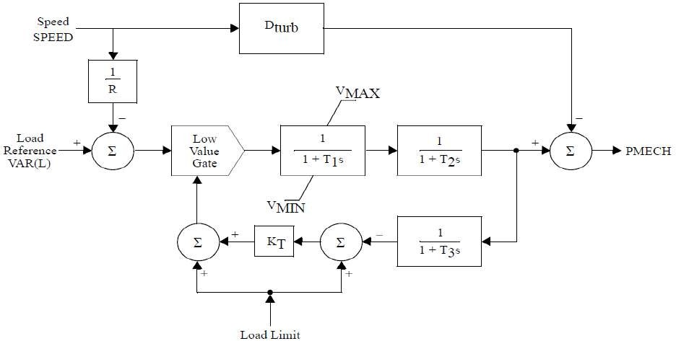
- GAST2A: HydroTurbine-Governor
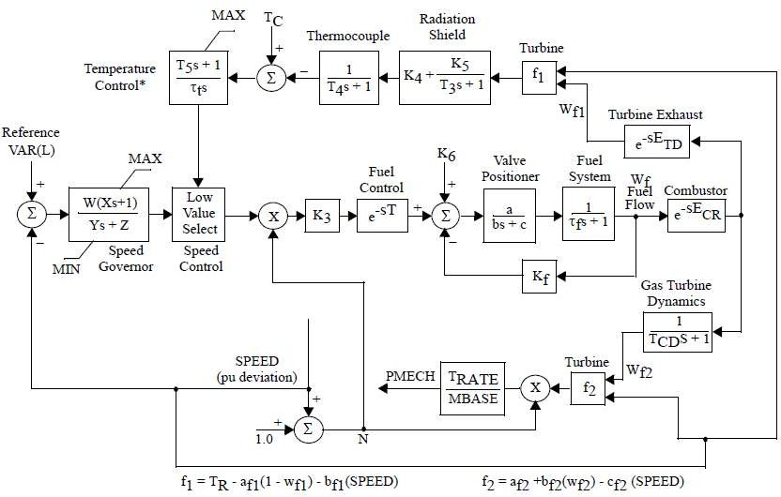

- GASTWD: Woodward Gas Turbine-GovernorModel
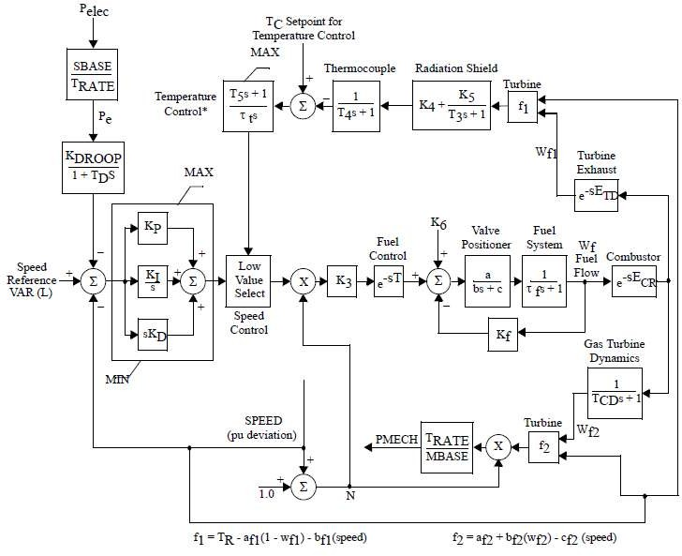

- WESGOV: Westinghouse Digital Governor for GasTurbine
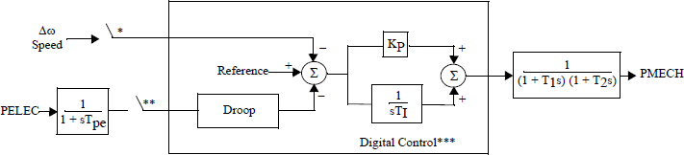
*Sample hold with sample period defined by ΔTC.
**Sample hold with sample period defined by ΔTP.
***Maximum change is limited to ALIM between sampling times.

- GGOV1: GE General Governor/TurbineModel

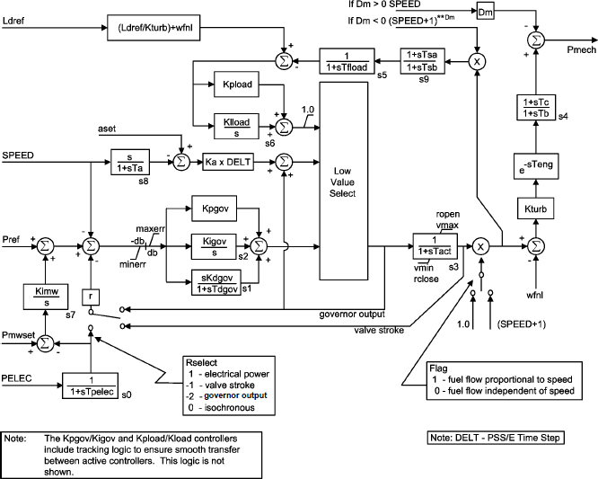
- PWTBD1: Pratt & Whitney Turboden Turbine-GovernorModel
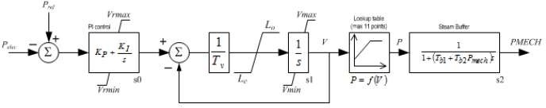

- URCSCT: Combined Cycle on SingleShaft
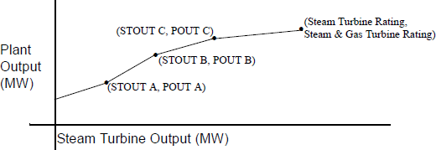
- URGS3T: WECC Gas TurbineModel

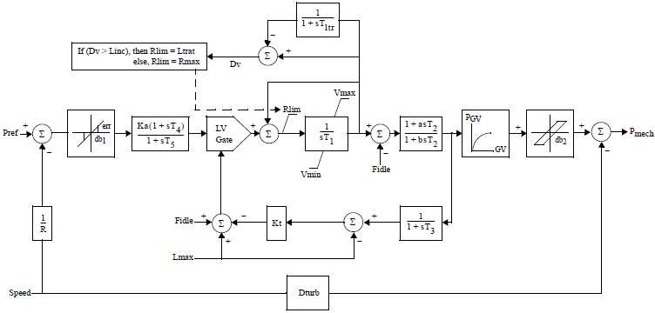
Source-PSSE Model Library

Figure 4: Open and short circuit characteristics

The saturation can be calculated using the following calculation:
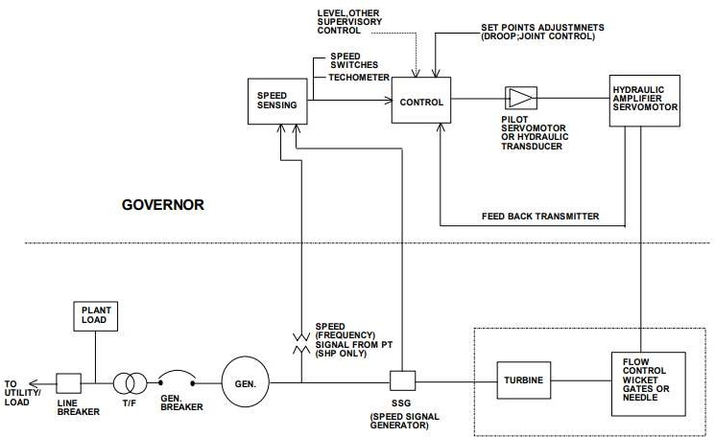

Figure 5: Governing system - Block Diagram (Typical) as per IEEE std. -75

Procedure for furnishing information for modelling Hydro Power Generation in Indian Grid

  - Introduction:
The purpose of this document is to act as a guideline for exchange of information for accurate modelling of hydro power generation in India. Availability of fit-for-purpose steady state and dynamics models of hydro power generation will enable secure operation of Indian power grid and enable identification of potential weak points in the grid so as to take appropriate remedial actions.

  - Applicability:
The guideline shall be applicable to all hydro power generation in India that can have an impact on operation of the power grid of India, irrespective of connection at Intra-STS or ISTS (Inter-state Transmission System).
This document presents the desired information for collection of data for modelling of hydro power generation in PSS/E software, a software suite being used pan-India at CEA, CTU, SLDCs, RLDCs, and NLDC for modelling of India’s power grid. A systematic set of data and basic criteria for furnishing data are presented.

  - Need for a fit-for-purposemodel:
There is a cost involved in developing and validating dynamic models of power system equipment. But there are much higher benefits for the power system if this leads to a functional, fit-for-purpose model, and arrangements that allow that model to be maintained over time.
A functional fit-for-purpose dynamic model will:
    - Facilitate significant power system efficiencies by allowing power system operations to confidently identify the secure operating envelope and thereby manage securityeffectively
    - Allow assessment of impact on grid elements due to connection of new elements (network elements, generators, or loads) for necessary correctiveactions
    - Permit power system assets to be run with margins determined on the basis of security assessments
    - Facilitate the tuning of control systems, such as power system stabilizers, voltage- and frequency-based special control schemesetc.
    - Improve accuracy of online security tools, particularly for unusual operating conditions, which in turn is likely to result in higher reliability of supply to power systemusers.
The power system model would enable steady state and electromechanical transient simulation studies that deliver reasonably accurate outcomes.

  - Regulation:
- CEA Connectivity Standard 6.4.d:

The requester and user shall cooperate with RPC and Appropriate Load Despatch Centre in respect of the matters listed below, but not limitedto
furnish data as required by Appropriate Transmission Utility or Transmission Licensee, Appropriate Load Despatch Centre, Appropriate Regional Power Committee and any committee constituted by the Authority or appropriate Government for system studies or for facilitating analysis of tripping or disturbance in power system;

Here Requester and User Includes a generating company, captive generating plant, energy storage system, transmission licensee (other than Central Transmission Utility and State Transmission Utility), distribution licensee, solar park developer, wind park developer, wind-solar photovoltaic hybrid system, or bulk consumer (2019 Amendment)
- IEGC 4.1:

CTU, STU and Users connected to, or seeking connection to ISTS shall comply with Central Electricity Authority (Technical Standards for connectivity to the Grid) Regulations, 2007 which specifies the minimum technical and design criteria and Central Electricity Regulatory Commission (Grant of Connectivity, Long-term Access and Medium-term Open Access in inter-state Transmission and related matters) Regulations,2009.

  - Hydro Power PlantClassification:
    - Run-of-river:
Run of river hydropower projects have no, or very little, storage capacity behind the dam and generations dependent on the timing and size of river flows.
    - Reservoir(HPP):
Reservoir based hydropower schemes have the ability to store water behind the dam in a reservoir in order to de-couple generation from hydro inflows. A hydroelectric reservoir makes use of potential energy of water for generating electricity. Water is held back by the dam, and released through a turbine, which in turn produces electricity. Reservoir capacities can be small or very large, depending on the characteristics of the site and the economics of damconstruction.
    - Pumped storage(PSP):
Pumped storage hydropower schemes use off-peak electricity to pump water from a reservoir located after the tailrace to the top of the reservoir, so that the pumped storage plant can generate electricity at peak times and provide grid stability and flexibility services
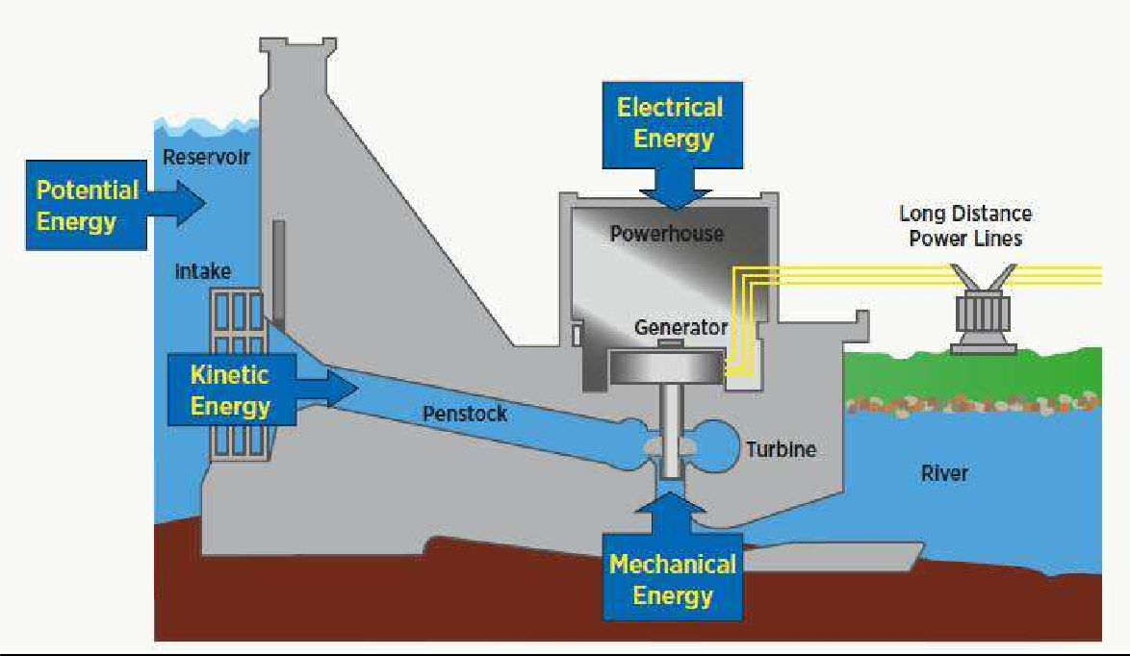
Figure 1: Typical "LOW HEAD" Hydro Power Plant with storage

Types of hydraulic turbines in regional grid:
The conventional hydroelectric generator can be classified broadly into three categories based on the hydraulic turbine type given as under:
- Pelton wheelturbine
- KaplanTurbine
- FrancisTurbine
- Bulb and other types ofturbines

Pelton wheel turbine is an impulse turbine for high head and low discharges (flow rate) conditions. Kaplan wheel turbine is a reaction type turbine suitable for low head and high discharge (flow rate) conditions. Francis turbine is mix type of turbine that operates at medium head and flow rate.
Among the hydro generators the Francis turbine generators are characterized by unstable operation zone over a certain range of generation (typically 10-70%) where it experiences vibration due to cavitation. Cavitation is the resulting vibration caused by bubbles formed in water column due to pressure change and this causes loss of head and turbine efficiency. The Pelton wheel turbines on the other hand do have better load following characteristics and are capable of extended part load operation since they don’t have any such forbiddenzones.
Region wise distribution of different turbine types has been given below:

Region | Pelton | Capacity | Francis | Capacity | Kaplan | Capacity | Bulb | Capacity
 | Number | MW | Number | MW | Number | MW | Number | MW
ER | 6 | 1200 | 27 | 3014 | 13 | 534 | 0 | 0
NER | 1 | 1.5 | 38 | 1260.5 | 0 | 0 | 0 | 0
NR | 48 | 1580 | 103 | 10544 | 3 | 94 | 0 | 0
SR | 68 | 4705 | 48 | 4096 | 12 | 426 | 20 | 594
WR | 23 | 1047 | 56 | 5266 | 20 | 885 | 0 | 0
All India | 146 | 8534 | 272 | 24181 | 48 | 1939 | 20 | 594
Source: Report on Operational Analysis for Optimization of Hydro resources – FOLD
https://posoco.in/hydro-committee-report/

The following information is required:
- Electrical Single Line Diagram of coal fired thermal stationdepicting;
  - For individual generating units: type of technology, Complete Generator OEM Technical Datasheet (which comprises namely generator parameters like impedances & time constants, generator capability curve, V-curve, generator open and short circuit characteristics, excitation system details, inertia of generator & exciter), generator name plate, generator SAT report including short circuit and open circuit test results during commissioning/recentoverhauling.
  - Generator step up transformer: GT name plate/datasheet, details of LV, MV and HV, MVA rating, impedance, tap changer details, vector group, short-circuit parameters (actual positive & zero sequence impedance of GT, NGR nameplate withimpedance).
  - Excitation system :- Type of excitation system (Direct Current Commutator Exciters (type DC), AC Excitation (Rotor or brushless excitation) Systems (type AC) and Static Excitation Systems (type ST), Excitation system schematics (Block diagram of AVR system), transfer function block diagram of Excitation system, excitation transformer nameplate, saturation curves of the exciter (I_{a} versus I_{f} curve), IEEE standard model of excitation system, IEEE standard model and its parameter of subsystems such as Power system stabilizer (PSS), Under Excitation Limiter (UEL), Over Excitation Limiter (OEL), Voltage per Hz Limiter(V/Hz) control etc. and details thereof, factory acceptance test reports (FAT). Excitation system actual settings to be provided. AVR test report (excitation step responsetest).

  - Power System Stabilizer (PSS): Transfer function block diagram of PSS, IEEE Standard Model, Actual PSS software settings, PSS commissioning report and Recent PSS tuningreport.
  - Turbine-Governor system :- Type of prime mover (hydro-electric or pumped storage), type of hydro turbine (impulse or reaction turbine) and details of head, model of turbine (including details of technology, valves, valve characteristics), model of governor control system (including details of technology, valves, valves characteristics) , penstock details (length, area, diameter, thickness, elastic or non-elastic, no of penstock supplied through common tunnel and flow of water through turbine) , mode of operation (hydro, pump storage or synchronous condenser) and control, surge tank details (height, diameter and restricted inlet orifice), pump characteristic (Active power Vs head) ramp rates, losses in case of synchronous condenser operation (Mechanical loss and copper loss as a function of MVAr output), Block diagram of turbine- governor system, IEEE standard model of turbine governor system and its transfer function diagram and its parameters, Turbine inertia, commissioning report of turbine-governor system or recent governor testingreport.
- Generic models of individual components (generator, exciter, turbine-governor and PSS of hydro power generator (refer sections 3.2 to section3.5)
  - Model should be suitable for an integration time step between 1ms and 20ms, and suitable for operation up-to 100s
  - Simulation results depicting validation of generic models against user-defined models (for P, Q, V, I) and against actual measurement (after commissioning) to beprovided.
- Encrypted user defined model (UDM) in a format suitable for latest PSSE release PSS/E (*.dll files) for electromechanical transient simulation for components of hydro power generators (in case non- availability of validated genericmodel)
  - User guide for Encrypted models to be provided including instructions on how the model should be set-up
  - Corresponding transfer function block diagrams to beprovided
  - Simulation results depicting validation of User-Defined models against actual measurement to beprovided
  - The use of black-box type representation is notpreferred

Annexure: Formats for submission of modelling data for hydro power generator

Version History:

Version no. | Release Date | Prepared by* | Checked/Issued by* | Changes
*Mention Designation and Contact Details
Details submitted:

Details pending:

  - Details of models in PSS/E for modelling hydro powergenerator:
    - Synchronous Machine – HPP and PSPtypes

Category | Parameter Description | Data
Generator Nameplate | Rated apparent power in MVA
 | Rated terminal voltage
 | Rated power factor
 | Rated speed (in RPM)
 | Rated frequency (in Hz)
 | Rated excitation (in Amperes and Volts)
Type of synchronous machine | Round rotor or salient pole No. of poles
Generator capability curve | The generator capability curve shows the reactive capability of the machine and should include any restrictions on the real or reactive power range like under/over excitation limits, stability limits, etc.  Capability curve should have properly labelled axis and legible data
Generator Open Circuit and Short Circuit Characteristic | Graph of excitation current versus terminal voltage and stator current
 | No load excitation current – used to derive per unit values
 | Excitation current at rated stator current
Generator vee-curves | Otherwise referred to as “V-curve”.  A plot of the terminal (armature) current versus the generating unit field voltage.
Resistance values | Resistance measurements of field winding and stator winding to a known temperature
Generator Data sheet | Direct axis synchronous reactance Xd in p.u. (Unsaturated or saturated)
 | Direct axis transient synchronous reactance Xd’ in p.u. (Unsaturated or saturated)
 | Direct axis sub-transient synchronous reactance Xd’’ in p.u. (Unsaturated or saturated)
 | Stator leakage reactance Xa in p.u. (Unsaturated or saturated )
 | Quadrature axis synchronous reactance Xq in p.u. (Unsaturated or saturated )
 | Quadrature axis transient synchronous reactance Xq’ in p.u. (Unsaturated or saturated )
 | Quadrature axis sub-transient synchronous reactance Xq’’ in p.u. (Unsaturated or saturated )
 | Direct axis open circuit transient time constant Tdo’ in sec
 | Direct axis open circuit sub-transient time constant Tdo’’ in sec
 | Quadrature axis open circuit transient time constant Tqo’ in sec
 | Quadrature axis open circuit sub-transient time constant Tqo’’ in sec
 | Inertia constant of total rotating mass (generator, AVR, turbo-governor set) H in MW.s/MVA
 | Speed Damping D
 | Saturation constant S (1.0) in p.u.
 | Saturation constant S (1.2) in p.u.

Category | Parameter Description | Data
 | Nameplate Rating
Generator step up transformer (GSUT) | - Rated primary and secondaryvoltage  - Vectorgroup
 | - Impedance
 | - Tapchangerdetails (Numberoftaps,tapposition,tapratioetc.)
Auxiliary power (i.e. active and reactive auxiliary load) | Value of auxiliary load (MW and Mvar) at rated power of the generating unit.
 | Whether or not the load trips if the generating unit trips.
Test Reports | Factory acceptance test (FAT) reports

    - SiteLoad

 | Low Output |  |  | High Output
 | kW | kvar | kVA | kW | kvar | kVA
Auxiliary Load

    - ExcitationSystem

Category | Parameter Description | Data
Type of Automatic Voltage Regulator (AVR) | Manufacturer and product details (for example ABB UNITROL)
 | Type of control system :- Analogue or digital
 | Year of commissioning / Year of manufacture
 | As found settings (obtained either from HMI or downloaded from controller in digital systems)
Type of excitation system | Static excitation system OR
Indirect excitation system (i.e. rotating exciter)
- AC exciter,or
- DCexciter
Details of AVR converter | Rated excitation current (converter rating in Amperes)
 | Six pulse thyristor bridge or PWM converter
Source of excitation supply | Excitation transformer or auxiliary supply (Details thereof)
 | If excitation transformer, nameplate information required
Schematics | Saturation curves of the exciter (if applicable – see Type AC and DC)
 | Drawings of excitation system, typically prepared and supplied by the OEM
 | Single line diagram (i.e. one-line diagram) for the excitation system
Excitation limiters | What excitation limiters are commissioned?
 | Under Excitation Limiters settings
 | Over Excitation Limiters settings
 | Voltage/frequency limiter
 | Stator current limiter
 | Minimum excitation current limiter

Category | Parameter Description | Data
PSS | Is the AVR equipped with a PSS?
 | How many input Channels does the PSS have? (speed, real power output or both
 | IfthePSSusesspeed,isthisaderivedspeedsignal(i.e.synthesizedspeed signal) or measured directly (i.e. actual rotorspeed)?
Type of PSS
Block Diagram of PSS and as commissioned parameters value (Gain, time constants, filter coefficients, output limits of the PSS )
Test Reports | Factory acceptance test (FAT) reports

    - Turbine Details (to be filled in for the HPP and PSPseparately)

Category | Parameter Description | Data
Type of prime mover | Hydro-electric turbine Other (Pumped storage)
Manufacturer of turbine | Manufacturer and name plate details
Modes of operation | Type of modes of operation capable:  - Generator  - Pumpstorage  - Synchronouscondenser
Governor | - Electro-mechanical governor (including settings anddrawings)  - Digital electric governor (including settings anddrawings)  - PID governor details andsettings  - Transient droop (dashpot) governor details andsettings  - Tacho-accelerometric governor details andsettings  - Input transducerdetails  - Transfer functiondata
 | Digital electric governor
Ramp rates | How fast can the turbine increase and/or decrease load, specified in MW/min Guide vane/wicket gate characteristic, including opening, closing rates/times and limits
Droop | Droop setting (% on machine base)
Frequency influence limiters
- Maximum frequency deviation limiter (eg +/-2Hz)
- Maximum influence limiter (eg 10% ofrating)
Dead band | Details of frequency dead band (typically in Hz or RPM)
Hydro-electric turbine | Type of hydro turbine  - Impulseturbines:typicalwithhighheadplants(Peltonwheel)  - Reaction turbine : typical with low and medium head plants (suchas Francis and Kaplanturbine  Head, water flow, velocity and pressure (e.g. intake and outtake/draft tube)

Penstock | Length (m)
 | Area (m²)
 | Internal penstock diameter
 | Pipe thickness, material or other characteristics (such as tapering)
 | Non-elastic or elastic
 | Linear or non-linear model (with or without relief valve) or Kaplan model
 | Flow of water through turbine (m³/s) – with gates fully open
 | Number of penstocks supplied from common tunnel
Pressure relief valve | Drawings/schematics
 | Settings
 | Operational descriptions
Surge tank, reservoir and tail water (i.e. head) | Vertical distance between the upper reservoir and level of turbine (in meters)
 | Head at turbine admission (lake head minus tailrace head) – (in meters)
 | Head loss due to friction in conduit (in meters)
 | Surge tank height, diameter and other characteristics (e.g. restricted inlet orifice)
Pump characteristics | Active power draw vs head (table)
 | PSS status when pumping (on/off/not used)
Synchronous condenser | Dewatered when operating as Syncon (yes/no)
Losses when operating as Syncon:
- Mechanical loss ( 0 Mvar) : ……MW
- Copper loss (table) MW loss as a function of MVaroutput
Other | Details of protection schemes that could influence dynamics (if any)
 | Details of resonance chamber for pipes (if any)
 | Temperature (e.g. water , ambient , unit)
 | Characteristic curve of blade versus gate (from 0MW to maximum MW)

  - Generic Models for synchronousmachine
Hydro machines are multi-pole machines and depending upon the saturation characteristic of the machine they are classified in two groups:

- GENSAL – Salient pole machine with quadratic saturationfunction
- GENSAE – Salient pole machine with exponential saturationfunction

Category | Parameter Description | Data
GENERATOR model
GENSAE OR GENSAL | Direct axis open circuit transient time constant Tdo’ in sec
 | Direct axis open circuit sub-transient time constant Tdo’’ in sec
 | Quadrature axis open circuit sub-transient time constant Tqo’’ in sec
 | Inertia constant of total rotating mass H in MW.s/MVA
 | Speed Damping D
 | Direct axis synchronous reactance Xd in p.u. (Unsaturated or saturated)
 | Quadrature axis synchronous reactance Xq in p.u. (Unsaturated or saturated )
 | Direct axis transient synchronous reactance Xd’ in p.u. (Unsaturated or saturated)
Direct axis sub-transient synchronous reactance Xd’’ in p.u. (Unsaturated or saturated)
= Quadrature axis sub-transient synchronous reactance Xq’’ in p.u. (Unsaturated or
saturated )
 | Stator leakage reactance Xl
 | Saturation constant S (1.0) in p.u.
 | Saturation constant S (1.2) in p.u.

While entering the values in above table, following relationship must be kept:
Xd>Xq>Xq’≥Xd’>Xq”≥Xd’’ Tdo’>Td’>Tdo’’>Td’’
Tqo’’>Tq’>Tqo’’>Tq’’

  - Excitation systemmodel:
If a generic model is used, the first step must be to identify what type of exciter is present in the excitation system. The IEEE Std 421.5 (IEEE Recommended Practice for Excitation System Models for Power System Stability Studies published on 26th Aug 2016) has published several generic models, which are classified into threegroups:
- Type DC : for excitation systems with a DCexciter
- Type AC : for excitation systems with an ACexciter
- Type ST : for excitation systems with a staticexciter
The following table shows the types of models separated into their respective groups.

DC exciter | AC exciter | Static excitation system
Type DC1A | Type AC1A | Type ST1A
Type DC2A | Type AC2A | Type ST2A
Type DC3A | Type AC4A | Type ST3A
Type DC4B | Type AC5A | Type ST4B
 | Type AC6A | Type ST5B
 | Type AC7B | Type ST6B
 | Type AC8B | Type ST7B

Category |  | Parameter Description | Data
 | DC Exciter
ESDC1A OR ESDC2A |  | TR regulator input filter time constant (sec)
 |  | KA (> 0) (pu) voltage regulator gain
 |  | TA (s), voltage regulator time constant
 |  | TB (s), lag time constant
 |  | TC (s), lead time constant
 |  | VRMAX (pu) regulator output maximum limit or Zero
 |  | VRMIN (pu) regulator output minimum limit
 |  | KE (pu) exciter constant related to self-excited field
 |  | TE (> 0) rotating exciter time constant (sec)
 |  | KF (pu) rate feedback gain
 |  | TF1 (> 0) rate feedback time constant (sec)
 |  | Switch
 |  | E1, exciter flux at knee of curve (pu)
 |  | SE(E1), saturation factor at knee of curve
 |  | E2, maximum exciter flux (pu)
 |  | SE(E2), saturation factor at maximum exciter flux (pu)

Category | Parameter Description | Data
DC Exciter
ESDC3A | TR regulator input filter time constant (sec)
 | KV (pu) limit on fast raise/lower contact setting
 | VRMAX (pu) regulator output maximum limit or Zero
 | VRMIN (pu) regulator output minimum limit
 | TRH ( > 0) Rheostat motor travel time (sec)
 | TE ( > 0) exciter time-constant (sec)
 | KE (pu) exciter constant related to self-excited field
 | VEMIN (pu) exciter minimum limit
 | E1, exciter flux at knee of curve (pu)
 | SE(E1), saturation factor at knee of curve
 | E2, maximum exciter flux (pu)
 | SE(E2), saturation factor at maximum exciter flux (pu)
ESDC4B | TR regulator input filter time constant (sec)
 | KP (pu) (> 0) voltage regulator proportional gain
 | KI (pu) voltage regulator integral gain
 | KD (pu) voltage regulator derivative gain
 | TD voltage regulator derivative channel time constant (sec)
 | VRMAX (pu) regulator output maximum limit
 | VRMIN (pu) regulator output minimum limit
 | KA (> 0) (pu) voltage regulator gain
 | TA voltage regulator time constant (sec)
 | KE (pu) exciter constant related to self-excited field
 | TE (> 0) rotating exciter time constant (sec)
 | KF (pu) rate feedback gain
 | TF (> 0) rate feedback time constant (sec)
 | VEMIN (pu) minimum exciter voltage output
 | E1, exciter flux at knee of curve (pu)
 | SE(E1), saturation factor at knee of curve
 | E2, maximum exciter flux (pu)
 | SE(E2), saturation factor at maximum exciter flux (pu)

Category | Parameter Description | Data
AC Exciter
ESAC1A | TR regulator input filter time constant (sec)
 | TB (s), lag time constant
 | TC (s), lead time constant
 | KA (> 0) (pu) voltage regulator gain
 | TA (s), voltage regulator time constant
 | VAMAX (pu) regulator output maximum limit
 | VAMIN (pu) regulator output minimum limit
 | TE (> 0) rotating exciter time constant (sec)
 | KF (pu) rate feedback gain
 | TF (> 0) rate feedback time constant (sec)
 | KC (pu) rectifier loading factor proportional to commutating reactance
 | KD (pu) demagnetizing factor, function of AC exciter reactances
 | KE (pu) exciter constant related to self-excited field
 | E1, exciter flux at knee of curve (pu)
 | SE(E1), saturation factor at knee of curve
 | E2, maximum exciter flux (pu)
 | SE(E2), saturation factor at maximum exciter flux (pu)
 | VRMAX (pu) regulator output maximum limit
 | VRMIN (pu) regulator output minimum limit
ESAC2A | TR regulator input filter time constant (sec)
 | TB (s), lag time constant
 | TC (s), lead time constant
 | KA (> 0) (pu) voltage regulator gain
 | TA (s), voltage regulator time constant
 | VAMAX (pu) regulator output maximum limit
 | VAMIN (pu) regulator output minimum limit
 | KB, Second stage regulator gain
 | VRMAX (pu) regulator output maximum limit
 | VRMIN (pu) regulator output minimum limit
 | TE (> 0) rotating exciter time constant (sec)
 | VFEMAX, parameter of VEMAX, exciter field maximum output
 | KH, Exciter field current feedback gain
 | KF (pu) rate feedback gain
 | TF (> 0) rate feedback time constant (sec)
 | KC (pu) rectifier loading factor proportional to commutating reactance
 | KD (pu) demagnetizing factor, function of AC exciter reactances
 | KE (pu) exciter constant related to self-excited field
 | E1, exciter flux at knee of curve (pu)
 | SE(E1), saturation factor at knee of curve
 | E2, maximum exciter flux (pu)
 | SE(E2), saturation factor at maximum exciter flux (pu)

Category | Parameter Description | Data
AC Exciter
ESAC3A | TR regulator input filter time constant (sec)
 | TB (s), lag time constant
 | TC (s), lead time constant
 | KA (> 0) (pu) voltage regulator gain
 | TA (s), voltage regulator time constant
 | VAMAX (pu) regulator output maximum limit
 | VAMIN (pu) regulator output minimum limit
 | TE (> 0) rotating exciter time constant (sec)
 | VEMIN (pu) minimum exciter voltage output
 | KR (>0), Constant associated with regulator and alternator field power supply
 | KF (pu) rate feedback gain
 | TF (> 0) rate feedback time constant (sec)
 | KN, Exciter feedback gain
EFDN, A parameter defining for which value of UF the feedback gain shall change
from KF to KN
 | KC, rectifier regulation factor (pu)
 | KD, exciter regulation factor (pu)
 | KE (pu) exciter constant related to self-excited field
 | VFEMAX, parameter of VEMAX, exciter field maximum output
 | E1, exciter flux at knee of curve (pu)
 | SE(E1), saturation factor at knee of curve
 | E2, maximum exciter flux (pu)
 | SE(E2), saturation factor at maximum exciter flux (pu)
ESAC4A | TR regulator input filter time constant (sec)
 | VIMAX, Maximum value of limitation of the integrator signal VI in p.u
 | VIMIN, Minimum value of limitation of the signal VI in p.u.
 | TB (s), lag time constant
 | TC (s), lead time constant
 | KA (> 0) (pu) voltage regulator gain
 | TA (s), voltage regulator time constant
 | VRMAX (pu) regulator output maximum limit
 | VRMIN (pu) regulator output minimum limit
 | KC, rectifier regulation factor (pu)

Category | Parameter Description | Data
AC Exciter
ESAC5A | TR regulator input filter time constant (sec)
 | KA (> 0) (pu) voltage regulator gain
 | TA (s), voltage regulator time constant
 | VRMAX (pu) regulator output maximum limit
 | VRMIN (pu) regulator output minimum limit
 | KE (pu) exciter constant related to self-excited field
 | TE (> 0) rotating exciter time constant (sec)
 | KF (pu) rate feedback gain
 | TF1 (sec), Regulator stabilizing circuit time constant in seconds
 | TF2 (sec), Regulator stabilizing circuit time constant in seconds
 | TF3 (sec), Regulator stabilizing circuit time constant in seconds
 | E1, exciter flux at knee of curve (pu)
 | SE(E1), saturation factor at knee of curve
 | E2, maximum exciter flux (pu)
 | SE(E2), saturation factor at maximum exciter flux (pu)
AC6A | TR regulator input filter time constant (sec)
 | KA (> 0) (pu) voltage regulator gain
 | TA (s), voltage regulator time constant
 | TK (sec), Lead time constant
 | TB (s), lag time constant
 | TC (s), lead time constant
 | VAMAX (pu) regulator output maximum limit
 | VAMIN (pu) regulator output minimum limit
 | VRMAX (pu) regulator output maximum limit
 | VRMIN (pu) regulator output minimum limit
 | TE (> 0) rotating exciter time constant (sec)
 | VFELIM, Exciter field current limit reference
 | KH, Damping module gain
 | VHMAX, damping module limiter
 | TH (sec), damping module lag time constant
 | TJ (sec), damping module lead time constant
 | KC, rectifier regulation factor (pu)
 | KD, exciter regulation factor (pu)
 | KE (pu) exciter constant related to self-excited field
 | E1, exciter flux at knee of curve (pu)
 | SE(E1), saturation factor at knee of curve
 | E2, maximum exciter flux (pu)
 | SE(E2), saturation factor at maximum exciter flux (pu)

Category | Parameter Description | Data
AC Exciter
AC7B | TR (sec) regulator input filter time constant
 | KPR (pu) regulator proportional gain
 | KIR (pu) regulator integral gain
 | KDR (pu) regulator derivative gain
 | TDR (sec) regulator derivative block time constant
 | VRMAX (pu) regulator output maximum limit
 | VRMIN (pu) regulator output minimum limit
 | KPA (pu) voltage regulator proportional gain
 | KIA (pu) voltage regulator integral gain
 | VAMAX (pu) regulator output maximum limit
 | VAMIN (pu) regulator output minimum limit
 | KP (pu)
 | KL (pu)
 | KF1 (pu)
 | KF2 (pu)
 | KF3 (pu)
 | TF3 (sec) time constant (> 0)
 | KC (pu) rectifier loading factor proportional to commutating reactance
 | KD (pu) demagnetizing factor, function of AC exciter reactances
 | KE (pu) exciter constant related fo self-excited field
 | TE (pu) exciter time constant (>0)
 | VFEMAX (pu) exciter field current limit (> 0)
 | VEMIN (pu)
 | E1, exciter flux at knee of curve (pu)
 | SE(E1), saturation factor at knee of curve
 | E2, maximum exciter flux (pu)
 | SE(E2), saturation factor at maximum exciter flux (pu)

Category | Parameter Description | Data
AC Exciter
AC8B | TR (sec) regulator input filter time constant
 | KPR (pu) regulator proportional gain
 | KIR (pu) regulator integral gain
 | KDR (pu) regulator derivative gain
 | TDR (sec) regulator derivative block time constant
 | VPIDMAX (pu) PID maximum limit
 | VPIDMIN (pu) PID minimum limit
 | KA (pu) voltage regulator proportional gain
 | TA (sec) voltage regulator time constant
 | VRMAX (pu) regulator output maximum limit
 | VRMIN (pu) regulator output minimum limit
 | KC (pu) rectifier loading factor proportional to commutating reactance
 | KD (pu) demagnetizing factor, function of AC exciter reactances
 | KE (pu) exciter constant related fo self-excited field
 | TE (pu) exciter time constant (>0)
 | VFEMAX (pu) max exciter field current limit (> 0)
 | VEMIN (pu),
 | E1, exciter flux at knee of curve (pu)
 | SE(E1), saturation factor at knee of curve
 | E2, maximum exciter flux (pu)
 | SE(E2), saturation factor at maximum exciter flux (pu)
Static Exciter
ST1A | TR (sec) regulator input filter time constant
 | VIMAX, Controller Input Maximum
 | VIMIN, Controller Input Minimum
 | TC (s), Filter 1st Derivative Time Constant
 | TB (s), l Filter 1st Delay Time Constant
 | TC1 (s), Filter 2nd Derivative Time Constant
 | TB1 (s), Filter 2nd Delay Time Constant
 | KA (pu) voltage regulator proportional gain
 | TA (sec) voltage regulator time constant
 | VAMAX (pu) regulator output maximum limit
 | VAMIN (pu) regulator output minimum limit
 | VRMAX (pu) regulator output maximum limit
 | VRMIN (pu) regulator output minimum limit
 | KC (pu) rectifier loading factor proportional to commutating reactance
 | KF (pu) rate feedback gain
 | TF (> 0) rate feedback time constant (sec)
 | KLR, Current Input Factor
 | ILR, Current Input Reference

Category | Parameter Description | Data
Static Exciter
ST2A | TR (sec) regulator input filter time constant
 | KA (pu) voltage regulator proportional gain
 | TA (sec) voltage regulator time constant
 | VRMAX (pu) regulator output maximum limit
 | VRMIN (pu) regulator output minimum limit
 | KE (pu) exciter constant related fo self-excited field
 | TE (pu) exciter time constant (>0)
 | KF (pu) rate feedback gain
 | TF (> 0) rate feedback time constant (sec)
 | KP (pu) voltage regulator proportional gain
 | KI (pu) voltage regulator integral gain
 | KC (pu) rectifier loading factor proportional to commutating reactance
 | EFDMAX
ST3A | TR (sec) regulator input filter time constant
 | VIMAX, Maximum value of limitation of the signal VI in p.u.
 | VIMIN, Minimum value of limitation of the signal VI in p.u.
 | KM, Forward gain constant of the inner loop field regulator
 | TC (s), lag time constant
 | TB (s), lead time constant
 | KA (pu) voltage regulator proportional gain
 | TA (sec) voltage regulator time constant
 | VRMAX (pu) regulator output maximum limit
 | VRMIN (pu) regulator output minimum limit
 | KG, Feedback gain constant of the inner loop field regulator
 | KP (pu) voltage regulator proportional gain
 | KI (pu) voltage regulator integral gain
 | VBMAX, Maximum value of limitation of the signal VB in p.u.
 | KC (pu) rectifier loading factor proportional to commutating reactance
 | XL, Reactance associated with potential source
 | VGMAX, Maximum value of limitation of the signal VG in p.u
 | Ɵ_{P} (degrees)
 | TM (sec), Forward time constant of the inner loop field regulator
 | VMMAX, Maximum value of limitation of the signal VM in p.u
 | VMMIN, Minimum value of limitation of the signal VM in p.u.

Category | Parameter Description | Data
Static Exciter
ST4B | TR (sec) regulator input filter time constant
 | KPR (pu) regulator proportional gain
 | KIR (pu) regulator integral gain
 | VRMAX (pu) regulator output maximum limit
 | VRMIN (pu) regulator output minimum limit
 | TA (sec) voltage regulator time constant
 | KPM, Regulator gain
 | KIM, Regulator gain
 | VMMAX, Maximum value of limitation of the signal in p.u.
 | VMMIN, Minimum value of limitation of the signal in p.u.
 | KG
 | KP (pu) voltage regulator proportional gain
 | KI (pu) voltage regulator integral gain
 | VBMAX
 | KC (pu) rectifier loading factor proportional to commutating reactance
 | XL
 | Ɵ_{P} (degrees)
ST5B | TR regulator input filter time constant (sec)
 | TC1 lead time constant of first lead-lag block (voltage regulator channel) (sec)
 | TB1 lag time constant of first lead-lag block (voltage regulator channel) (sec)
 | TC2 lead time constant of second lead-lag block (voltage regulator channel) (sec)
 | TB2 lag time constant of second lead-lag block (voltage regulator channel) (sec)
 | KR (>0) (pu) voltage regulator gain
 | VRMAX (pu) voltage regulator maximum limit
 | VRMIN (pu) voltage regulator minimum limit
 | T1 voltage regulator time constant (sec)
 | KC (pu)
 | TUC1 lead time constant of first lead-lag block (under-excitation channel) (sec)
 | TUB1 lag time constant of first lead-lag block (under-excitation channel) (sec)
 | TUC2 lead time constant of second lead-lag block (under-excitation channel) (sec)
 | TUB2 lag time constant of second lead-lag block (under-excitation channel) (sec)
 | TOC1 lead time constant of first lead-lag block (over-excitation channel) (sec)
 | TOB1 lag time constant of first lead-lag block (over-excitation channel) (sec)
 | TOC2 lead time constant of second lead-lag block (over-excitation channel) (sec)
 | TOB2 lag time constant of second lead-lag block (over-excitation channel) (sec)

Category | Parameter Description | Data
Static Exciter
ST6B | TR regulator input filter time constant (sec)
 | KPA (pu) (> 0) voltage regulator proportional gain
 | KIA (pu) voltage regulator integral gain
 | KDA (pu) voltage regulator derivative gain
 | TDA voltage regulator derivative channel time constant (sec)
 | VAMAX (pu) regulator output maximum limit
 | VAMIN (pu) regulator output minimum limit
 | KFF (pu) pre-control gain of the inner loop field regulator
 | KM (pu) forward gain of the inner loop field regulator
 | KCI (pu) exciter output current limit adjustment gain
 | KLR (pu) exciter output current limiter gain
 | ILR (pu) exciter current limit reference
 | VRMAX (pu) voltage regulator output maximum limit
 | VRMIN (pu) voltage regulator output minimum limit
 | KG (pu) feedback gain of the inner loop field voltage regulator
 | TG (> 0) feedback time constant of the inner loop field voltage regulator (sec)
ST7B | TR regulator input filter time constant (sec)
 | TG lead time constant of voltage input (sec)
 | TF lag time constant of voltage input (sec)
 | Vmax (pu) voltage reference maximum limit
 | Vmin (pu) voltage reference minimum limit
 | KPA (pu) (>0) voltage regulator gain
 | VRMAX (pu) voltage regulator output maximum limit
 | VRMIN (pu) voltage regulator output minimum limit
 | KH (pu) feedback gain
 | KL (pu) feedback gain
 | TC lead time constant of voltage regulator (sec)
 | TB lag time constant of voltage regulator (sec)
 | KIA (pu) (>0) gain of the first order feedback block
 | TIA (>0) time constant of the first order feedback block (sec)

- DC Exciters Genericmodel:
  - 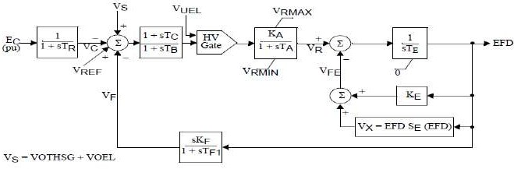Type DC1A: 1992 IEEE type DC1A excitation systemmodel

  - Type DC2A: 1992 IEEE type DC2A excitation systemmodel

  - Type DC3A: IEEE 421.5 2005 DC3A excitationsystem
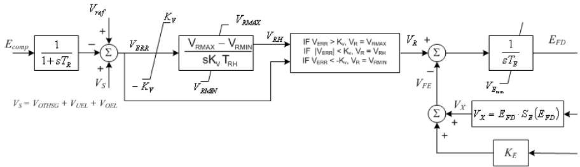

  - Type DC4B: IEEE 421.5 2005 DC4B excitationsystem

- AC Exciters GenericModels:

  - Type AC1A: 1992 IEEE type AC1A excitation systemmodel

  - Type AC2A: 1992 IEEE type AC2A excitation systemmodel

  - Type AC3A: 1992 IEEE type AC3A excitation systemmodel

  - Type AC4A: 1992 IEEE type AC4A excitation systemmodel

  - Type AC5A: 1992 IEEE type AC5A excitation systemmodel

  - Type AC6A: IEEE 421.5 excitation systemmodel

  - Type AC7B: IEEE 421.5 2005 AC7B excitationsystem
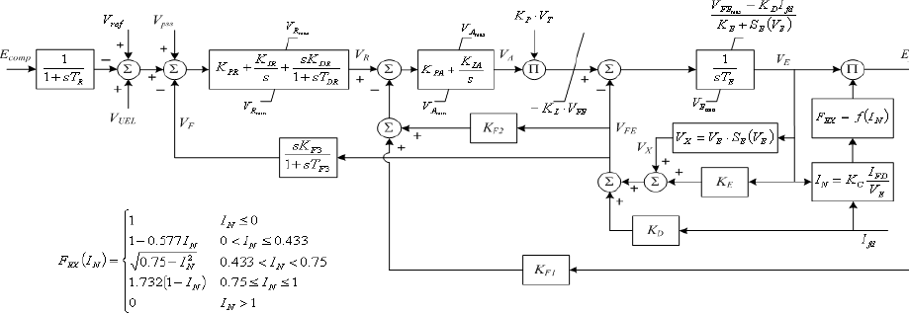

  - Type AC8B: IEEE 421.5 2005 AC8B excitationsystem

- Commonly Used Static Exciters Generic Models blockdiagrams:

  - Type ST1A: 1992 IEEE type ST1A excitation systemmodel

  - Type ST2A: 1992 IEEE type ST2A excitation systemmodel

  - Type ST3A: 1992 IEEE type ST3A excitation systemmodel
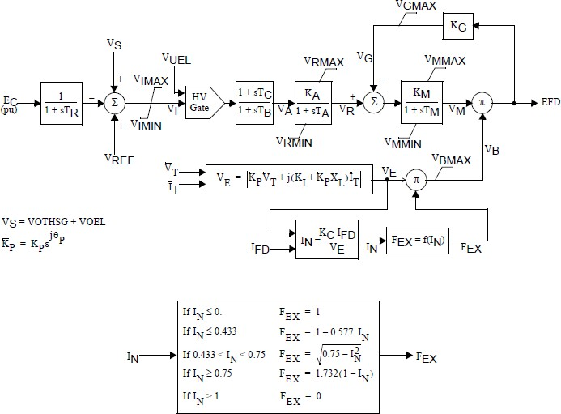

  - Type ST4B: IEEE type ST4B potential or compounded source-controlled rectifierexciter

  - Type ST5B: IEEE 421.5 2005 ST5B excitationsystem
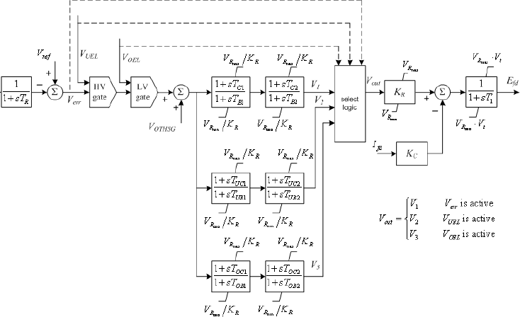

  - Type ST6B: IEEE 421.5 2005 ST6B excitationsystem

  - Type ST7B: IEEE 421.5 2005 ST7B excitationsystem
Source-PSSE Model Library
  - Power systemstabilizer:
The function of the PSS is to add to the unit’s characteristic electromechanical oscillations. This is achieved by modulating excitation to develop a component in electrical torque in phase with rotor speed deviations.
The most important aspect when considering a PSS model is the number of inputs. The following table shows the type of models separated based on the inputs:

Type | Inputs | Remarks
PSS1A | Single input | Two lead-lags  Input can either be speed, frequency or power
PSS2B | Dual input | Integral of accelerating power type stabiliser Speed and Power  Most common type  Supersedes PSS2A (three versus two lead lags)
PSS3B | Dual input | Power and rotor angular frequency deviation  Stabilising signal is a vector sum of processed signals Not very common

Category |  | Parameter Description | Data
 | Stabilizer Models
PSS1A |  | A1, Filter coefficient
 |  | A2, Filter coefficient
 |  | TR, transducer time constant
 |  | 0
 |  | 0
 |  | 0
 |  | T1, 1st Lead-Lag Derivative Time Constant
 |  | T2, 1st Lead-Lag Delay Time Constant
 |  | T3, 2nd Lead-Lag Derivative Time Constant
 |  | T4, 2nd Lead-Lag Delay Time Constant
 |  | Tw, Washout Time Constant
 |  | Tw, Washout Time Constant
 |  | Ks, input channel gain
 |  | VSTMAX, Controller maximum output
 |  | VSTMAX, Controller minimum output
 |  | 0
 |  | 0
PSS2B |  | TW1, 1st Washout 1th Time Constant
 |  | TW2, 1st Washout 2th Time Constant
 |  | T6, 1st Signal Transducer Time Constant
 |  | TW3, 2nd Washout 1th Time Constant
 |  | TW4, 2nd Washout 2th Time Constant
 |  | T7, 2nd Signal Transducer Time Constant
 |  | KS2, 2nd Signal Transducer Factor
 |  | KS3, Washouts Coupling Factor
 |  | T8, Ramp Tracking Filter Deriv. Time Constant
 |  | T9, Ramp Tracking Filter Delay Time Constant
 |  | KS1, PSS Gain
 |  | T1, 1st Lead-Lag Derivative Time Constant
 |  | T2, 1st Lead-Lag Delay Time Constant
 |  | T3, 2nd Lead-Lag Derivative Time Constant
 |  | T4, 2nd Lead-Lag Delay Time Constant
 |  | T10, 3rd Lead-Lag Derivative Time Constant
 |  | T11, 3rd Lead-Lag Delay Time Constant
 |  | VS1MAX, Input 1 Maximum limit
 |  | VS1MIN, Input 1 Minimum limit
 |  | VS2MAX, Input 2 Maximum limit
 |  | VS2MIN, Input 2 Minimum limit
 |  | VSTMAX, Controller Maximum Output
 |  | VSTMIN, Controller Minimum Output

Category | Parameter Description | Data
Stabilizer Models
PSS3B | KS1 (pu) (≠0), input channel #1 gain
 | T1 input channel #1 transducer time constant (sec)
 | Tw1 input channel #1 washout time constant (sec)
 | T2 input channel #2 transducer time constant (sec)
 | Tw2 input channel #2 washout time constant (sec)
 | Tw3 (0), main washout time constant (sec)
 | A1, Filter coefficient
 | A2, Filter coefficient
 | A3, Filter coefficient
 | A4, Filter coefficient
 | A5, Filter coefficient
 | A6, Filter coefficient
 | A7, Filter coefficient
 | A8, Filter coefficient
 | VSTMAX, Controller maximum output
 | VSTMAX, Controller minimum output

Commonly Used Power System Stabilizer generic models block diagrams:
- PSS1A: IEEE Std. 421.5-2005 PSS1A Single-Input Stabilizermodel
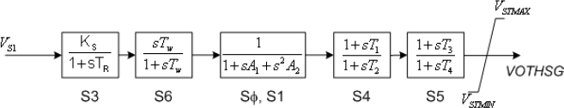
- PSS2B: IEEE 421.5 2005 PSS2B IEEE dual-input stabilizermodel

- PSS3B: IEEE Std. 421.5 2005 PSS3B IEEE dual-input stabilizermodel
Source-PSSE Model Library

  - Generic models forturbine-governor:
The following table is a list for common generic models of hydro turbines:

Type | Name | Remarks
HYGOV | Hydro-turbine Governor | Simple hydro model with unrestricted head race  and tail race, no surge tank
HYGOVDU | Hydro turbine-governor model with speed  dead band | Added asymmetrical deal band
HYGOVM | Hydro-Turbine Governor | Includes detailed representation of surge chamber
WEHGOV | Woodward Electric Hydro Governor  Model | Woodward hydro governor with non-linear model  for penstock dynamics
HYGOVT | Hydro Turbine-Governor traveling wave  model | Travelling-wave solution applied to penstock and  tunnel
PIDGOV | Hydro Turbine Governor | Straight forward penstock configuration with  PID governor
HYGOVR1 | Fourth order lead-lag hydro-turbine | for a unit with digital controls, allows anonlinear  relationship between the gate position andpower
TURCZT | Czech hydro or steam turbine governor model | General-purpose hydro and thermal turbine-  governor model. Penstock dynamic is not included in the model
TWDM1T | Tail water depression hydro governor model 1 | same basic permanent and transient droop elements as the HYGOV model, but it adds a  representation for a tail water depression protection system
TWDM2T | Tail water depression hydro governor  model 2 | Same as TWDM1T and uses a governor  proportional-integral-derivative (PID) controller
WPIDHY | Woodward PID hydro governor model | includes governor controls representing  a Woodward PID hydro governor .The model  includes a nonlinear gate/power relationship and a linearized turbine/penstock model.
WSHYDD | WECC double derivative hydro governor model | Double-derivative hydro turbine-governor mode. Includes two dead band, also includes anonlinear gate/power relationship and a linearizedturbine/  penstock model
WSHYGP | WECC GP hydro governor plus turbine model | WECC GP hydro turbine-governor model with a PID controller, penstock dynamics are similar to  those of the WECC WSHYDD

Source: PSSE Model Library, for models other than the above list refer to
https://w3.usa.siemens.com/smartgrid/us/en/transmission-grid/products/grid-analysis-tools/transmission-system-planning/transmission-system-planning-tab/pages/user-support.aspx

Category | Parameter Description | Data
TURBINE GOVERNOR model
HYGOV | R, permanent droop
 | r, temporary droop
 | Tr (>0) governor time constant
 | Tf (>0) filter time constant
 | Tg (>0) servo time constant
 | + VELM, gate velocity limit
 | GMAX, maximum gate limit
 | GMIN, minimum gate limit
 | TW (>0) water time constant
 | At, turbine gain
 | Dturb, turbine damping
 | qNL, no power flow
HYGOVDU | R, permanent droop
 | r, temporary droop
 | Tr (>0) governor time constant
 | Tf (>0) filter time constant
 | Tg (>0) servo time constant
 | + VELM, gate velocity limit
 | GMAX, maximum gate limit
 | GMIN, minimum gate limit
 | TW (>0) water time constant
 | At, turbine gain
 | Dturb, turbine damping
 | qNL, no power flow
 | DBH (pu), droop for over-speed, (> 0)
 | DBL (pu), droop for under-speed, (< 0)
 | TRate (MW), turbine rating, if zero, then MBASE used

Category | Parameter Description | Data
TURBINE GOVERNOR model
HYGOVM | Prated, rated turbine power (MW
 | Qrated, rated turbine flow (cfs or cms)
 | Hrated, rated turbine head (ft or m)
 | Grated, gate position at rated conditions (pu)
 | QNL, no power flow (pu of Qrated)
 | R, permanent droop (pu)
 | r, temporary droop (pu)
 | Tr, governor time constant ( > 0 ) (sec)
 | Tf, filter time constant ( > 0 ) (sec)
 | Tg, servo time constant ( > 0 ) (sec)
 | MXGTOR, maximum gate opening rate (pu/sec)
 | MXGTCR, maximum gate closing rate (< 0 ) (pu/sec)
 | MXBGOR, maximum buffered gate opening rate (pu/sec)
 | MXBGCR, maximum buffered gate closing rate (< 0 ) (pu/sec)
 | BUFLIM, buffer upper limit (pu)
 | GMAX, maximum gate limit (pu)
 | GMIN, minimum gate limit (pu)
RVLVCR, relief valve closing rate (< 0 ) (pu/sec) or MXJDOR, maximum jet deflector
opening rate (pu/sec)
RVLMAX, maximum relief valve limit (pu) or MXJDCR, maximum jet deflector closing
rate (< 0 ) (pu/sec)
 | HLAKE, lake head (ft or m)
 | HTAIL, tail head (ft or m)
PENL/A, summation of penstock, scroll case and draft tube lengths/ cross sections (> 0)
(1/ft or 1/m)
 | PENLOS, penstock head loss coefficient (ft/cfs2 or m/cms2)
TUNL/A, summation of tunnel lengths/cross sections (>0)
(1/ft or 1/m)
 | TUNLOS, tunnel head loss coefficient (ft/cfs² or m/cms²)
 | SCHARE, surge chamber effective cross section (>0) (ft² or m²)
 | SCHMAX, maximum water level in surge chamber (ft or m)
 | SCHMIN, minimum water level in surge chamber (ft or m)
SCHLOS, surge chamber orifice head loss coefficient
(ft/cfs² or m/cms²)
 | DAMP1, turbine damping under RPM1
 | RPM1, over speed (pu)
 | DAMP2, turbine damping above RPM2
 | RPM2, over speed (pu)

Category | Parameter Description | Data
TURBINE GOVERNOR model
WEHGOV | R-PERM-GATE (Feedback settings)
 | R-PERM-PE (Feedback settings)
 | TPE (sec), Power time constant
 | Kp, Proportional gain
 | KI, Integral gain
 | KD, Derivative gain
 | TD (sec), Derivative time constant
 | TP (sec), Gate servo time constant
 | TDV (sec), Time constant
 | Tg (sec), Gate servo time constant
 | GTMXOP (>0), Max gate opening velocity
 | GTMXCL (<0), Max gate closing velocity
 | GMAX, Maximum governor output
 | GMIN, Minimum governor output
 | DTURB, Turbine damping factor
 | TW (sec), Water inertia time constant
 | Speed Dead Band (DBAND)
 | DPV, Governor limit factor
 | DICN, Gate limiter modifier
 | GATE 1
 | GATE 2
 | GATE 3
 | GATE 4
 | GATE 5
 | FLOW G1
 | FLOW G2
 | FLOW G3
 | FLOW G4
 | FLOW G5
 | FLOW P1
 | FLOW P2
 | FLOW P3
 | FLOW P4
 | FLOW P5
 | FLOW P6
 | FLOW P7
 | FLOW P8
 | FLOW P9
 | FLOW P10
 | PMECH1

Category | Parameter Description | Data
TURBINE GOVERNOR model
WEHGOV | PMECH2
 | PMECH3
 | PMECH4
 | PMECH5
 | PMECH6
 | PMECH7
 | PMECH8
 | PMECH9
 | PMECH10
HYGOVT | Prated, rated turbine power (MW)
 | Qrated, rated turbine flow (cfs or cms)
 | Hrated, rated turbine head (ft or m)
 | Grated, gate position at rated conditions (pu)
 | QNL, no power flow (pu of Qrated)
 | R, permanent droop
 | r, temporary droop (pu)
 | Tr, governor time constant (> 0) (sec)
 | Tf, filter time constant (> 0) (sec)
 | Tg, servo time constant (> 0) (sec)
 | MXGTOR, maximum gate opening rate (pu/sec)
 | MXGTCR, maximum gate closing rate (< 0) (pu/sec)
 | MXBGOR, maximum buffered gate opening rate (pu/sec)
 | MXBGCR, maximum buffered gate closing rate (< 0) (pu/sec)
 | BUFLIM, buffer upper limit (pu)
 | GMAX, maximum gate limit (pu)
 | GMIN, minimum gate limit (pu)
RVLVCR, relief valve closing rate (< 0) (pu/sec) or MXJDOR, maximum jet deflector
opening rate (pu/sec)
RVLMAX, maximum relief valve limit (pu) or MXJDCR, maximum jet deflector closing
rate (< 0) (pu/sec)
 | HLAKE, lake head (ft or m)
 | HTAIL, tail head (ft or m)
 | PENLGTH, penstock length (ft or m)
 | PENLOS, penstock head loss coefficient (ft/cfs2 or m/cms2)
 | TUNLGTH, tunnel length (ft or m)
 | TUNLOS, tunnel head loss coefficient (ft/cfs2 or m/cms2)
 | SCHARE, surge chamber effective cross section (>0) (ft2 or m2)
 | SCHMAX, maximum water level in surge chamber (ft or m)
 | SCHMIN, minimum water level in surge chamber (ft or m)
 | SCHLOS, surge chamber orifice head loss coefficient (ft/cfs2 or m/cms2)
 | DAMP1, turbine damping under RPM1
 | RPM1, overspeed (pu)

Category | Parameter Description | Data
TURBINE GOVERNOR model
HYGOVT | DAMP2, turbine damping above RPM2
 | RPM2, overspeed (pu)
 | PENSPD, penstock wave velocity (>0) (ft/sec or m/sec)
 | PENARE, penstock cross section (>0) (ft2 or m2)
 | TUNSPD, tunnel wave velocity (>0) (ft/sec or m/sec)
 | TUNARE, tunnel cross section (>0) (ft2 or m2)
PIDGOV | Rperm, permanent drop, pu
 | Treg (sec), speed detector time constant
 | Kp, proportional gain, pu/sec
 | Ki, reset gain, pu/sec
 | Kd, derivative gain, pu
 | Ta (sec) > 0, controller time constant
 | Tb (sec) > 0, gate servo time constant
 | Dturb, turbine damping factor, pu
 | G0, gate opening at speed no load, pu
 | G1, intermediate gate opening, pu
 | P1, power at gate opening G1, pu
 | G2, intermediate gate opening, pu
 | P2, power at gate opening G2, pu
 | P3, power at full opened gate, pu
 | Gmax, maximum gate opening, pu
 | Gmin, minimum gate opening, pu
 | Atw > 0, factor multiplying Tw, pu
 | Tw (sec) > 0, water inertia time constant
 | Velmax, minimum gate opening velocity, pu/sec
 | Velmin < 0, minimum gate closing velocity, pu/sec
HYGOVR1 | db1, Intentional dead band width, Hz
 | Err, deadband hysteresis (p.u.)
 | Td (sec), Input filter time constant, s
 | T1 (sec), Lead time constant 1, s
 | T2 (sec) q, Lag time constant 1, s
 | T3 (sec), Lead time constant 2, s
 | T4 (sec), Lag time constant 2, s
 | T5 (sec), Lead time constant 3, s
 | T6 (sec), Lag time constant 3, s
 | T7 (sec), Lead time constant 4, s
 | T8 (sec), Lag time constant 4, s
 | KP, proportional gain
 | R, Steady-state droop, p.u.
 | Tt, Power feedback time constant, s

Category | Parameter Description | Data
TURBINE GOVERNOR model
HYGOVR1 | KG, Gate servo gain, p.u.
 | TP (sec), Gate servo time constant, s
 | VELOPEN, Maximum gate opening velocity, p.u./s
 | VELCLOSE, Maximum gate closing velocity, p.u./s (<0)
 | PMAX, Maximum gate opening, p.u. of mwcap
 | PMIN, Minimum gate opening, p.u. of mwcap
 | db2, Unintentional deadband, MW
 | TW (>0) water time constant
 | At, turbine gain
 | Dturb, turbine damping
 | qNL, no power flow
 | Trate (Turbine MW rating)
TURCZT | fDEAD (pu), Frequency Dead Band
 | fMIN (pu), Frequency Minimum Deviation
 | fMAX (pu), Frequency Maximum Deviation
 | KKOR (pu), Frequency Gain
 | KM > 0 (pu), Power Measurement Gain
 | KP (pu), Regulator Proportional Gain
 | SDEAD (pu), Speed Dead Band
 | KSTAT (pu), Speed Gain
 | KHP (pu), High Pressure Constant
 | TC (sec), Measuring transducer time constant
 | T 1 (sec), Regulator Integrator Time Constant
 | TEHP (sec), Hydro Converter Time Constant
 | TV > 0 (sec), Regulation Valve Time Constant
 | THP (sec), High Pressure Time Constant
 | TR (sec), Reheater time constant
 | TW (sec), Water Time Constant
 | NTMAX (pu), Power Regulator-Integrator Maximum Limiter
 | NTMIN (pu), Power Regulator-Integrator Minimum Limiter
 | GMAX (pu), Valve Maximum Open
 | GMIN (pu), Valve Minimum Open
 | VMIN (pu/sec), Valve Maximum Speed Close
 | VMAX (pu/sec), Valve Maximum Speed Open
TWDM1T | R, permanent droop
 | r, temporary droop
 | Tr, governor time constant (>0)
 | Tf, filter time constant (>0)
 | Tg, servo time constant (>0)
 | VELMX, open gate velocity limit (pu/sec)

Category | Parameter Description | Data
TURBINE GOVERNOR model
TWDM1 | VELMN, close gate velocity limit (pu/sec) (<0)
 | GMAX, maximum gate limit
 | GMIN, minimum gate limit
 | TW, water time constant (sec) (>0)
 | At, turbine gain
 | Dturb, turbine damping
 | qNL, no power flow
 | F1, frequency deviation (pu)
 | TF1, time delay (sec)
 | F2, frequency deviation (pu)
 | sF2, frequency (pu/sec)
 | TF2, time delay (sec)
 | GMXRT, rate with which GMAX changes when TWD is tripped (pu/sec)
 | NREF, setpoint frequency deviation (pu)
 | Tft, frequency filter time constant (>0
TWDM2 | TREG (sec), governor time constant (s)
 | Reg, permanent droop (p.u. on generator MVA rating)
 | KP, controller proportional gain (p.u.)
 | KI, controller integral gain (p.u./s)
 | KD, controller derivative gain (p.u.-s)
 | TA (sec) (> 0), controller time constant (s)
 | TB (sec) (> 0), controller time constant (s)
 | VELMX (pu/sec), open gate velocity limit (p.u./s)
 | VELMN (pu/sec) (> 0), close gate velocity limit (p.u./s)
 | GATMX (pu), maximum gate limit (p.u.)
 | GATMN (pu), minimum gate limit (p.u.)
 | TW (sec) (> 0), water time constant (s)
 | At, turbine gain
 | qNL, flow rate at no load (p.u.)
 | Dturb, turbine damping factor
 | F1, frequency deviation (pu)
 | TF1, time delay (sec)
 | F2, frequency deviation (pu)
 | sF2, frequency (pu/sec)
 | TF2, time delay (sec)
 | PREF, power reference (pu)
 | Tft, frequency filter time constant (sec) (>0)

Category | Parameter Description | Data
TURBINE GOVERNOR model
WPIDHY | TREG (sec), governor time constant (s)
 | REG1, permanent droop (p.u. on generator MVA base)
 | KP, controller proportional gain (p.u.)
 | KI, controller integral gain (p.u./s)
 | KD, controller derivative gain (p.u./s)
 | TA (>0) (sec), controller time constant (s)
 | TB (>0) (sec), controller time constant (s)
 | VELMX (>0), open gate velocity limit (p.u./s)
 | VELMN (<0), close gate velocity limit (p.u./s)
 | GATMX, maximum gate limit (p.u.)
 | GATMN, minimum gate limit (p.u.)
 | TW (>0) (sec), water time constant (s)
 | PMAX, maximum gate position (p.u.)
 | PMIN, minimum gate position (p.u.)
 | D
 | G0, gate position at no load (p.u.)
 | G1, first gate intermediate position (p.u.)
 | P1, power at gate position G1 (p.u. on generator MVA rating)
 | G2, second gate intermediate position (p.u.)
 | P2, power at gate position G2 (p.u. on generator MVA rating)
 | P3, power at fully open gate (p.u. on generator MVA rating)
WSHYDD | db1, deadband width (p.u.)
 | Err, deadband hysteresis (p.u.)
 | Td (sec), input filter time constant (s)
 | K1, derivative gain (p.u.)
 | Tf (sec), derivative time constant (s)
 | KD, double derivative gain (p.u.)
 | KP, integral gain (p.u.)
 | R, droop (p.u. on Trate)
 | Tt, power feedback time constant (s)
 | KG, gate servo gain (p.u.)
 | TP (sec), gate servo time constant (s)
 | VELOPEN (>0), maximum gate opening rate (p.u./s)
 | VELCLOSE (>0), maximum gate closing rate (p.u./s)
 | PMAX, maximum gate opening (p.u.)
 | PMIN, minimum gate opening (p.u.)
 | db2, deadband (p.u.)
 | GV1, coordinate of power-gate look-up table (p.u. gate)
 | PGV1, coordinate of power-gate look-up table (p.u. power)
 | GV2, coordinate of power-gate look-up table (p.u. gate)

Category | Parameter Description | Data
TURBINE GOVERNOR model
WSHYDD | PGV2, coordinate of power-gate look-up table (p.u. power)
 | GV3, coordinate of power-gate look-up table (p.u. gate)
 | PGV3, coordinate of power-gate look-up table (p.u. power)
 | GV4, coordinate of power-gate look-up table (p.u. gate)
 | PGV4, coordinate of power-gate look-up table (p.u. power)
 | GV5, coordinate of power-gate look-up table (p.u. gate)
 | PGV5, coordinate of power-gate look-up table (p.u. power)
 | Aturb, turbine lead time constant multiplier
 | Bturb (> 0), turbine lag time constant multiplier
 | Tturb (> 0) (sec), turbine time constant (s)
 | Trate, turbine rating (MW)
WSHYGP | db1, deadband width (p.u.)
 | Err, deadband hysteresis (p.u.)
 | Td (sec), input filter time constant (s)
 | K1, derivative gain (p.u.)
 | Tf (sec), derivative time constant (s)
 | KD, double derivative gain (p.u.)
 | KP, integral gain (p.u.)
 | R, droop (p.u. on Trate)
 | Tt, power feedback time constant (s)
 | KG, gate servo gain (p.u.)
 | TP (sec), gate servo time constant (s)
 | VELOPEN (>0), maximum gate opening rate (p.u./s)
 | VELCLOSE (>0), maximum gate closing rate (p.u./s)
 | PMAX, maximum gate opening (p.u.)
 | PMIN, minimum gate opening (p.u.)
 | db2, deadband (p.u.)
 | GV1, coordinate of power-gate look-up table (p.u. gate)
 | PGV1, coordinate of power-gate look-up table (p.u. power)
 | GV2, coordinate of power-gate look-up table (p.u. gate)
 | PGV2, coordinate of power-gate look-up table (p.u. power)
 | GV3, coordinate of power-gate look-up table (p.u. gate)
 | PGV3, coordinate of power-gate look-up table (p.u. power)
 | GV4, coordinate of power-gate look-up table (p.u. gate)
 | PGV4, coordinate of power-gate look-up table (p.u. power)
 | GV5, coordinate of power-gate look-up table (p.u. gate)
 | PGV5, coordinate of power-gate look-up table (p.u. power)
 | Aturb, turbine lead time constant multiplier
 | Bturb (> 0), turbine lag time constant multiplier
 | Tturb (> 0) (sec), turbine time constant (s)
 | Trate, turbine rating (MW)

Commonly Used Hydro Turbine Generic Models Block Diagrams:

- HYGOV: HydroTurbine-Governor

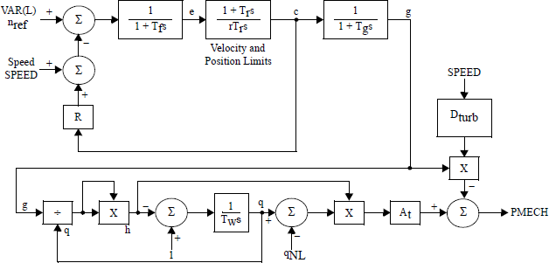
- HYGOVDU: HydroTurbine-Governor

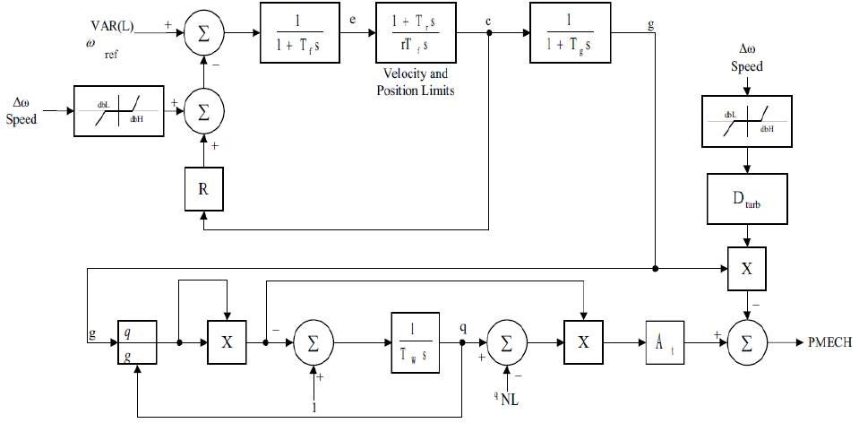

- HYGOVM: Hydro Turbine-Governor Lumped ParameterModel

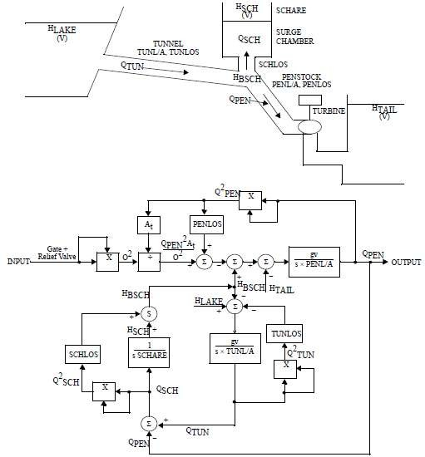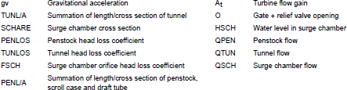

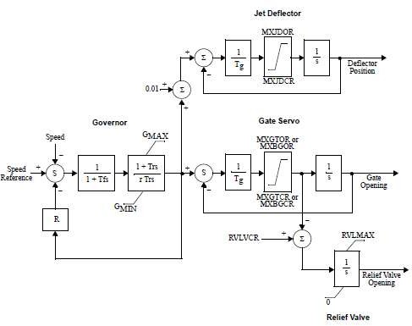

- WEHGOV: Woodward Electric Hydro GovernorModel

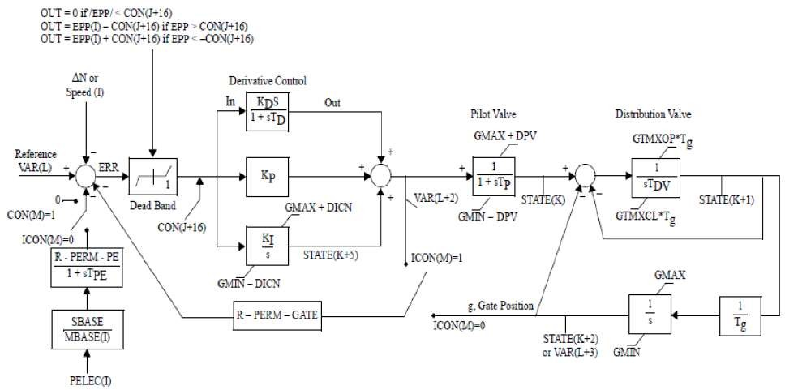
Governor and Hydraulic Actuators

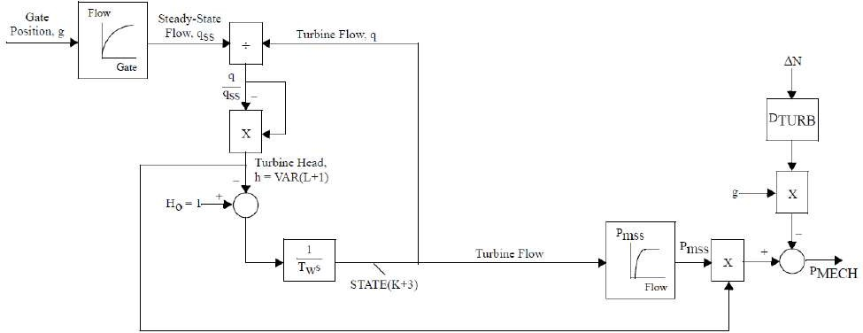

Turbine Dynamics
- HYGOVT: Hydro Turbine-Governor Traveling WaveModel

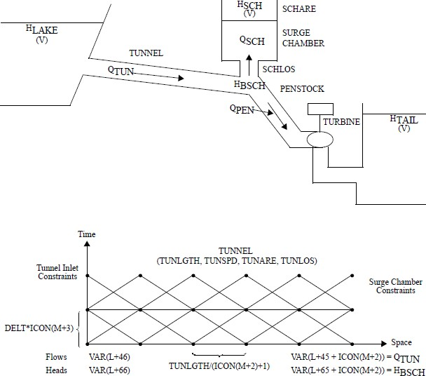

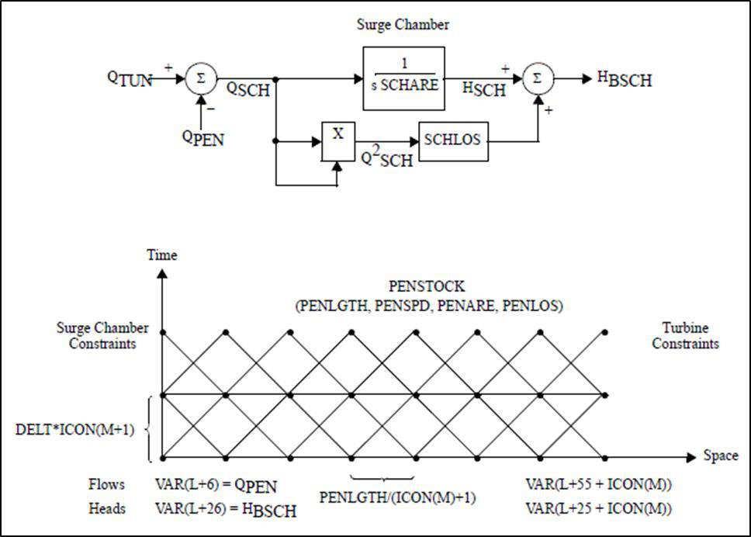
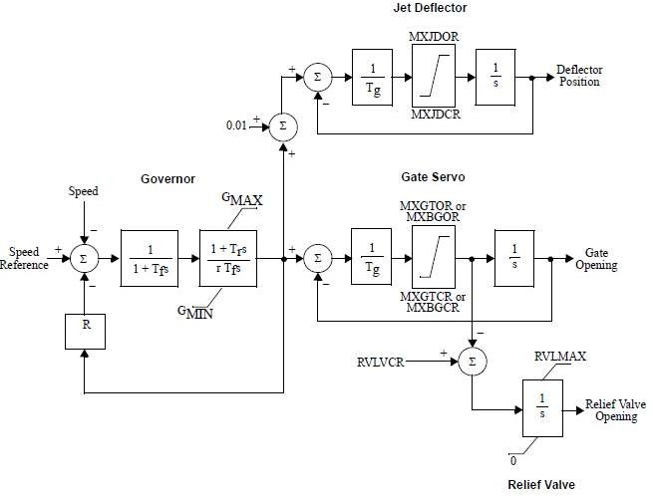

- PIDGOV: HydroTurbine-Governor
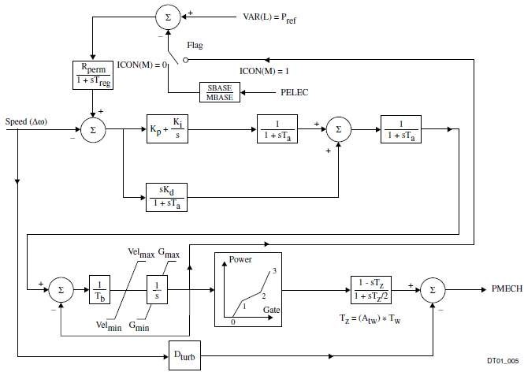
- HYGOVR1: Fourth order lead-laghydro-turbine
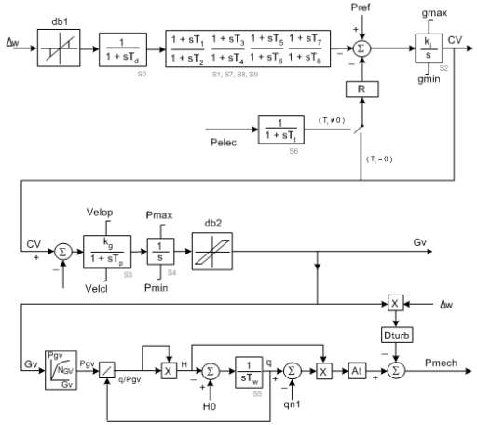

- TURCZT: Czech Hydro and SteamGovernor

- TWDM1T: Tail Water Depression Hydro Governor Model1
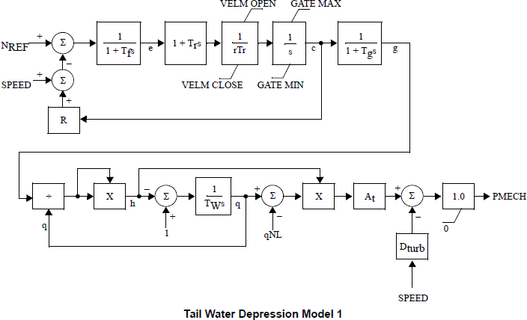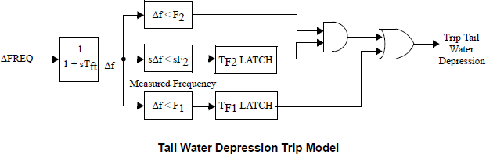

- TWDM2T: Tail Water Depression Hydro Governor Model2
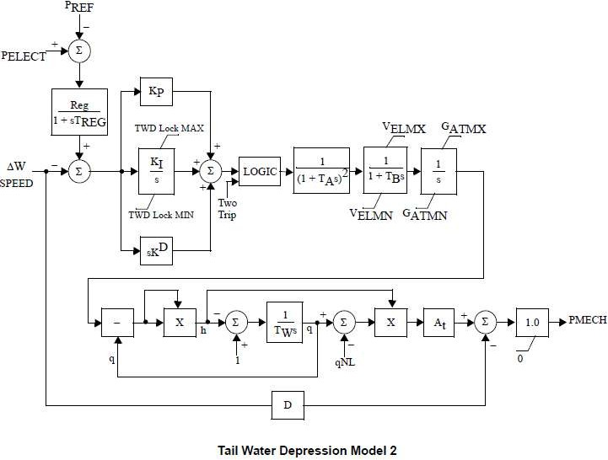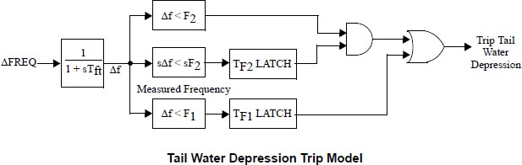

- WPIDHY: Woodward PID HydroGovernor
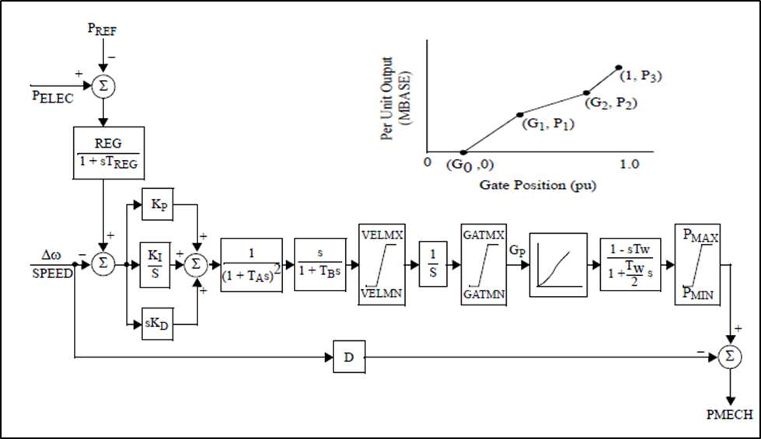

- WSHYDD: WECC Double-Derivative HydroGovernor
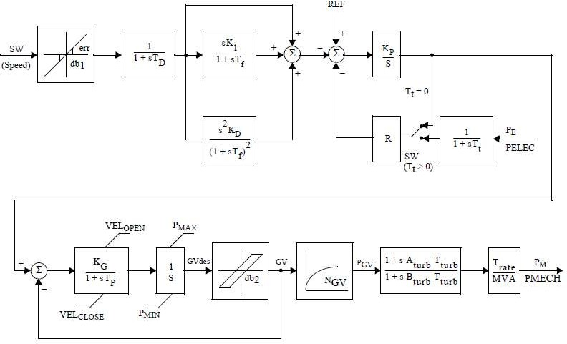

- WSHYGP: WECC GP Hydro Governor PlusTurbine
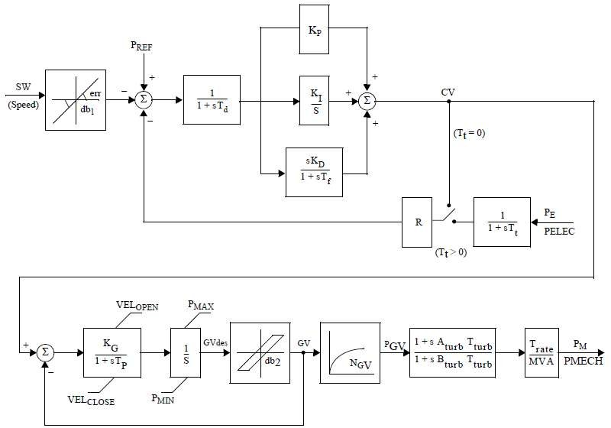

Source-PSSE Model Library

Calculation of saturation parameters:
Figure 2: Open and short circuit characteristics

The saturation can be calculated using the following calculation:
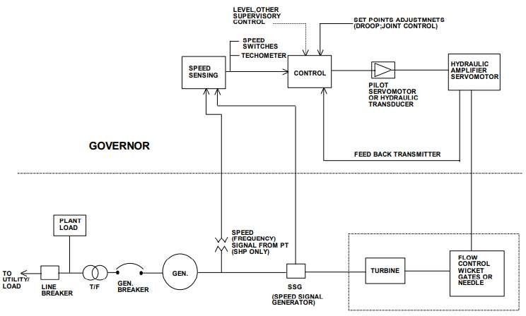

Figure 3: Governing system - Block Diagram (Typical) as per IEEE std. -75

Annex-5

Hydro Plant Details
 | Project/Plant details
1 | Company/SLDC name:
2 | Owner of the power station:
3 | Project name and location:
4 | Contact Number & Name of the Nodal person : Mr./ Ms.
5 | Total Installed Capacity(MW): (e.g.2x100MW):
6 | Turbine type: Francis /Kaplan / Pelton/Bulb/Any other
7 | Intake River & Diversion dam:
8 | Hydro station type - ROR/ ROR with poundage/Storage type:
 | Reservoir details
1 | Power station- Underground/Surface :
2 | Energy content at FRL and Target energy for financial year :
3 | Monthly design energy/10 daily energy:
4 | Water usage (other than electricity production)- Irrigation/Flood control/ Bilateral  treaty/ hydrology :
5 | Which are the riparian States?
6 | Is the Station part of the tandem hydro system? If yes then what are the constraints in  operating the station?
7 | Which is next hydro station (with pondage /reservoir) on the upstream and  downstream side?
8 | What is the accounting period for total water inflows and releases from the station?
9 | Monthly pattern of release of water( over the day too)
10 | What are the tools for forecasting the inflow silt etc. how much early (from the  generation time) inflow forecasting is available?
 | Beneficiaries of Plant
11 | Who owns the Station and Who operates the Hydro Electric Station?
12 | Which are the entities having entitlement on the power generated from the Station?
 | Control/Direction
13 | Which agency assesses the water inflows for the river basin on which the hydro  station is built?
14 | Which are the sectors/ entities that are entitled for water usage from the reservoir?
15 | Who decides the allocation of water available for different usage such as drinking  water, irrigation, industrial use, tourism, power generation?
16 | Is the Station operation governed under some water sharing treaty?
17 | In case the hydro station has multiple beneficiaries- Who coordinate the scheduling?
18 | Who manages the water releases? Who decides the quantum of water available for  power generation?
19 | Whereistheofftakeforwaterforirrigation/drinkingwater-Fromtheupstreamfrom thereservoirordownstreamofthetailrace?Whatistheoperatingdomainforthe  plant operator with respect to the water releases?
20 | What is the philosophy for despatching the station - (managing peak demand / load  following / ramping / deviation control / other)
21 | How is the station compensated for the energy generated? Is the tariff multi-part or  single part?

Hydro Plant Details
 | Pumped mode operation
22 | Pumped Storage Capability available (Y/N), If yes operational since when?/Reason  for Not utilized
23 | In case of a pumped storage station, can the water be released when the lower  reservoir is full?
 | Scheduling aspects
24 | Is the Station given a day-ahead schedule? If yes, can the schedule be revised in real-  time?
25 | Whataretheconsiderations/aspectstobetakencarewhilerevisingday-ahead injectionschedule?
 | Operations
26 | What is the operating range for operating the unit in the station?
27 | Does the station have overload capacity (Yes/No)? If yes, how much?
28 | Time required for synchronizing the unit and Time from synchronization to full load.
29 | Isthestationcapableofoperatingincondensermode?Ifyes,hasiteveroperatedin this mode?
30 | Is the station capable of black start(Yes/No) & AGC (Yes/No)
31 | Who assesses the performance of the station? What are the indices for measuring the  performance of the station?
32 | What is the periodicity of assessing the performance and any incentive scheme?
33 | Operational constraint
 | Others
34 | Comments if any

Check List of information to be submitted by New State Entity to SLDC

Annex-6

Sr.  No. | Item | Available I  Not Available /  Value | Remark
 | Name of the New Regional Entity:
 | Name of the Region / Concerned RLDC:
I | Metering Details
A | Main Meters (feeder wise, with nos.)
B | Standby Meter (feeder wise, with nos.)
C | Check Meter (feeder wise. with nos.)
2 | Generation
A | Total Installed Capacity (MW)
B | No. of Units
C | Capacity of each unit (MW)
D | FGM() / RGMO capability as per IEGC.  Collected unit wise details
I | [)ate of Commercial Operation (unit wise)
3 | Transmission Connectivity
A | Voltage Level (kV)
B | No. of Circuits
C | Node of Connectivity to the Grid  (in case of more than one node, add rows)
I) | Date of the charging of lines / connection to the Grid (node wise)
Ii | Map / Diagram showing connectivity to the Grid
F | Details of Reactive Compensation
(3 | DetailsofTransformers—Number.MVArating. VoltageRatio,vectorofeachtransformerbank
4 | Protection
A | Details of Protective Relays obtained
B | WhetherProtectionSettingshavebeensuppliedtothe  SLDC for Protection Coordination
C | Any Special Protections Schemes used
5 | Station Details
A | Single Line / Bus Diagram identi1iing all equipment
6 | Telemetry
A | Type of Data Gateway (Remote Terminal Unit!  Substation Automation System Gateway)
B | Data Communication connectivity followed (As per  interface requirement and other guideline made available by the respective SLDC)
7 | Communication
A | Details of the communication media, interface and  capacity being targeted for connection for Data Communication MainChannel
B | [)etails of the communication media, interface and  capacity being targeted for connection for Data  Communication — Standby Channel
C | Voice Communication — Main
D | Voice Communication — Standby

E | Integration of Station Data in the SCADA of the  Concerned SLDC
F | Integration of Station Data in the SCADA of RLDC
G | Details of any dedicated communication (Voice /  Data)thattheStationhaswithanotherControlArea and the neighboringstation
S | Manning of the Control Room
A | Contact details (Telephone, FAX)
I) | Contact person
C | Escalation Matrix starting from Control Room Shift  In—charge to Senior Level
I) | Details of the Shift Operation
9 | Modification of various applications to include the New State Entity at the Concerned SLDC
A | Scheduling
B | Metering
C | Accounting (UI)
1) | Reporting Systems  Has the new entity been informed about the information submission requirements to the SLDCs along with periodicity?
10 | Bank Account Details of the new State Entity
A | Bank Account No.
B | Bank Name & Branch
C | Bank Address
1) | SLDCbankaccountdetailsbeenintimatedtothenew  entity
11 | Agreement Details
A | Quantum for which LTA has been sought (MW)
B | Long Term Agreement (MW) fbr which PPA exists
C | Medium Term Agreement (MW) for which PPA  exists
12 | Simulation Studies
A | Incorporation in the assessment of Transfer  Capability
13 | Undertakings to be obtained
A | Undertaking obtained from new entity that it is not  going to breach any PPA to sell in short term
14 | Intimation to Concerned RPC about addition of a New Regional Entity
A | Intimation sent
B | Inclusion in the REA

